|  |  |  |  |  |
| --- | --- | --- | --- | --- |
|  |  | | |  |
|  |  | | |  |
|  | Personal and Portable Profiles  <<Feature>>  (F002032/B;1) | | |  |
|  |  | | |  |
| Document Type | **Feature Document (FD)** | | |  |
| Template Version | **6.0b / FFSD 8.0** | | |  |
| SysML Report Template Version | **O (11/12/2019)** | | |  |
| Document ID | **VDOC075158** | | |  |
| Document Location | [**Link to Spec in VSEM**](https://www.vsemweb.ford.com/tc/launchapp?-attach=true&-s=226TCSession&-o=TjpBES7Lx3NrTDAAAAAAAAAAAAA&servername=Production_Server) | | |  |
| Document Owner | **Justin Bauer, Walter Stephens** | | |  |
| Document Revision | **1.4** | | |  |
| Document Status | **Released** | | |  |
| Date Issued | **10/07/2020** | | |  |
| Date Revised | **10/06/2021** | | |  |
| Document Classification | GIS1 Item Number: | **27.60/35** | |  |
| GIS2 Classification: | **Confidential** | |
|  | | | | |
|  | | | | |
| Document Approval | | | | |
| Person | Role | | Email Confirmation | Date |
|  |  | |  |  |
|  |  | |  |  |

**Auto-Generated by MagicDraw**

Printed Copies Are Uncontrolled

# Disclaimer

**This document contains Ford Motor Company Confidential information. Disclosure of the information contained in any portion of this document is not permitted without the expressed, written consent of a duly authorized representative of Ford Motor Company, Dearborn, Michigan, U.S.A.**

**Copyright, Ó 2016 Ford Motor Company**

This document contains information developed and accumulated by and for FORD MOTOR COMPANY. As such, it is a proprietary document, which, if disseminated to unauthorized persons, would provide others with restricted information, data, or procedures not otherwise available, exposing the FORD MOTOR COMPANY to potential harm.

Employees and suppliers having custody of this specification or authorized to use it must be cognizant of its proprietary nature and ensure that the information herein is not made available to unauthorized persons.

FORD MOTOR COMPANY reserves the right to protect this work as an unpublished copyrighted work in the event of an inadvertent or deliberate unauthorized publication. FORD MOTOR COMPANY also reserves its rights under copyright laws to protect this work as a published work.

This document or portions thereof shall not be distributed outside FORD MOTOR COMPANY without prior written consent. Refer all questions concerning disclosure to the author(s) or to any duly authorized representative of Ford Motor Company.

# Contents

Disclaimer 2

Contents 3

1 Introduction 6

1.1 Document Purpose 6

1.2 Document Scope 6

1.3 Document Audience 6

1.3.1 Stakeholder List 6

1.4 Document Organization 6

1.4.1 Document Context 6

1.4.2 Document Structure 7

1.5 Document Conventions 7

1.5.1 Requirements Templates 7

1.6 References 7

1.6.1 Ford Documents 7

1.6.2 External Documents and Publications 7

1.7 Glossary 8

1.7.1 Parameters / Values 8

2 Feature Overview 9

2.1 Purpose and Description of Feature 9

2.2 Feature Variants 9

2.2.1 Regions & Markets 9

2.3 Input Requirements 9

2.3.1 Legal Requirements 9

2.3.2 Trustmark Requirements 9

2.3.3 Industry Standards 9

2.4 Lessons Learned 10

2.5 Assumptions 10

3 Feature Context 11

3.1 Feature Context Diagram 11

3.2 List of Influences 12

4 Feature Modeling 15

4.1 Operation Modes and States 15

4.2 Use Cases 16

4.2.1 Use Case Diagram 16

4.2.2 Actors 18

4.2.3 Use Case Descriptions 19

4.3 Driving and Operation Scenarios 31

4.4 Decision Tables 31

5 Feature Requirements 32

5.1 Functional Requirements 32

5.1.1 Error Handling 57

5.2 Non-Functional Requirements 58

5.2.1 Safety 58

5.2.2 Security 58

5.2.3 Reliability 58

5.3 HMI Requirements 58

5.4 Other Requirements 62

5.4.1 Design Requirements 62

5.4.2 Manufacturing Requirements 63

5.4.3 Service Requirements 63

5.4.4 After Sales Requirements 65

5.4.5 Process Requirements 65

5.4.6 Uncategorized Requirements 65

6 Functional Safety 66

6.1 System Behaviors for HARA 66

6.2 Safety Assumptions 66

6.3 Safety Goals 67

6.4 Functional Safety Requirements 67

6.4.1 Safety Goal: 68

6.4.2 Derivation of Functional Safety Requirements on Assumptions 68

6.5 ASIL Decomposition of Functional Safety Requirements 68

6.5.1 Decomposition of Functional Safety Requirement REQ-352205/A 68

7 CyberSecurity 69

7.1 Security Goals 69

7.2 Cybersecurity Requirements 69

7.2.1 Usage of SyncP 69

7.2.2 Timestamp 69

7.2.3 Timestamp Persistence 70

7.2.4 Profile Replay Protection 70

7.2.5 Input Validation 71

7.2.6 Application of Profile Data and Settings 71

7.2.7 Secure Authentication 71

7.2.8 Retry Strategy for Profile Delivery 72

7.2.9 Retry Strategy for Application of Settings 72

7.2.10 Module Swap 73

7.2.11 Master Reset 73

7.2.12 Cloud Encryption of Profile Data at Rest 74

7.2.13 In-Vehicle Encryption of Profile Data at Rest 74

7.2.14 Secure Account Linking 75

7.2.15 Secure Recall 75

7.2.16 Security Logging 75

8 Architecture 77

8.1 Functional Architecture 77

8.1.1 List of Functions 96

8.2 Logical Architecture 108

8.2.1 Logical Elements 108

8.2.2 Logical Interfaces 110

9 Open Concerns 115

10 Revision History 116

11 Appendix 117

11.1 Definitions 117

11.2 Abbreviations 117

**List of Figures**

Figure 1: Portable Profiles Context 12

Figure 2: Front Passenger Profiles 12

Figure 3: Logical Operating Modes 15

Figure 4: PPP Feature Use Cases 17

Figure 5: Passenger Profile Use Cases 18

Figure 6: 1 Link New Vehicle Profile w/ FP Account 79

Figure 7: 2 Link Pre-existing Vehicle Profile w/ FP account 79

Figure 8: 6 Unlink Vehicle Profile From FP Account 80

Figure 9: 7 Synchronize Profile with the Cloud 81

Figure 10: 9 Recall Profile and ID User 82

Figure 11: 10 Remove and Disassociate Portable Profile 83

Figure 12: 11/12 Off-Board Profile Create/Edit 84

Figure 13: 13 Configure profile settings at vehicle pre-delivery (RVS) 85

Figure 14: 14 Remove Profile from Vehicle va Off-Board Interface 86

Figure 15: 15 Restore Changed Profile 87

Figure 16: 16 Update Profile in Vehicle 88

Figure 17: 17 Configure PPP through FCS Portal 89

Figure 18: Create Passenger Profile via HMI - First Entry 91

Figure 19: Delete Passenger Profile 91

Figure 20: Edit Front Passenger Name/Avatar 93

Figure 21: Edit Front Passenger Profile Settings 95

Figure 22: Recall Passenger Profile 95

Figure 23: Structure Diagrams1 108

**List of Tables**

Table 1: Features described in this FD 6

Table 2: Ford internal Documents *(not specified in SysML model)* 7

Table 3: External documents and publications *(not specified in SysML model)* 8

Table 4: Parameters / Values used in this document *(Not supported by MagicDraw report generation)* 8

Table 5: Feature Variants 9

Table 6: Regions & Markets 9

Table 7: List of Influences 14

Table 8: Operation Modes and States on Logical Operating Modes 16

Table 9: Transitions between Operation Modes and States on Logical Operating Modes 16

Table 10: List of Actors 19

Table 11: System Behaviors for HARA 66

Table 12: List of Functions on 1 Link New Vehicle Profile w/ FP Account 98

Table 13: List of Functions on 2 Link Pre-existing Vehicle Profile w/ FP account 99

Table 14: List of Functions on 6 Unlink Vehicle Profile From FP Account 100

Table 15: List of Functions on 7 Synchronize Profile with the Cloud 101

Table 16: List of Functions on 9 Recall Profile and ID User 101

Table 17: List of Functions on 10 Remove and Disassociate Portable Profile 101

Table 18: List of Functions on 11/12 Off-Board Profile Create/Edit 102

Table 19: List of Functions on 13 Configure profile settings at vehicle pre-delivery (RVS) 102

Table 20: List of Functions on 14 Remove Profile from Vehicle va Off-Board Interface 103

Table 21: List of Functions on 15 Restore Changed Profile 103

Table 22: List of Functions on 16 Update Profile in Vehicle 104

Table 23: List of Functions on 17 Configure PPP through FCS Portal 104

Table 24: List of Functions on Create Passenger Profile via HMI - First Entry 105

Table 25: List of Functions on Delete Passenger Profile 106

Table 26: List of Functions on Edit Front Passenger Name/Avatar 106

Table 27: List of Functions on Edit Front Passenger Profile Settings 107

Table 28: List of Functions on Recall Passenger Profile 108

Table 29: Logical Elements 110

Table 30: Feature Interactions 114

Table 31: Open Concerns *(Not supported by MagicDraw report generation)* 115

# Introduction

## Document Purpose

A Feature Document (FD) document specifies **what** the feature shall do and how it shall behave from customer perspective. It should also provide reasoning and background **why** we have the feature in the vehicle.

The FD also serves as an Item Definition as defined by ISO26262 for those features, which follow the Ford Functional Safety process.

To get more information about the concept of feature, function and component level abstraction refer to the [Ford RE Wiki](http://wiki.ford.com/display/RequirementsEngineering/Requirements+Engineering+for+SW+Enabled+Features). For details on the Ford Functional Safety (ISO26262) process refer to the [Ford Functional Safety Sharepoint](https://pd3.spt.ford.com/sites/GlobalFunctionalSafety/Pages/default.aspx).

## Document Scope

This Feature Document (FD) specifies the following features:

|  |  |  |  |
| --- | --- | --- | --- |
| **Feature ID** | **Feature Name** | **Owner** | **Reference** |
| F002032/B;1 | Personal and Portable Profiles  (Program(s): Cross Carline) | Justin Bauer, Walter Stephens |  |

Table 1: Features described in this FD

## Document Audience

The FD is written by the feature owner of Justin Bauer, Walter Stephens. All Stakeholders, i.e., all people who have a valid interest in the feature should read and, if possible, review the FD. It needs to be guaranteed, that all stakeholders have access to the currently valid version of the FD.

**#Hint:** The FD template has the IP Classification “Proprietary” by default. IP Classification “Confidential” might be required in some cases, e.g. by Ford Functional Safety.

### Stakeholder List

For the latest list of stakeholder of the feature and their influence refer to <Put VSEM Link here>.

**#Hint:** Refer to [Ford RE Wiki – Stakeholder List](http://wiki.ford.com/display/RequirementsEngineering/Stakeholder+Analysis) on how to create a stakeholder list. The stakeholder list should be stored in VSEM in the pseudo folder “General Data Artifacts” of the corresponding feature.

## Document Organization

### Document Context

Refer to the [Specification Structure page](http://wiki.ford.com/display/RequirementsEngineering/Specification+templates) in the [Ford RE Wiki](http://wiki.ford.com/display/RequirementsEngineering/Requirements+Engineering+for+SW+Enabled+Features) to understand how the FD relates to other Ford Requirements Documents and Specifications.

### Document Structure

The structure of this document is explained below:

**Section 1** – Introduction how to use this document including responsibilities and requisite documents. Explains the terminology. Gives a clarification of the definitions, concepts and abbreviations used in the document.

**Section 2** – Feature Description. States briefly the background and the purpose of the feature, feature variants and corresponding regions and markets. Also includes input requirements, assumptions and constraints.

**Section 3** – Feature Context describes all external entities, which have an influence on the feature.

**Section 4** – Feature Modeling. Contains Use Case, Driving Scenarios, State Charts to describe the functional behavior of the feature.

**Section 5** – Safety. Lists System Behaviors and Safety Goals of the feature.

**Section 6** – Feature Requirements. Lists functional and non-functional requirements of the feature.

**Section 7** – Architecture. Shows the coarse architecture, which the feature requirements are deployed to. Describes the elements and the boundary of the feature as well as the decomposition and distribution of associated functions.

**Section 8** – List of Open Concerns

**Section 9** – Document Change History including a list of new or modified requirements. The requirements in this document are tagged, and this section contains different types of tables listing all, new, or changed requirements by their title and page no.

**Section 10** – Appendix

**#Hint:** All sections are mandatory, unless explicitly marked by the tag “#Classification” as “optional” or as applicable e.g. to certain domains like “Functional Safety”.

## Document Conventions

### Requirements Templates

Each requirement, use case or scenario in this specification shall follow the corresponding template given in the document template *Specification_Macros.dotm* at [RE Wiki - Specification Templates](http://wiki.ford.com/display/RequirementsEngineering/Specification+templates?src=contextnavpagetreemode).

#### Identification of requirements

#### Requirements Attributes

The templates provided by *Specification_Macros.dotm* define a list of attributes for each requirement. This helps to classify the requirement. The attributes are explained at [RE Wiki - Requirements Attributes](http://wiki.ford.com/display/RequirementsEngineering/Requirements+Attributes?src=contextnavpagetreemode).

## References

### Ford Documents

List here all Ford internal documents, which are directly related to the feature.

| **Reference** | **Title** | **Doc. ID** | **Document Location** | **Revision** |
| --- | --- | --- | --- | --- |
|  |  |  |  |  |

Table 2: Ford internal Documents *(not specified in SysML model)*

### External Documents and Publications

The list of external documents could include books, reports and online sources.

**#Hint:** You may refer to [IEEE Citation Reference](http://www.ieee.org/documents/ieeecitationref.pdf) on how to format a reference.

| **Reference** | **Document / Publication** | **Document Location** |
| --- | --- | --- |
|  |  |  |

Table 3: External documents and publications *(not specified in SysML model)*

## Glossary

**#Hint**: Terms, concepts and abbreviations used in the document shall be defined and illustrated here. Note that changes to terms and/or concepts described in this section tend to cause major updates to this document.

The tables below have feature specific definitions and abbreviations. For additional, non-feature specific terms please refer to the [RE Glossary](http://wiki.ford.com/display/RequirementsEngineering/Glossary?src=contextnavpagetreemode)

See Appendix for Definitions and Abbreviations.

### Parameters / Values

| **Name** | **Description** | **Range / Resolution** |
| --- | --- | --- |
|  |  |  |

Table 4: Parameters / Values used in this document *(Not supported by MagicDraw report generation)*

# Feature Overview

## Purpose and Description of Feature

**#Hint:** Some descriptive text to explain the purpose and functionality of the feature.

Develop a cloud-based platform / ecosystem to deliver a personalized in-vehicle experience that is seamlessly transferrable between Ford/Lincoln vehicles. This would reduce the time and effort a customer needs to setup / customize a vehicle (known pain point for subscription based ownership). Creating a personalized experience will increase customer loyalty and provide a data platform for vehicle and cloud based predictions, Digital Assistant, in-vehicle purchases and other monetization strategies. This in-vehicle profile will link with the centralized member profile for a common profile across all channels of the ecosystem.

## Feature Variants

**#Hint:** Definitions for different variants of the feature (if applicable). Give each variant a descriptive name by which it can be referenced further on in the document. If no variant exists, state “No Feature Variants”.

The Variant Description should give a short informative text which describes the variants of the feature.

|  |  |  |
| --- | --- | --- |
| **Variant Name** | **Variant Description** | **Remarks** |
| **No Feature Variants** | No Feature Variants |  |

Table 5: Feature Variants

### Regions & Markets

**#Hint:** Description of purpose and functionality of the feature. If there is no variant, give feature name in first column.

|  |  |  |  |  |  |  |
| --- | --- | --- | --- | --- | --- | --- |
| **Market /**  **Region**  Variant Name | **North America** | **South America** | **Europe** | **Middle East/Africa** | **Asia / Pacific** | **China** |
| **No Feature Variants** | Optional | Optional | Optional | Optional | Optional | Optional |

Table 6: Regions & Markets

## Input Requirements

**#Hint:** List all input requirements, which are relevant for the feature. Typically, attribute requirements, legal requirements as well as national and international standards have to be considered.

### Legal Requirements

* 654386/A : Compliance with FMVSS101
  + The Feature shall comply with FMVSS101.

### Trustmark Requirements

No Trustmark Requirements specified.

### Industry Standards

* 654387/A : ISO 26262
  + The system should be developed according to Ford's implementation of Functional Safety.

## Lessons Learned

**#Hint:** Additional information and lessons learned from previous development or related features. A typical source for Lessons Learned is the FMA Quality History.

**#Functional Safety:** In context of Functional Safety Lessons Learned and similar information will be used to check the completeness of the Functional Safety Goals and assumptions in the Hazard Analysis and Risk Assessment (HARA).

**#Link:** [Ford Functional Safety Sharepoint](https://pd3.spt.ford.com/sites/GlobalFunctionalSafety/Pages/default.aspx)

1. There needs to be a clear way to wipe customer data from a vehicle.
2. Selecting a driver profile should set priority on Bluetooth connection. The owner of the active profile should have their phone connected via Bluetooth.
3. Positional settings (seats, mirrors, steering wheel, AHUD) should be part of the Portable Profile. Not having these settings is seen as a big miss with the competition.
4. Customers want the ability to access their Driver Profile from a mobile application.
5. Profile displays should be simple and easy to use so there are no added distractions or complications for the driver.
6. Key Fobs are not a completely reliable way to apply a driver profile to a vehicle. Families with 3 or more users of a vehicle cannot all have a key fob to associate to their profile.
7. After servicing a vehicle, the driver's profile should still be available or easily accessible. A customer does not want to have to reset or restore settings after servicing their vehicle.

## Assumptions

**#Classification**: Optional

**#Hint:** A list of known assumptions concerning the effects of the feature’s behavior on other features or elements (i.e., dependencies) as well as assumptions on the behavior expected by the feature (e.g. known limitations). During the course of the feature development most of those assumptions are typically either converted into actual requirements or discarded at some point – such that this chapter remains mostly empty. For assumptions, which are relevant for the Functional Safety process refer to chapter 6.2 “Safety Assumptions”

No Assumptions specified.

# Feature Context

## Feature Context Diagram

**#Hint:** High level diagram of feature interactions with the environment, people or other feature or other external entities.

**#Link:** [RE Wiki - Context Diagram](http://wiki.ford.com/pages/viewpage.action?pageId=107676234&src=contextnavpagetreemode)

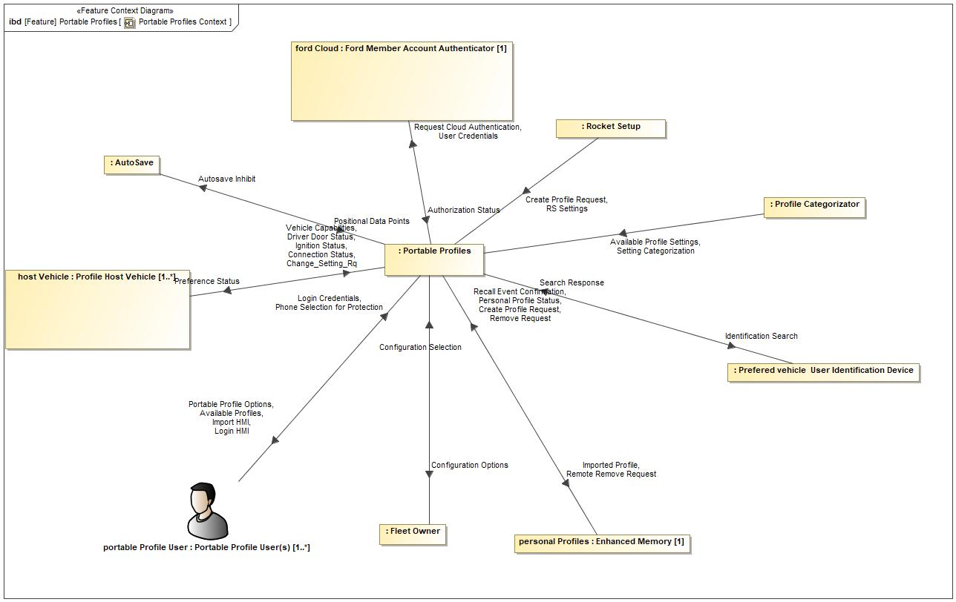

Figure 1: Portable Profiles Context

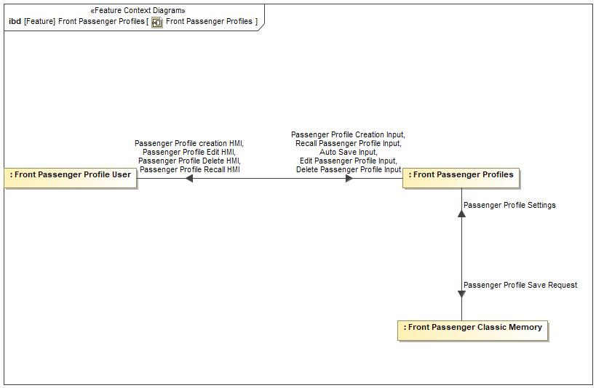

Figure 2: Front Passenger Profiles

## List of Influences

|  |  |  |
| --- | --- | --- |
| **ID** | **External Entity** | **Influence Description** |
| Authorization Status |  | User is authenticated by the cloud account manager. |
| Auto Save Input |  | Customer input to the front passenger Auto Save prompt. |
| Autosave Inhibit | Portable Profiles To AutoSave | Portable Profiles inhibiting the auto save functionality due to profile protection status. |
| Available Profile Settings |  | Defined list of profile parameters defined by the Profile Attribute. |
| Available Profiles | Portable Profiles To | Available profiles as a result of an identification search |
| Change_Setting_Rq |  | User's input to changes to their Portable Profile settings. |
| Configuration Options | Portable Profiles To | Option provided to the Fleet Owner to configure PPP. |
| Configuration Selection |  | Fleet Owner selection to configure PPP. |
| Connection Status |  | Sync Bluetooth tells PPP which mobile device is actively paired to the vehicle. |
| Create Profile Request | Rocket Setup To Portable Profiles | Request to create a profile that is send from Enhanced Memory to the Profile Management Server of PPP. |
| personal Profiles (Enhanced Memory) To Portable Profiles | Request to create a profile that is send from Enhanced Memory to the Profile Management Server of PPP. |
| Delete Passenger Profile Input |  | Customer input to delete a front passenger profile. |
| Driver Door Status |  | Vehicle tells PPP when the driver door goes from closed to ajar. |
| Edit Passenger Profile Input |  | Customer input to edit a front passenger profile. |
| Identification Search | Portable Profiles To | Portable Profiles searching for available profiles. |
| Ignition Status |  | Vehicle tells PPP what the ignition status of the vehicle is. |
| Import HMI | Portable Profiles To | HMI to allow the user to import a profile. |
| Imported Profile | Portable Profiles To personal Profiles (Enhanced Memory) | Notify Enhanced Memory that there is a new imported profile in the vehicle. |
| Login Credentials |  | User providing login credentials to the system. |
| Login HMI | Portable Profiles To | HMI to allow the user to input their user credentials. |
| Passenger Profile creation HMI | Front Passenger Profiles To | Vehicle HMI to create a front passenger profile. |
| Passenger Profile Creation Input |  | Customer input to create a front passenger profile. |
| Passenger Profile Delete HMI | Front Passenger Profiles To | Vehicle HMI to delete a front passenger profile. |
| Passenger Profile Edit HMI | Front Passenger Profiles To | Vehicle HMI to edit a front passenger profile. |
| Passenger Profile Recall HMI | Front Passenger Profiles To | Vehicle HMI to recall a front passenger profile. |
| Passenger Profile Save Request | Front Passenger Profiles To Front Passenger Classic Memory | Request to the front passenger classic memory system to save a seat position. |
| Passenger Profile Settings | Front Passenger Classic Memory To Front Passenger Profiles | Seat position settings provided to the front passenger profile by the front passenger classic memory system. |
| Personal Profile Status | personal Profiles (Enhanced Memory) To Portable Profiles | Profile active/inactive status. |
| Phone Selection for Protection |  | User deciding which phone to user for profile protection. |
| Portable Profile Options | Portable Profiles To | The feature providing the user with profile options for their settings. |
| Positional Data Points | AutoSave To Portable Profiles | Autosave notifying PPP which positional data point should be part of the profile. |
| Preference Status | Portable Profiles To |  |
| Recall Event Confirmation | personal Profiles (Enhanced Memory) To Portable Profiles | Enhanced Memory telling PPP that there has been a Profile Recall Event. |
| Recall Passenger Profile Input |  | Customer input to recall a front passenger profile. |
| Remote Remove Request | Portable Profiles To personal Profiles (Enhanced Memory) | Remove profile request coming from outside of the vehicle will be sent from the Profile Management Server to Enhanced Memory so that Enhanced Memory can perform a delete profile operation. |
| Remove Request | personal Profiles (Enhanced Memory) To Portable Profiles | Remove request coming from Enhanced Memory. |
| Request Cloud Authentication | Portable Profiles To | PPP requesting the cloud to authenticate a user's credentials. |
| RS Settings | Rocket Setup To Portable Profiles | Pre-determined group of settings that Rocket Setup will use to populate a newly created Portable Profile. |
| Search Response |  | Mobile devices in vicinity of host vehicle responding to a search request. |
| Setting Categorization |  | Profile Attribute deciding how to categorize profile data. |
| User Credentials | Portable Profiles To | User credentials being sent from PPP to cloud to be verified. |
| Vehicle Capabilities |  | Vehicle providing information to PPP about what personalized features it has. |

Table 7: List of Influences

# Feature Modeling

## Operation Modes and States

**#Classification:** Optional (Mandatory for Functional Safety)

**#Link:** [RE Wiki – State Charts](http://wiki.ford.com/display/RequirementsEngineering/State+Charts?src=contextnavpagetreemode)

**#Hint:** State Charts are a popular means to express feature behavior in terms of states and modes. An advantage of this state machine like approach is that consistency can be easily verified.

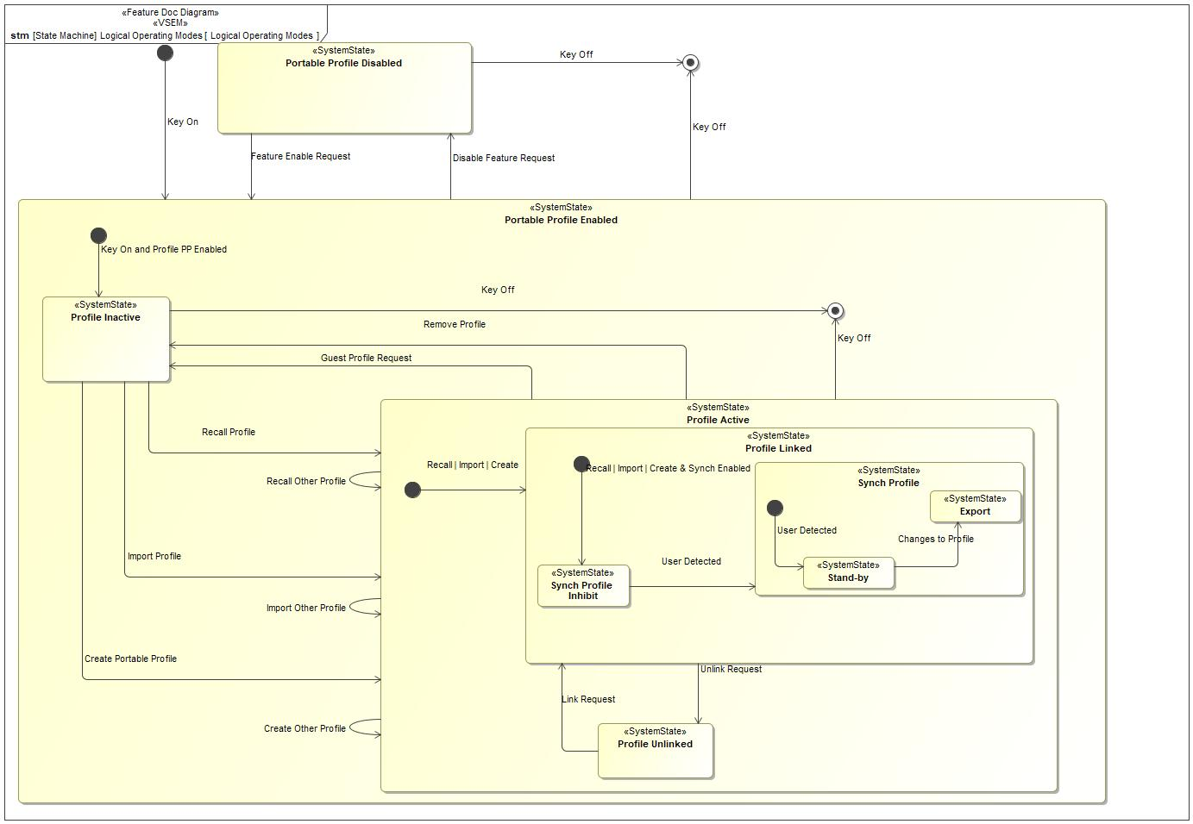

Figure 3: Logical Operating Modes

|  |  |  |
| --- | --- | --- |
| **State** | **Description** | **Requirements Reference** (optional) |
| Export | Changes are made to an active profile and the settings are synchronized with the master profile in the cloud. |  |
| Portable Profile Disabled | Feature is disabled in the host vehicle. |  |
| Portable Profile Enabled | Feature is Enabled in the host vehicle. |  |
| Profile Active | There is an active Profile in the host vehicle. |  |
| Profile Inactive | There is no active Profile in the host vehicle. |  |
| Profile Linked | The active profile is linked to a FordPass account. |  |
| Profile Unlinked | The active Profile is not linked to a FordPass account. |  |
| Stand-by | Portable Profile is able to accept preference changes. |  |
| Synch Profile | Autosave is enabled, owner of the active Profile is identified by the feature. |  |
| Synch Profile Inhibit | Autosave is inhibited for the active Profile because the owner of the active Profile has not been identified. |  |

Table 8: Operation Modes and States on Logical Operating Modes

|  |  |  |
| --- | --- | --- |
| **Transition ID** | **Description** | **Requirements Reference**  (optional) |
| T1 | Trigger signal: Key Off |  |
| T2 | Trigger signal: Key On |  |
| T3 | Trigger signal: Create Other Profile |  |
| T4 | Trigger signal: Key Off |  |
| T5 | Trigger signal: Changes to Profile |  |
| T6 | Trigger signal: Link Request |  |
| T7 | Trigger signal: Unlink Request |  |
| T8 | Trigger signal: Key Off |  |
| T9 | Trigger signal: Feature Enable Request |  |
| T10 | Trigger signal: Recall | Import | Create & Synch Enabled |  |
| T11 | Trigger signal: Import Profile |  |
| T12 | Trigger signal: User Detected |  |
| T13 | Trigger signal: Create Portable Profile |  |
| T14 | Trigger signal: User Detected |  |
| T15 | Trigger signal: Recall Profile |  |
| T16 | Trigger signal: Disable Feature Request |  |
| T17 | Trigger signal: Recall | Import | Create |  |
| T18 | Trigger signal: Key Off |  |
| T19 | Trigger signal: Key On and Profile PP Enabled |  |
| T20 | Trigger signal: Import Other Profile |  |
| T21 | Trigger signal: Guest Profile Request |  |
| T22 | Trigger signal: Remove Profile |  |
| T23 | Trigger signal: Recall Other Profile |  |

Table 9: Transitions between Operation Modes and States on Logical Operating Modes

## Use Cases

**#Classification:** Optional

**#Link:** [RE Wiki – Use Cases](http://wiki.ford.com/display/RequirementsEngineering/Use+Cases+Overview?src=contextnavpagetreemodehttp://wiki.ford.com/display/RequirementsEngineering/Use+Cases?src=contextnavpagetreemode)

### Use Case Diagram

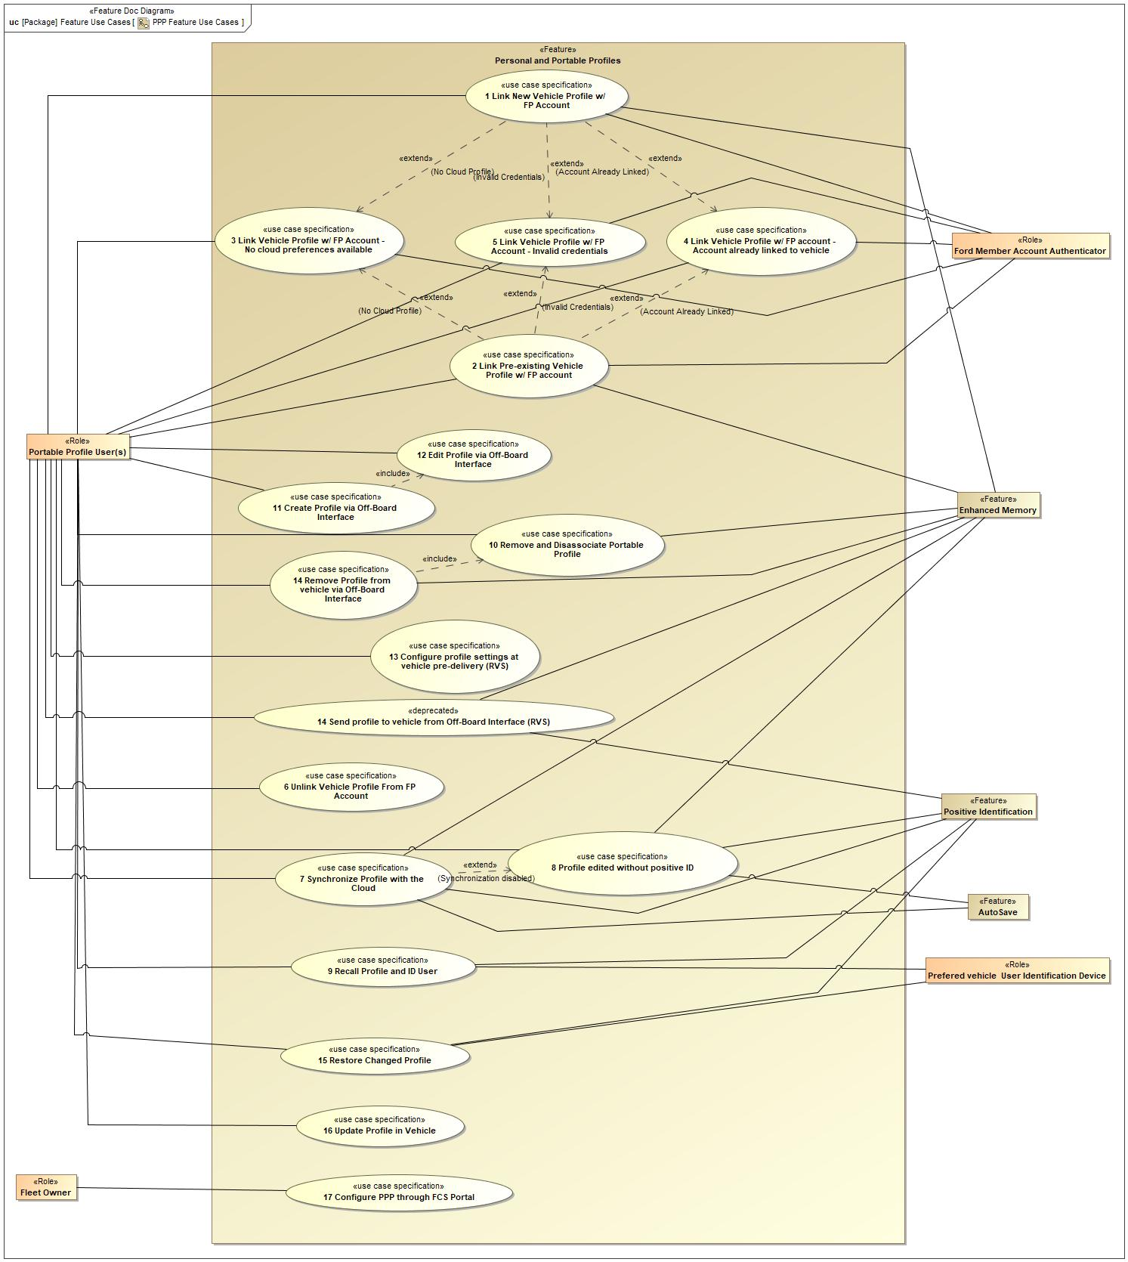

Figure 4: PPP Feature Use Cases

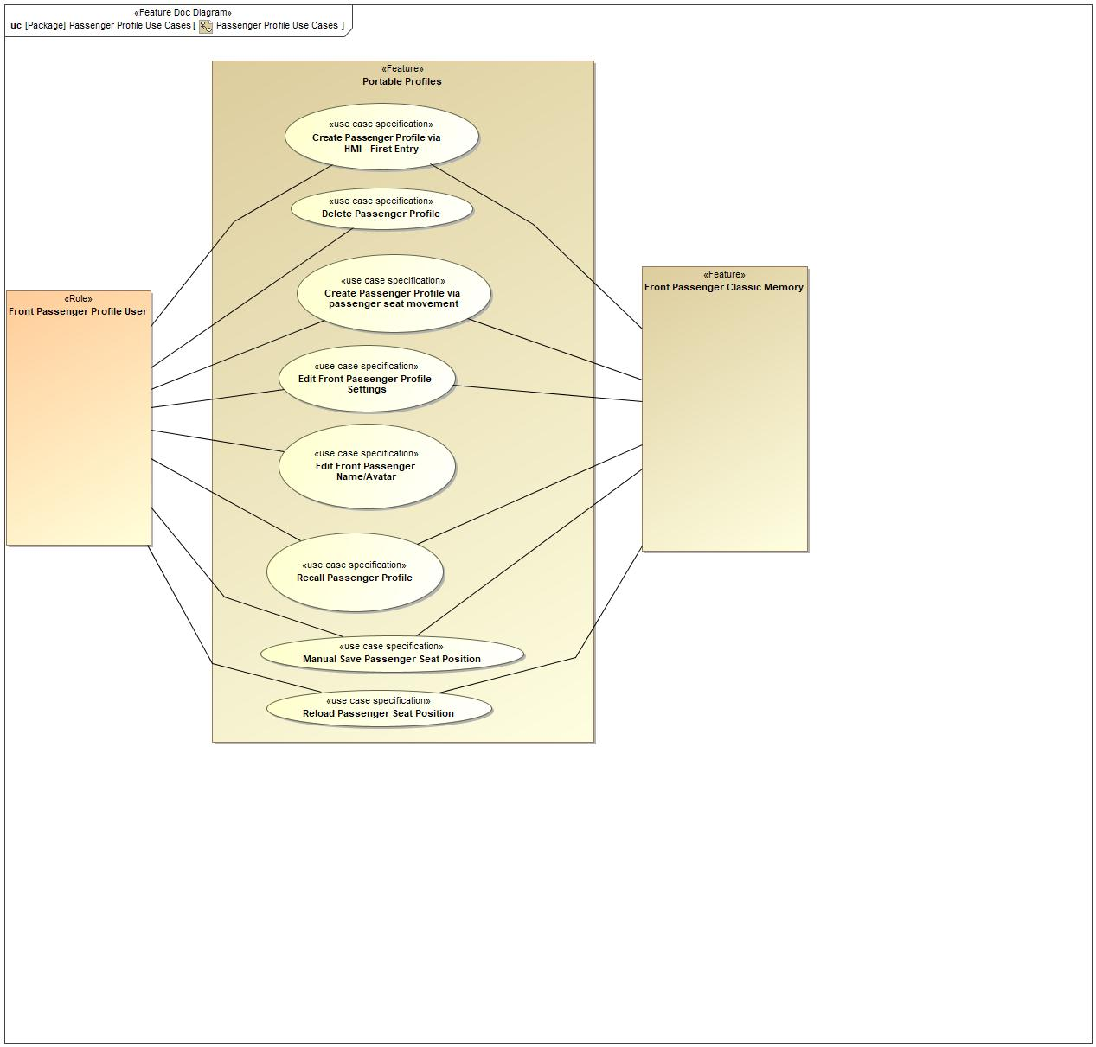

Figure 5: Passenger Profile Use Cases

### Actors

| **Actor** | **Description** |
| --- | --- |
| AutoSave | Feature that automatically saves the positional preferences to an active profile. |
| Enhanced Memory | Memory system that associates several personalized settings to a memory seat button and key fob. |
| Fleet Owner | User that owns a fleet of vehicles with which they manage the PPP feature in. |
| Ford Member Account Authenticator | System used to authenticate users of the Ford ecosystem. |
| Front Passenger Classic Memory |  |
| Front Passenger Profile User |  |
| Portable Profile User(s) | User of the PPP feature. This person initiates the use cases. |
| Positive Identification | Vehicle function that identifies who is inside of a Ford/Lincoln vehicle. |

Table 10: List of Actors

### Use Case Descriptions

**#Classification:** Optional

REQ-387142/A 1 Link New Vehicle Profile w/ FP Account

|  |  |  |
| --- | --- | --- |
| **Actors** |  | Enhanced Memory |
|  | Ford Member Account Authenticator |
|  | Portable Profile User(s) |
| **Subject** |  | Personal and Portable Profiles |
| **Description** |  | User adds/creates a new vehicle profile and links it to their FordPass Account. Any cloud profile preferences will be downloaded and applied to new vehicle profile. |
| **Preconditions** | PreC1 | Account has pre-existing profile preferences |
| PreC2 | User has a valid FordPass account |
| PreC3 | Vehicle has cloud connectivity |
| **Triggers** | T1 | User navigates to profile screen and selects to add a new profile. |
| **Main Flow Description** |  | User navigates to vehicle profile menu and add/creates a profile. User enters FordPass account credentials in vehicle and is authenticated. Vehicle imports pre-existing profile preferences while user finishes in vehicle profile creation. Profile preferences are applied to the newly created vehicle profile. |
| **Main Flow** | M1 | User selects to add a new vehicle profile. |
| M2 | In Vehicle Login provides HMI that allows the user to input their FordPass login credentials. Screen may also provide alternative method to provide FordPass Login, such as QR code. |
| M3 | User inputs FordPass credentials via method provided. |
| M4 | In Vehicle Login authenticates user credentials. |
| M5 | Cloud profile that is associated to linked FordPass account is downloaded to the host vehicle. |
| M6 | Vehicle HMI prompts user to enable or disable positive ID. |
| M7 | User selects to enable positive ID. |
| M8 | Vehicle HMI prompts user to setup primary authentication method. |
| M9 | Vehicle HMI prompts user to create a secondary authentication passcode. |
| M10 | Cloud profile preferences are applied to the newly created vehicle profile. |
| M11 | New Profile is made active. |
| **Alternative Flow Description** |  | See "Link Vehicle Profile w/ FP Account - Invalid credentials" use case. |
| **Exceptional Flow Description** |  | See "Link Vehicle Profile w/ FP Account - No cloud preferences available" use case. |
| **Exceptional Flow Description** |  | See "Link Vehicle Profile w/ FP Account - Account already linked to vehicle" use case. |
| **Postconditions** | PostC1 | Cloud profile preferences applied to vehicle profile. |
| PostC2 | FordPass account associated to vehicle and vehicle profile. |
| PostC3 | Positive ID methods configured for profile. |

REQ-387150/A 2 Link Pre-existing Vehicle Profile w/ FP account

|  |  |  |
| --- | --- | --- |
| **Actors** |  | Enhanced Memory |
|  | Ford Member Account Authenticator |
|  | Portable Profile User(s) |
| **Subject** |  | Personal and Portable Profiles |
| **Description** |  | User links their FordPass account to a pre-existing vehicle profile. Any cloud profile preferences will be downloaded and applied to the vehicle profile. |
| **Preconditions** | PreC1 | Enhanced Memory (Personal Profile) created in vehicle |
| PreC2 | User has valid FordPass account |
| PreC3 | Vehicle has cloud connectivity |
| **Triggers** | T1 | Portable Profile User navigates to pre-exisiting vehicle profile. |
| **Main Flow Description** |  | User enters vehicle profile menu and selects target profile. Option to link profile is provided and user selects. User enters login credentials and links their profile to their account. If there is a cloud profile associated with the linked FordPass account, the cloud profile preferences will be imported and applied to the vehicle profile. |
| **Main Flow** | M1 | Vehicle HMI displays selected profile with the option to link their FordPass account. |
| M2 | User selects option to link their FordPass account. |
| M3 | In-Vehicle Login provides HMI screen that asks the user to input their FordPass Login credentials. Screen may also provide alternative method to provide FordPass Login, such as QR code. |
| M4 | User inputs FordPass Login credentials via method provided. |
| M5 | In-Vehicle Login authenticates user credentials. |
| M6 | Check if there is an associated cloud profile |
| M7 | If there is, the cloud profile is downloaded and applied to the vehicle profile. |
| **Alternative Flow Description** |  | See "Link Vehicle Profile w/ FP Account - Invalid Credentials" use case. |
| **Exceptional Flow Description** |  | See "Link Vehicle Profile w/ FP Account - no cloud preferences" use case. |
| **Exceptional Flow Description** |  | See "Link Vehicle Profile w/ FP Account - Account already linked to vehicle" use case. |
| **Postconditions** | PostC1 | Cloud Profile preferences are downloaded and applied to the pre-exisiting vehicle profile. |
| PostC2 | Pre-existing vehicle profile is linked to the users FordPass account. |

REQ-387143/A 3 Link Vehicle Profile w/ FP Account - No cloud preferences available

|  |  |  |
| --- | --- | --- |
| **Actors** |  | Enhanced Memory |
|  | Ford Member Account Authenticator |
|  | Portable Profile User(s) |
| **Subject** |  | Personal and Portable Profiles |
| **Description** |  | User links their FordPass account to a vehicle profile, but there are no cloud profile preferences to download. Vehicle profile preferences are exported to create the cloud profile. |
| **Preconditions** | PreC1 | FordPass account does not have an associated cloud profile |
| PreC2 | User has a valid FordPass Account |
| PreC3 | Vehicle has cloud connectivity |
| **Triggers** | T1 | User linked their FordPass account to a vehicle profile. |
| **Main Flow Description** |  | Vehicle profile settings are collected and exported as soon as the vehicle profile is created and linked to a FordPass account. The exported profile settings create a cloud profile associated to the linked FordPass account. |
| **Main Flow** | M1 | Vehicle collects portable vehicle profile settings. |
| M2 | Vehicle sends profile settings to the cloud. |
| M3 | Cloud creates a cloud profile for the linked FordPass account and populates the profile with the exported portable vehicle profile settings. |
| **Postconditions** | PostC1 | Cloud profile contains portable vehicle settings exported from the vehicle profile. |
| PostC2 | Cloud profile created for linked FordPass account. |

REQ-387145/A 4 Link Vehicle Profile w/ FP account - Account already linked to vehicle

|  |  |  |
| --- | --- | --- |
| **Actors** |  | Enhanced Memory |
|  | Ford Member Account Authenticator |
|  | Portable Profile User(s) |
| **Subject** |  | Personal and Portable Profiles |
| **Description** |  | User attempts to link a vehicle profile to a FordPass account that is already linked to a different vehicle profile in the same vehicle. |
| **Preconditions** | PreC1 | User has a valid FordPass account |
| PreC2 | User's FordPass account is already linked to another profile on host vehicle. |
| PreC3 | Vehicle has cloud connectivity. |
| **Triggers** | T1 | User attempts to link a vehicle profile to a FordPass account. |
| **Main Flow Description** |  | User attempts to link a FordPass account to a vehicle profile that the account is already associated to it. HMI displays notification that account already linked to another vehicle profile. HMI provides option for user to recall the linked profile or to cancel the operation. |
| **Main Flow** | M1 | Vehicle compares FordPass account authentication to other vehicle profiles. |
| M2 | ForPass account is found to be linked to another vehicle profile. |
| M3 | Vehicle HMI displays option for user to recall the linked vehicle profile or to cancel the operation. |
| **Postconditions** | PostC1 | User notified that account is already linked |
| PostC2 | Vehicle HMI displays option to recall linked account or cancel operation. |

REQ-387144/A 5 Link Vehicle Profile w/ FP Account - Invalid credentials

|  |  |  |
| --- | --- | --- |
| **Actors** |  | Enhanced Memory |
|  | Ford Member Account Authenticator |
|  | Portable Profile User(s) |
| **Subject** |  | Personal and Portable Profiles |
| **Description** |  | User enters invalid FordPass credentials when attempting to link their FordPass account to a vehicle profile. |
| **Preconditions** | PreC1 | User has attempted to enter credentials less than 5 times. |
| PreC2 | Vehicle has cloud connectivity |
| **Triggers** | T1 | User attempts to link FordPass account to vehicle profile. |
| **Main Flow Description** |  | User enters invalid FordPass account credentials when attempting to associate account with vehicle and vehicle profile. FordPass account is found to be invalid and the vehicle HMI allows the user to re-submit their account credentials. |
| **Main Flow** | M1 | In Vehicle Login attempts to authenticate FordPass credentials. |
| M2 | In Vehicle Login finds credentials to be invalid. |
| M3 | Vehicle HMI prompts user to re-submit FordPass credentials until the user cancels the operation, credentials are authenticated or the maximum ammount of attempts has been reached (maximum is 5). |
| **Postconditions** | PostC1 | Vehicle HMI prompts user to re-submit account credentials |

REQ-352312/A 6 Unlink Vehicle Profile From FP Account

|  |  |  |
| --- | --- | --- |
| **Actors** |  | Portable Profile User(s) |
| **Subject** |  | Feature |
| **Subject** |  | Personal and Portable Profiles |
| **Description** |  | User unlinks their profile from their FordPass account. |
| **Preconditions** | PreC1 | Owner of the profile is positively identified or positive ID is disabled. |
| PreC2 | Profile is linked to a FordPass account |
| **Triggers** | T1 | User navigates to their vehicle profile menu. |
| **Main Flow Description** |  | User navigates to their linked vehicle profile and selects to unlink their profile from their FordPass account. |
| **Main Flow** | M1 | User selects to unlink their profile. |
| M2 | Profile is unlinked from the FordPass account. |
| **Alternative Flow Description** |  | Owner of the vehicle profile is not positively identified.User attempts to unlink their profile from their FordPass account. Vehicle HMI prompts the user to input their secondary authentication passcode to make the change. |
| **Postconditions** | PostC1 | Profile is not linked to a FordPass account. |

REQ-387147/A 7 Synchronize Profile with the Cloud

|  |  |  |
| --- | --- | --- |
| **Actors** |  | AutoSave |
|  | Enhanced Memory |
|  | Portable Profile User(s) |
|  | Positive Identification |
| **Subject** |  | Feature |
| **Subject** |  | Personal and Portable Profiles |
| **Description** |  | User makes a change to their profile settings and the settings are exported and synchronized with the master copy. |
| **Preconditions** | PreC1 | Change was made to at least one vehicle profile setting |
| PreC2 | Owner of active profile is positively identified by the vehicle or positive ID is disabled |
| PreC3 | Vehicle has cloud connectivity |
| PreC4 | Vehicle profile is linked to FordPass account |
| **Triggers** | T1 | User switches vehicle profiles |
| T2 | User turns off vehicle |
| **Main Flow Description** |  | Changes made to portable vehicle profile settings are collected and ready to be sent to the cloud. Upon the export trigger (profile change or vehicle off), only the changed setting is exported to the linked FordPass cloud profile. |
| **Main Flow** | M1 | Vehicle exports any portable vehicle profile settings that have changed. |
| M2 | Cloud receives changed settings and updates the linked cloud profile with the altered settings. |
| **Postconditions** | PostC1 | All changed portable vehicle preference settings are sent to the cloud and updated in linked cloud profile. |

REQ-387148/A 8 Profile edited without positive ID

|  |  |  |
| --- | --- | --- |
| **Actors** |  | AutoSave |
|  | Enhanced Memory |
|  | Portable Profile User(s) |
|  | Positive Identification |
| **Subject** |  | Personal and Portable Profiles |
| **Description** |  | A change is made to a vehicle profile setting, but the owner of that profile is not identified or Synchronization is disabled for that profile. |
| **Preconditions** | PreC1 | Positive ID is enabled for the active profile. |
| PreC2 | Profile owner is not positively identified. |
| **Triggers** | T1 | Change is made to profile setting/preference. |
| **Main Flow Description** |  | A change is made to a profile setting/preference. The preference will be active in the vehicle but will not be saved to the vehicle profile or exported to the cloud profile |
| **Main Flow** | M1 | Vehicle HMI prompts user to enter secondary authentication passcode. |
| M2 | User does not input passcode and selects to cancel. |
| M3 | Vehicle profile does not save changed setting. |
| **Alternative Flow Description** |  | User does input secondary authentication passcode. User is positively identified and that changed setting is saved to the vehicle profile and synchronized with the cloud. |
| **Postconditions** | PostC1 | Changed setting is not saved or synchronized withthe cloud profile. |

9 Recall Profile and ID User

|  |  |  |
| --- | --- | --- |
| **Actors** |  | Portable Profile User(s) |
|  | Positive Identification |
|  | Prefered vehicle User Identification Device |
| **Subject** |  | Personal and Portable Profiles |
| **Description** |  | A user profile is recalled in a vehicle and the feature attempts to positively identify the owner of the profile, if enabled by the user. |
| **Preconditions** | PreC1 | Profile saved to host vehicle |
| **Triggers** | T1 | Profile recalled in Host Vehicle |
| **Main Flow Description** |  | A Portable Profile User recalls their profile in the vehicle. Upon recall the feature attempts to positively identify the user using their primary authentication method (if enabled). Upon profile authentication the vehicle downloads a newer profile version from the cloud. |
| **Main Flow** | M1 | User enters host vehicle and profile is recalled. |
| M2 | Recalled profile settings are made active. |
| M3 | Positive Identification system attempts to identify the User through their primary authentication method. |
| M4 | User is positively identified and their profile is fully activated. |
| M5 | Profile authentication status is displayed to the user. |
| M6 | The feature checks the cloud profile storage for an updated profile. |
| M7 | Updated profile is downloaded and applied to the active vehicle profile. |
| **Alternative Flow Description** |  | Positive ID is disabled for the profile. Profile settings are recalled and activated and the feature checks for a newer profile version in the cloud. |
| **Alternative Flow Description** |  | Primary authentication fails and the vehicle prompts the user to enter their secondary authentication method (passcode). |
| **Exceptional Flow Description** |  | Neither primary nor secondary authentication methods are successful in positively identifying the user. Profile is not authenticated and is inhibited from updates. |
| **Postconditions** | PostC1 | Portable Profile User is positively identified as the owner of the active profile. |
| PostC2 | Updated profile version (if available) is downloaded and applied to the vehicle profile |

REQ-352329/A 10 Remove and Disassociate Portable Profile

|  |  |  |
| --- | --- | --- |
| **Actors** |  | Enhanced Memory |
|  | Portable Profile User(s) |
| **Subject** |  | Feature |
| **Subject** |  | Personal and Portable Profiles |
| **Description** |  | Removing a Portable Profile while inside a host vehicle. |
| **Preconditions** | PreC1 | Vehicle has cloud connectivity. |
| PreC2 | Vehicle profile linked to FordPass account. |
| **Triggers** | T1 | User navigates to profile menu. |
| **Main Flow Description** |  | User removes their linked vehicle profile from the vehicle. A request is sent to the cloud to disassociate the cloud profile from the specified vehicle. |
| **Main Flow** | M1 | User removes vehicle profile from the vehicle. |
| M2 | Request sent from vehicle to cloud to disassociate cloud profile from specified vehicle. |
| M3 | Cloud profile disassociates from the vehicle. |
| **Postconditions** | PostC1 | Cloud profile disassociated from specified vehicle. |
| PostC2 | Vehicle profile removed from vehicle. |

REQ-352316/A 11 Create Profile via Off-Board Interface

|  |  |  |
| --- | --- | --- |
| **Actors** |  | Ford Member Account Authenticator |
|  | Portable Profile User(s) |
| **Subject** |  | Feature |
| **Subject** |  | Personal and Portable Profiles |
| **Description** |  | User creates a Cloud profile that is associated with their FordPass account using an off-board (not in vehicle) interface. |
| **Preconditions** | PreC1 | User does not have a cloud profile associated with their FordPass account |
| PreC2 | User has a FordPass account |
| PreC3 | User has a means to access the FordPass account (FordPass App or Owners site) |
| **Triggers** | T1 | User opens off-board profile user interface and navigates to the cloud profile interface. |
| **Main Flow Description** |  | User opens cloud profile interface and selects to create a cloud profile. The cloud profile interface will display profile settings and preferences for the user to configure. Once completed, the profile settings/preferences are sent to the cloud profile storage. Cloud profile is created and associated with FordPass account. |
| **Main Flow** | M1 | User enters cloud profile interface. |
| M2 | User selects to create a cloud profile. |
| M3 | Cloud profile interface displays profile settings and preferences for the user to configure. |
| M4 | User configures profile settings and preferences. |
| M5 | User saves settings/preferences and completes profile creation. |
| M6 | Settings/preferences are sent to the cloud profile storage and are associated with the FordPass account. |
| **Postconditions** | PostC1 | Cloud profile is associated with the user's FordPass account. |
| PostC2 | Cloud profile is created and stored in cloud profile storage. |

REQ-387149/A 12 Edit Profile via Off-Board Interface

|  |  |  |
| --- | --- | --- |
| **Actors** |  | Portable Profile User(s) |
| **Subject** |  | Personal and Portable Profiles |
| **Description** |  |  |
| **Preconditions** | PreC1 | Cloud profile previously created for FordPass account. |
| PreC2 | User logged into FordPass account. |
| **Triggers** | T1 | User enters cloud profile interface, via FordPass app or Owner's site, and selects to edit their profile. |
| **Main Flow Description** |  | User selects to edit their cloud profile. Cloud profile interface displays profile settings/preferences that are able to be editted via off-board interface. User makes changes and saves to the cloud profile storage. |
| **Main Flow** | M1 | User selects to edit their cloud profile. |
| M2 | Cloud profile interface displays profile settings and preferences that are able to be editted. |
| M3 | User makes desired changes to the cloud profile. |
| M4 | Changes are saved and sent to the cloud profile storage. |
| **Postconditions** | PostC1 | All cloud profile changes are saved and stored in the cloud profile storage. |

REQ-387151/A 13 Configure profile settings at vehicle pre-delivery (RVS)

|  |  |  |
| --- | --- | --- |
| **Actors** |  | Portable Profile User(s) |
| **Subject** |  | Personal and Portable Profiles |
| **Description** |  | User orders a vehicle and is able to pre-configure specific vehicle preferences before receiving the vehicle. |
| **Preconditions** | PreC1 | User has a FordPass account. |
| PreC2 | User has a cloud profile associated to their FordPass account. |
| **Triggers** | T1 | Initial purchase/order status to enable Remote Vehicle Setup |
| T2 | VIN of desired vehicle added to FordPass garage |
| **Main Flow Description** |  | After receiving the initial purchase/order status the Remote Vehicle Setup option is enabled in FordPass. The user selects this option and is prompted with vehicle specific settings/preferences that they can configure. Some settings will be pre-populated with cloud profile preferences. The user will configure any desired settings and save to their cloud profile. |
| **Main Flow** | M1 | Remote Vehicle Setup option is enabled on FordPass and Owner's site. |
| M2 | User selects option and opens Remote Vehicle Setup. |
| M3 | Remote Vehicle Setup displays vehicle specific settings/preferences to the user. |
| M4 | The user configures any desired settings. |
| M5 | Configured settings are saved and sent to the cloud profile storage. |
| **Alternative Flow Description** |  | User does not have a cloud profile created yet. Remote Vehicle Setup will prompt user to create a cloud profile first before configuring their Remote Vehicle Setup preferences. |
| **Postconditions** | PostC1 | All pre-configured settings are stored in the cloud profile. |

REQ-387146/A 14 Send profile vehicle from Off-Board Interface (RVS)

|  |  |  |
| --- | --- | --- |
| **Actors** |  | Enhanced Memory |
|  | Portable Profile User(s) |
|  | Positive Identification |
| **Subject** |  | Personal and Portable Profiles |
| **Description** |  | User remotely sends their cloud profile to a specific vehicle using the FordPass App. |
| **Preconditions** | PreC1 | User has a FordPass account |
| PreC2 | User has a cloud profile associated to their FordPass account |
| **Triggers** | T1 | VIN of desired vehicle is added to the FordPass garage. |
| **Main Flow Description** |  | User navigates to desired vehicle in FordPass garage. FordPass displays the option to send the user's cloud profile to the vehicle. The user selects the option and the cloud profile is sent to the vehicle. In the vehicle, the user is positively identified and then welcomed to the vehicle (using name in cloud profile). The user is prompted to create a vehicle profile. Cloud profile settings are applied to the newly created vehicle profile. |
| **Main Flow** | M1 | User navigates to desired vehicle in FordPass garage. |
| M2 | FordPass displays option to send cloud profile to the vehicle. |
| M3 | User selects the option to send profile to the vehicle. |
| M4 | FordPass prompts the user to confirm settings selection and send profile to vehicle. |
| M5 | User confirms and sends profile to the vehicle. |
| M6 | Vehicle downloads and stores the cloud profile settings. |
| M7 | User turns on vehicle and provides positive ID (BLE Auto Pair, In-Vehicle Login) |
| M8 | Vehicle HMI welcomes the user (using NAME in cloud profile) |
| M9 | User accepts welcome and is prompted to created a vehicle profile. |
| M10 | Once the vehicle profile is created, the downloaded settings are applied to the newly created profile. |
| **Alternative Flow Description** |  | User postpones the welcome screen. The user will be able to access this welcome screen later (next key cycle or in the Vehicle Profiles menu) |
| **Exceptional Flow Description** |  | User decides to reject welcome screen. Downloaded profile settings are deleted from the vehicle and no vehicle profile is created. |
| **Postconditions** | PostC1 | Cloud profile settings are imported and applied to a newly created vehicle profile. |
| PostC2 | Vehcile profile is linked with the user's FordPass account. |

REQ-352308/A 15 Remove Profile from vehicle via Off-Board Interface

|  |  |  |
| --- | --- | --- |
| **Actors** |  | Enhanced Memory |
|  | Portable Profile User(s) |
| **Subject** |  | Feature |
| **Subject** |  | Personal and Portable Profiles |
| **Description** |  | Vehicle profile is removed from a specific vehicle. The cloud profile is also disassociated from the vehicle. |
| **Preconditions** | PreC1 | Receiving vehicle has cellular connection to cloud |
| PreC2 | User has FordPass Account |
| PreC3 | User has a cloud profile associated to their FordPass account |
| PreC4 | Vehicle profile linked to FordPass account is saved to specified vehicle |
| **Triggers** | T1 | User navigates to their profile in Cloud Profile Interface (FordPass app or owner's site). |
| **Main Flow Description** |  | User navigates to cloud profile menu in FordPass or Owners Site. User selects to remove their vehicle profile from a specific vehicle. Request is sent from the cloud to the specified vehicle. Vehicle executes the remove operation and alerts the cloud. Cloud profile disassociates form the specified vehicle. |
| **Main Flow** | M1 | Option to remove profile from specific vehicles is displayed to the user. |
| M2 | User selects which vehicle to remove their profile from. |
| M3 | Request is sent from the cloud to the specified vehicle to remove the profile. |
| M4 | When available, the vehicle receives the request and executes the remove operation. |
| M5 | Vehicle alerts cloud of successful vehicle profile removal. |
| M6 | Cloud profile disassociates from the specified vehicle. |
| **Postconditions** | PostC1 | Cloud profile is disassociated from specified vehicle. |
| PostC2 | Linked vehicle profile removed from specified vehicle. |

16 Restore Changed Profile

|  |  |  |
| --- | --- | --- |
| **Actors** |  | Portable Profile User(s) |
|  | Positive Identification |
|  | Prefered vehicle User Identification Device |
| **Subject** |  | Personal and Portable Profiles |
| **Description** |  | Correcting un-wanted changes made to a user's portable profile in a vehicle. |
| **Preconditions** | PreC1 | Changes made to user profile when profile was not authenticated. |
| PreC2 | User is authenticated |
| **Triggers** | T1 | User's profile is recalled and the user is authenticated |
| **Main Flow Description** |  | Changes were made to a user's profile when the user was not positively identified and authenticated in the vehicle. The changed settings are automatically corrected for the user. |
| **Main Flow** | M1 | User's profile is recalled and user is authenticated. |
| M2 | PPP feature recognizes that un-accepted changes were made to some profile settings. |
| M3 | PPP feature applies correct profile settings to the user's active profile. |
| **Postconditions** | PostC1 | Correct profile settings are applied to the user's active profile. |

17 Configure PPP through FCS Portal

|  |  |  |
| --- | --- | --- |
| **Actors** | Primary |  |
| Secondary |  |
| **Subject** |  | Personal and Portable Profiles |
| **Description** |  | Fleet owner requests to configure PPP OFF for their fleet vehicles through the FCS Portal. |
| **Preconditions** | PreC1 | Fleet Owner has access to FCS Portal |
| PreC2 | Fleet Owner has entered Fleet VINs into FCS Portal |
| PreC3 | PPP Configuration available in FCS Portal |
| PreC4 | Vehcile has cloud connectivity |
| **Triggers** | T1 | Fleet Owner navigates to FCS Portal |
| **Main Flow** | M1 | Fleet Owner finds and selects PPP Configuration option in FCS Portal and selects to configure PPP OFF |
| M2 | Fleet Owner submits remaining configuration options |
| M3 | FCS Portal communicates to the FCS cloud to cascade configuration requests to selected vehicles |
| M4 | FCS Cloud sends configuration package to Fleet Vehicles |
| M5 | Fleet Vehicle receives and processes configuration package |
| M6 | PPP is configured OFF in Fleet Vehicle |
| M7 | Fleet Vehicle communicates configuration status to FCS Cloud |
| M8 | FCS Cloud communicates configuration status to FCS Portal |
| M9 | FCS Portal displays configuration status to Fleet Owner |
| **Alternative Flow Description** |  | Fleet Vehicles already have PPP configured OFF and the Fleet Owner uses the FCS Portal to configure PPP ON. |
| **Exceptional Flow Description** |  | Error while sending configuration package to Fleet Vehicles. Error message displayed to the Fleet Owner via the FCS Portal. |
| **Postconditions** | PostC1 | Configuration Status displayed to the Fleet Owner via FCS Portal |
| PostC2 | PPP Configured OFF in Fleet Vehicles |

Reload Passenger Seat Position

|  |  |  |
| --- | --- | --- |
| **Actors** | Primary |  |
| Secondary |  |
| **Subject** |  | Portable Profiles |
| **Description** |  |  |
| **Preconditions** | PreC1 | Front Passenger Profile is Active |
| PreC2 | Unsaved change made to front passenger profile positional setting |
| PreC3 | Vehicle IGN is in RUN |
| **Triggers** | T1 | Unsaved change made to front passenger profile positional setting. |
| **Main Flow Description** |  | User requests to reload the previously saved passenger positional setting |
| **Main Flow** | M1 | User accesses front passenger profile edit menu of the active profile |
| M2 | PPP HMI displays actionable Reload positional button |
| M3 | User presses the Reload positionals button |
| M4 | PPP HMI requests a recall request of the active passenger profile |
| M5 | Passenger Profile manager sends recall request of the active passenger profile |
| M6 | Passenger profile setting server executes the recall request |
| M7 | PPP HMI displays the active front passenger profile |
| **Postconditions** | PostC1 | Previously saved passenger positional settings made active |
| PostC2 | Reload button no longer actionable |

Recall Passenger Profile

|  |  |  |
| --- | --- | --- |
| **Actors** | Primary |  |
| Secondary |  |
| **Subject** |  | Portable Profiles |
| **Description** |  |  |
| **Preconditions** | PreC1 | At least one front passenger profile is available. |
| PreC2 | Infotainment system is ON. |
| PreC3 | Vehicle IGN is in RUN. |
| **Triggers** | T1 | User selects to recall a front passenger profile. |
| **Main Flow Description** |  | User selects to recall a front passenger profile and the profile settings are made active. |
| **Main Flow** | M1 | User selects to recall a front passenger profile via PPP HMI. |
| M2 | PPP passenger profile manager sends profile settings of recalled profile to the setting servers. |
| M3 | Setting servers receive settings and make them active. |
| M4 | PPP HMI displays active front passenger profile. |
| **Postconditions** | PostC1 | Front passenger profile settings are made active. |
| PostC2 | SYNC displays active front passenger profile. |

Create Passenger Profile via passenger seat movement

|  |  |  |
| --- | --- | --- |
| **Actors** | Primary |  |
| Secondary |  |
| **Subject** |  | Portable Profiles |
| **Description** |  |  |
| **Preconditions** | PreC1 | Infotainment system is ON. |
| PreC2 | Vehicle IGN status is in RUN. |
| PreC3 | Zero front passenger profiles are available. |
| **Triggers** | T1 | Front Passenger moves the front passenger seat. |
| **Main Flow Description** |  | Front passenger moves the front passenger seat when no front passenger profiles are available. HMI promts user to create a front passenger profile. |
| **Main Flow** | M1 | Front passenger moves front passenger seat. |
| M2 | PPP receives moved seat notification. |
| M3 | PPP HMI prompts user to create a front passenger profile. |
| **Postconditions** | PostC1 | SYNC displays prompt to create the first front passenger profile |

Manual Save Passenger Seat Position

|  |  |  |
| --- | --- | --- |
| **Actors** | Primary |  |
| Secondary |  |
| **Subject** |  | Portable Profiles |
| **Description** |  |  |
| **Preconditions** | PreC1 | Front Passenger Profile is Active |
| PreC2 | Unsaved changed made to front passenger positional setting |
| PreC3 | Vehicle IGN is in RUN |
| **Triggers** | T1 | Unsaved change made to front passenger profile positional setting |
| **Main Flow Description** |  | User requests to manually save a front passenger profile positional setting through the passenger profile HMI |
| **Main Flow** | M1 | User accesses front passenger profile edit menu of the active profile |
| M2 | PPP HMI displays actionable Manual save button |
| M3 | User presses the Manual save button |
| M4 | PPP HMI requests a save operation of the active Passenger Profile |
| M5 | PPP Passenger Profile Manager sends the save request |
| M6 | Passenger Profile Setting Server executes the manual save |
| M7 | Passenge Profile Manager collects recently saved profile data |
| **Postconditions** | PostC1 | All saved passenger profile settings collected into passenger profile manager. |
| PostC2 | All saved passenger profile settings saved to active profile. |
| PostC3 | Manual button no longer actionable. |

Create Passenger Profile via HMI - First Entry

|  |  |  |
| --- | --- | --- |
| **Actors** | Primary |  |
| Secondary |  |
| **Subject** |  | Portable Profiles |
| **Description** |  |  |
| **Preconditions** | PreC1 | Infotainment System is ON |
| PreC2 | Max number of passenger profiles has not yet been reached |
| PreC3 | Vehicle IGN status is in RUN |
| **Triggers** | T1 | User selects to add passenger profile |
| **Main Flow Description** |  | Passenger chooses to create a front passenger profile via vehicle HMI |
| **Main Flow** | M1 | User selects to add passenger profile. |
| M2 | PPP HMI initiates passenger profile setup. |
| M3 | PPP HMI prompts user to add passenger profile username. |
| M4 | User enters username and selects next. |
| M5 | PPP HMI prompts user to select passenger profile avatar. |
| M6 | User selects avatar and selects next. |
| M7 | PPP HMI prompts user to adjust seat position to desired location. |
| M8 | User adjusts seats (if needed) and selects next. |
| M9 | PPP passenger profile manager collects passenger profile settings and stores with newly created passenger profile. |
| M10 | PPP HMI displays confirmation screen to the user. |
| **Exceptional Flow Description** |  | User exits passenger profile creation screens and the passenger profile creation is aborted. |
| **Postconditions** | PostC1 | All applicable front passenger settings are stored in ECG |
| PostC2 | Front passenger profile available in SYNC |

Delete Passenger Profile

|  |  |  |
| --- | --- | --- |
| **Actors** | Primary |  |
| Secondary |  |
| **Subject** |  | Portable Profiles |
| **Description** |  |  |
| **Preconditions** | PreC1 | At least one front passenger profile is available. |
| PreC2 | Infotainment system is ON. |
| PreC3 | Vehicle IGN is in RUN. |
| **Triggers** | T1 | User selects to delete a front passenger profile. |
| **Main Flow Description** |  | User selects to delete a front passenger profile. Profile data is deleted and profile can no longer be accessed. |
| **Main Flow** | M1 | User accesses front passenger profile menu and selects to delete a front passenger profile. |
| M2 | PPP deletes front passenger profile data from profile manager and PPP HMI. |
| M3 | PPP HMI displays confirmation that front passenger profile was deleted. |
| **Postconditions** | PostC1 | Front passenger profile can not be accessed. |
| PostC2 | Front passenger profile data is deleted. |

Edit Front Passenger Profile Settings

|  |  |  |
| --- | --- | --- |
| **Actors** | Primary |  |
| Secondary |  |
| **Subject** |  | Portable Profiles |
| **Description** |  |  |
| **Preconditions** | PreC1 | A front passenger profile is active. |
| PreC2 | Vehicle IGN is in RUN. |
| **Triggers** | T1 | Front Passenger alters a front passenger profile setting. |
| **Main Flow Description** |  | A user makes a change to a front passenger profile setting. The setting is collected and stored with the profile. |
| **Main Flow** | M1 | User changes a front passenger profile setting. |
| M2 | Setting server saves the change and notifies the PPP passenger profile manager. |
| M3 | PPP passenger profile manager collects and stores the changed setting. |
| **Alternative Flow Description** |  | Positionial setting was altered and Auto Save is configured ON. |
| **Alternative Flow Steps** | A1 | After the user makes a change to the front passenger profile setting, Auto Save displays the save prompt. |
| A2 | User selects to save the changed setting. |
| A3 | Auto Save commands the setting server to save the changed setting. |
| A4 | PPP passenger profile manager collects and stores the changed profile setting. |
| **Postconditions** | PostC1 | Changed profile settings are collected and stored with the profile. |

Edit Front Passenger Name/Avatar

|  |  |  |
| --- | --- | --- |
| **Actors** | Primary |  |
| Secondary |  |
| **Subject** |  | Portable Profiles |
| **Description** |  |  |
| **Preconditions** | PreC1 | At least one front passenger profile is available. |
| PreC2 | Infotainment system is ON. |
| PreC3 | Vehicle IGN is in RUN. |
| **Triggers** | T1 | User makes a change to a front passenger profile header setting (name/avatar) |
| **Main Flow Description** |  | User accesses a front passenger profile menu and changes a profile header setting. |
| **Main Flow** | M1 | User access a front passenger profile menu. |
| M2 | PPP HMI displays front passenger profile menu options. |
| M3 | User selects to edit a setting (name/avatar). |
| M4 | PPP HMI displays edit screen for selected setting. |
| M5 | User alters the setting and selects to save the change. |
| M6 | PPP saves the updated front passenger profile setting. |
| M7 | PPP HMI displays new front passenger profile setting. |
| **Postconditions** | PostC1 | New front passenger profile setting is displayed by SYNC. |
| PostC2 | New front passenger profile setting is saved to the profile. |

## Driving and Operation Scenarios

**#Classification:** Optional (Mandatory for Functional Safety)

**#Functional Safety:** Driving and operating scenarios which impact the functionality of the feature can be used to check, if the situation analysis in the HARA is complete

**#Link:** [RE Wiki – Driving Scenarios](http://wiki.ford.com/display/RequirementsEngineering/Driving+Scenarios?src=contextnavpagetreemode)

## Decision Tables

**#Classification:** Optional

**#Link:** [RE Wiki – Decision Tables](http://wiki.ford.com/display/RequirementsEngineering/Decision+Table).

**#Hint:** Use decision table, if behavior is not state based (in that case prefer state chart from ch. 4.1) and based purely on current inputs.

*Not supported by MagicDraw report generation.*

# Feature Requirements

**#Functional Safety:** In general, safety requirements are not listed here. However, it is possible that later in the development process, a non-safety requirement becomes a safety requirement. In such a case it may remain on this list.

**#Link:** [RE Wiki – How to write good requirements](http://wiki.ford.com/display/RequirementsEngineering/How+to+write+better+requirements?src=contextnavpagetreemode).

## Functional Requirements

Recall front passenger profile via vehicle HMI

The PPP feature shall provide a method for the front passenger profile to be recalled through the vehicle HMI.

|  |  |  |  |  |  |  |  |
| --- | --- | --- | --- | --- | --- | --- | --- |
| Requirement ID: | | | | | | | |
| **Rationale** |  | | | | | | |
| **Acceptance Criteria** |  | | | | | | |
| **Notes** |  | | | | | | |
| **Source** |  | | | | | **Owner** |  |
| **Source Req.** |  | | | | | **V&V Method** |  |
| **Type** |  | | | **Priority** |  | **Status** | In-Progress |
| [Req. Template](http://wiki.ford.com/display/RequirementsEngineering/Requirements+Attributes) Version | | 6.0 | End of Requirement | | | | |

Editing front passenger profile name and avatar

The PPP feature shall provide an option for a user to edit a previously created front passenger profile name and avatar.

|  |  |  |  |  |  |  |  |
| --- | --- | --- | --- | --- | --- | --- | --- |
| Requirement ID: | | | | | | | |
| **Rationale** |  | | | | | | |
| **Acceptance Criteria** |  | | | | | | |
| **Notes** |  | | | | | | |
| **Source** |  | | | | | **Owner** |  |
| **Source Req.** |  | | | | | **V&V Method** |  |
| **Type** |  | | | **Priority** |  | **Status** | In-Progress |
| [Req. Template](http://wiki.ford.com/display/RequirementsEngineering/Requirements+Attributes) Version | | 6.0 | End of Requirement | | | | |

Delete front passenger profile pre-conditions

In order to delete a front passenger profile, the following pre-conditions shall be true.

- Vehicle IGN status is in RUN

- At least one front passenger profile available in SYNC

- Infotainment System is ON

|  |  |  |  |  |  |  |  |
| --- | --- | --- | --- | --- | --- | --- | --- |
| Requirement ID: | | | | | | | |
| **Rationale** |  | | | | | | |
| **Acceptance Criteria** |  | | | | | | |
| **Notes** |  | | | | | | |
| **Source** |  | | | | | **Owner** |  |
| **Source Req.** |  | | | | | **V&V Method** |  |
| **Type** |  | | | **Priority** |  | **Status** | In-Progress |
| [Req. Template](http://wiki.ford.com/display/RequirementsEngineering/Requirements+Attributes) Version | | 6.0 | End of Requirement | | | | |

Inhale applicable settings on front passenger creation

When a front passenger profile is created, the PPP feature shall inhale all applicable front passenger profile settings into a central profile repository.

|  |  |  |  |  |  |  |  |
| --- | --- | --- | --- | --- | --- | --- | --- |
| Requirement ID: | | | | | | | |
| **Rationale** |  | | | | | | |
| **Acceptance Criteria** |  | | | | | | |
| **Notes** |  | | | | | | |
| **Source** |  | | | | | **Owner** |  |
| **Source Req.** |  | | | | | **V&V Method** |  |
| **Type** |  | | | **Priority** |  | **Status** | In-Progress |
| [Req. Template](http://wiki.ford.com/display/RequirementsEngineering/Requirements+Attributes) Version | | 6.0 | End of Requirement | | | | |

Front Passenger Profile option to manual save

When a front passenger moves a front passenger profile positional setting and does not save the new position through Auto Save, the PPP feature shall provide an option in the front passenger profile edit menu to manually save the new position to the front passenger profile.

|  |  |  |  |  |  |  |  |
| --- | --- | --- | --- | --- | --- | --- | --- |
| Requirement ID: | | | | | | | |
| **Rationale** |  | | | | | | |
| **Acceptance Criteria** |  | | | | | | |
| **Notes** |  | | | | | | |
| **Source** |  | | | | | **Owner** |  |
| **Source Req.** |  | | | | | **V&V Method** |  |
| **Type** |  | | | **Priority** |  | **Status** | In-Progress |
| [Req. Template](http://wiki.ford.com/display/RequirementsEngineering/Requirements+Attributes) Version | | 6.0 | End of Requirement | | | | |

Delete front passenger profile while driving

The PPP feature shall allow a user to delete a front passenger profile while the Vehicle Speed is greater than the Driver Restriction Threshold, as defined in DRIVE-RESv2-FUR-REQ-025157/A-HMI Driving Restriction.

|  |  |  |  |  |  |  |  |
| --- | --- | --- | --- | --- | --- | --- | --- |
| Requirement ID: | | | | | | | |
| **Rationale** |  | | | | | | |
| **Acceptance Criteria** |  | | | | | | |
| **Notes** |  | | | | | | |
| **Source** |  | | | | | **Owner** |  |
| **Source Req.** |  | | | | | **V&V Method** |  |
| **Type** |  | | | **Priority** |  | **Status** | In-Progress |
| [Req. Template](http://wiki.ford.com/display/RequirementsEngineering/Requirements+Attributes) Version | | 6.0 | End of Requirement | | | | |

Max number of front passenger profiles

The PPP feature shall have a configurable parameter to indicate the max number of possible front passenger profiles that the vehicle can support.

|  |  |  |  |  |  |  |  |
| --- | --- | --- | --- | --- | --- | --- | --- |
| Requirement ID: | | | | | | | |
| **Rationale** |  | | | | | | |
| **Acceptance Criteria** |  | | | | | | |
| **Notes** |  | | | | | | |
| **Source** |  | | | | | **Owner** |  |
| **Source Req.** |  | | | | | **V&V Method** |  |
| **Type** |  | | | **Priority** |  | **Status** | In-Progress |
| [Req. Template](http://wiki.ford.com/display/RequirementsEngineering/Requirements+Attributes) Version | | 6.0 | End of Requirement | | | | |

Editing front passenger Auto Save settings

The PPP feature shall provide an option for a user to toggle Auto Save setting to On or Off for a passenger profile.

|  |  |  |  |  |  |  |  |
| --- | --- | --- | --- | --- | --- | --- | --- |
| Requirement ID: | | | | | | | |
| **Rationale** |  | | | | | | |
| **Acceptance Criteria** |  | | | | | | |
| **Notes** |  | | | | | | |
| **Source** |  | | | | | **Owner** |  |
| **Source Req.** |  | | | | | **V&V Method** |  |
| **Type** |  | | | **Priority** |  | **Status** | In-Progress |
| [Req. Template](http://wiki.ford.com/display/RequirementsEngineering/Requirements+Attributes) Version | | 6.0 | End of Requirement | | | | |

Front passenger profile name restrictions

The PPP feature shall enforce the following profile name restrictions for front passenger profiles:

- Front passenger profile names shall be unique

- If an existing name is entered by the user, PPP shall provide notification to the user that the name exists, shall not allow the existing name to be overwritten, and shall provide the user retry opportunity until a unique name is entered.

- length of the front passenger profile name shall be at least 1 character and no more than 32 characters.

- must begin with an alphabetic character

- The button used to enter the Front Passenger Profile Name and continue to the next screen shall be made inactive (inoperable) until the Front Passenger Profile Name meets the above conditions.

- The keyboard used to enter the Front Passenger Profile Name shall stop accepting character input when the maximum character limit has been reached.

|  |  |  |  |  |  |  |  |
| --- | --- | --- | --- | --- | --- | --- | --- |
| Requirement ID: | | | | | | | |
| **Rationale** |  | | | | | | |
| **Acceptance Criteria** |  | | | | | | |
| **Notes** |  | | | | | | |
| **Source** |  | | | | | **Owner** |  |
| **Source Req.** |  | | | | | **V&V Method** |  |
| **Type** |  | | | **Priority** |  | **Status** | In-Progress |
| [Req. Template](http://wiki.ford.com/display/RequirementsEngineering/Requirements+Attributes) Version | | 6.0 | End of Requirement | | | | |

Recall last known front passenger profile

The PPP feature shall recall the last known front passenger profile when ignition is switched to ON and no other recall method has occurred.

|  |  |  |  |  |  |  |  |
| --- | --- | --- | --- | --- | --- | --- | --- |
| Requirement ID: | | | | | | | |
| **Rationale** |  | | | | | | |
| **Acceptance Criteria** |  | | | | | | |
| **Notes** |  | | | | | | |
| **Source** |  | | | | | **Owner** |  |
| **Source Req.** |  | | | | | **V&V Method** |  |
| **Type** |  | | | **Priority** |  | **Status** | In-Progress |
| [Req. Template](http://wiki.ford.com/display/RequirementsEngineering/Requirements+Attributes) Version | | 6.0 | End of Requirement | | | | |

Use of Auto Save for positional settings

When front passenger positional settings are changed, the PPP feature shall utilized the Auto Save functionality to save or prompt a save option to the user via the vehicle HMI.

|  |  |  |  |  |  |  |  |
| --- | --- | --- | --- | --- | --- | --- | --- |
| Requirement ID: | | | | | | | |
| **Rationale** |  | | | | | | |
| **Acceptance Criteria** |  | | | | | | |
| **Notes** |  | | | | | | |
| **Source** |  | | | | | **Owner** |  |
| **Source Req.** |  | | | | | **V&V Method** |  |
| **Type** |  | | | **Priority** |  | **Status** | In-Progress |
| [Req. Template](http://wiki.ford.com/display/RequirementsEngineering/Requirements+Attributes) Version | | 6.0 | End of Requirement | | | | |

Front passenger header information

While creating a front passenger profile, the PPP feature shall provide the option for the user to give the profile a name and avatar.

|  |  |  |  |  |  |  |  |
| --- | --- | --- | --- | --- | --- | --- | --- |
| Requirement ID: | | | | | | | |
| **Rationale** |  | | | | | | |
| **Acceptance Criteria** |  | | | | | | |
| **Notes** |  | | | | | | |
| **Source** |  | | | | | **Owner** |  |
| **Source Req.** |  | | | | | **V&V Method** |  |
| **Type** |  | | | **Priority** |  | **Status** | In-Progress |
| [Req. Template](http://wiki.ford.com/display/RequirementsEngineering/Requirements+Attributes) Version | | 6.0 | End of Requirement | | | | |

Creating front passenger profile pre-conditions

In order to create a front passenger profile, the PPP feature shall have the following pre-conditions.

- Vehicle IGN status is in RUN

- Max number of passenger profiles has not yet been reached

- Infotainment System is ON

|  |  |  |  |  |  |  |  |
| --- | --- | --- | --- | --- | --- | --- | --- |
| Requirement ID: | | | | | | | |
| **Rationale** |  | | | | | | |
| **Acceptance Criteria** |  | | | | | | |
| **Notes** |  | | | | | | |
| **Source** |  | | | | | **Owner** |  |
| **Source Req.** |  | | | | | **V&V Method** |  |
| **Type** |  | | | **Priority** |  | **Status** | In-Progress |
| [Req. Template](http://wiki.ford.com/display/RequirementsEngineering/Requirements+Attributes) Version | | 6.0 | End of Requirement | | | | |

Delete front passenger profile data

When a front passenger profile is deleted, the PPP feature shall delete all associated profile data from the central profile repository.

|  |  |  |  |  |  |  |  |
| --- | --- | --- | --- | --- | --- | --- | --- |
| Requirement ID: | | | | | | | |
| **Rationale** |  | | | | | | |
| **Acceptance Criteria** |  | | | | | | |
| **Notes** |  | | | | | | |
| **Source** |  | | | | | **Owner** |  |
| **Source Req.** |  | | | | | **V&V Method** |  |
| **Type** |  | | | **Priority** |  | **Status** | In-Progress |
| [Req. Template](http://wiki.ford.com/display/RequirementsEngineering/Requirements+Attributes) Version | | 6.0 | End of Requirement | | | | |

Option to create front passenger profile

The PPP feature shall provide an option in the vehicle HMI for a front passenger to create a vehicle profile.

|  |  |  |  |  |  |  |  |
| --- | --- | --- | --- | --- | --- | --- | --- |
| Requirement ID: | | | | | | | |
| **Rationale** |  | | | | | | |
| **Acceptance Criteria** |  | | | | | | |
| **Notes** |  | | | | | | |
| **Source** |  | | | | | **Owner** |  |
| **Source Req.** |  | | | | | **V&V Method** |  |
| **Type** |  | | | **Priority** |  | **Status** | In-Progress |
| [Req. Template](http://wiki.ford.com/display/RequirementsEngineering/Requirements+Attributes) Version | | 6.0 | End of Requirement | | | | |

Retaining saved front passenger profile settings

When a front passenger edits a front passenger profile setting, the PPP feature shall collect the changed setting into the centralized passenger profile repository.

|  |  |  |  |  |  |  |  |
| --- | --- | --- | --- | --- | --- | --- | --- |
| Requirement ID: | | | | | | | |
| **Rationale** |  | | | | | | |
| **Acceptance Criteria** |  | | | | | | |
| **Notes** |  | | | | | | |
| **Source** |  | | | | | **Owner** |  |
| **Source Req.** |  | | | | | **V&V Method** |  |
| **Type** |  | | | **Priority** |  | **Status** | In-Progress |
| [Req. Template](http://wiki.ford.com/display/RequirementsEngineering/Requirements+Attributes) Version | | 6.0 | End of Requirement | | | | |

Avatars provided to the user

The PPP feature shall provide a set of Avatars that the user can select from.

|  |  |  |  |  |  |  |  |
| --- | --- | --- | --- | --- | --- | --- | --- |
| Requirement ID: | | | | | | | |
| **Rationale** |  | | | | | | |
| **Acceptance Criteria** |  | | | | | | |
| **Notes** |  | | | | | | |
| **Source** |  | | | | | **Owner** |  |
| **Source Req.** |  | | | | | **V&V Method** |  |
| **Type** |  | | | **Priority** |  | **Status** | In-Progress |
| [Req. Template](http://wiki.ford.com/display/RequirementsEngineering/Requirements+Attributes) Version | | 6.0 | End of Requirement | | | | |

Front Passenger Profile option to reload saved position

When a front passenger moves a front passenger profile positional setting and does not save the new position through Auto Save, the PPP feature shall provide an option in the front passenger profile edit menu to reload the previously saved position.

|  |  |  |  |  |  |  |  |
| --- | --- | --- | --- | --- | --- | --- | --- |
| Requirement ID: | | | | | | | |
| **Rationale** |  | | | | | | |
| **Acceptance Criteria** |  | | | | | | |
| **Notes** |  | | | | | | |
| **Source** |  | | | | | **Owner** |  |
| **Source Req.** |  | | | | | **V&V Method** |  |
| **Type** |  | | | **Priority** |  | **Status** | In-Progress |
| [Req. Template](http://wiki.ford.com/display/RequirementsEngineering/Requirements+Attributes) Version | | 6.0 | End of Requirement | | | | |

FCS Enrollment Path for PPP

The PPP feature shall leverage the existing FCS enrollment path to cascade PPP configuration requests from the FCS Portal to the Fleet Vehicles.

|  |  |  |  |  |  |  |  |
| --- | --- | --- | --- | --- | --- | --- | --- |
| Requirement ID: | | | | | | | |
| **Rationale** |  | | | | | | |
| **Acceptance Criteria** |  | | | | | | |
| **Notes** |  | | | | | | |
| **Source** |  | | | | | **Owner** |  |
| **Source Req.** |  | | | | | **V&V Method** |  |
| **Type** |  | | | **Priority** |  | **Status** | In-Progress |
| [Req. Template](http://wiki.ford.com/display/RequirementsEngineering/Requirements+Attributes) Version | | 6.0 | End of Requirement | | | | |

Unique passenger profile name

The PPP feature shall solicit a unique front passenger profile name compared to the other front passenger profiles. However, the front passenger profile name can be the same as a Driver profile name.

|  |  |  |  |  |  |  |  |
| --- | --- | --- | --- | --- | --- | --- | --- |
| Requirement ID: | | | | | | | |
| **Rationale** |  | | | | | | |
| **Acceptance Criteria** |  | | | | | | |
| **Notes** |  | | | | | | |
| **Source** |  | | | | | **Owner** |  |
| **Source Req.** |  | | | | | **V&V Method** |  |
| **Type** |  | | | **Priority** |  | **Status** | In-Progress |
| [Req. Template](http://wiki.ford.com/display/RequirementsEngineering/Requirements+Attributes) Version | | 6.0 | End of Requirement | | | | |

Max number of passenger profiles reached

When the max number of front passenger profiles has been reached, the PPP feature shall disable the create/add front passenger profile option.

|  |  |  |  |  |  |  |  |
| --- | --- | --- | --- | --- | --- | --- | --- |
| Requirement ID: | | | | | | | |
| **Rationale** |  | | | | | | |
| **Acceptance Criteria** |  | | | | | | |
| **Notes** |  | | | | | | |
| **Source** |  | | | | | **Owner** |  |
| **Source Req.** |  | | | | | **V&V Method** |  |
| **Type** |  | | | **Priority** |  | **Status** | In-Progress |
| [Req. Template](http://wiki.ford.com/display/RequirementsEngineering/Requirements+Attributes) Version | | 6.0 | End of Requirement | | | | |

Front passenger profile creation while driving

The PPP feature shall allow the user to create a front passenger profile while the Vehicle Speed is greater than the Driver Restriction Threshold, as defined in DRIVE-RESv2-FUR-REQ-025157/A-HMI Driving Restriction.

|  |  |  |  |  |  |  |  |
| --- | --- | --- | --- | --- | --- | --- | --- |
| Requirement ID: | | | | | | | |
| **Rationale** |  | | | | | | |
| **Acceptance Criteria** |  | | | | | | |
| **Notes** |  | | | | | | |
| **Source** |  | | | | | **Owner** |  |
| **Source Req.** |  | | | | | **V&V Method** |  |
| **Type** |  | | | **Priority** |  | **Status** | In-Progress |
| [Req. Template](http://wiki.ford.com/display/RequirementsEngineering/Requirements+Attributes) Version | | 6.0 | End of Requirement | | | | |

Front passenger profile creation interruption

If the front passenger profile creation process is interrupted prior to completion, the PPP feature shall abort the profile creation process and delete any data associated to the aborted profile.

|  |  |  |  |  |  |  |  |
| --- | --- | --- | --- | --- | --- | --- | --- |
| Requirement ID: | | | | | | | |
| **Rationale** |  | | | | | | |
| **Acceptance Criteria** |  | | | | | | |
| **Notes** |  | | | | | | |
| **Source** |  | | | | | **Owner** |  |
| **Source Req.** |  | | | | | **V&V Method** |  |
| **Type** |  | | | **Priority** |  | **Status** | In-Progress |
| [Req. Template](http://wiki.ford.com/display/RequirementsEngineering/Requirements+Attributes) Version | | 6.0 | End of Requirement | | | | |

Profile creation prompt after seat movement

If there are no front passenger profiles created in the vehicle and the front passenger seat is moved, the PPP feature shall prompt the user in the vehicle HMI to create a front passenger profile. Vehicle IGN status must be in RUN and infotainment must be ON.

|  |  |  |  |  |  |  |  |
| --- | --- | --- | --- | --- | --- | --- | --- |
| Requirement ID: | | | | | | | |
| **Rationale** |  | | | | | | |
| **Acceptance Criteria** |  | | | | | | |
| **Notes** |  | | | | | | |
| **Source** |  | | | | | **Owner** |  |
| **Source Req.** |  | | | | | **V&V Method** |  |
| **Type** |  | | | **Priority** |  | **Status** | In-Progress |
| [Req. Template](http://wiki.ford.com/display/RequirementsEngineering/Requirements+Attributes) Version | | 6.0 | End of Requirement | | | | |

Delete Front Passenger Profile

The PPP feature shall provide an option for a user to delete a front passenger profile from the vehicle HMI one at a time.

|  |  |  |  |  |  |  |  |
| --- | --- | --- | --- | --- | --- | --- | --- |
| Requirement ID: | | | | | | | |
| **Rationale** |  | | | | | | |
| **Acceptance Criteria** |  | | | | | | |
| **Notes** |  | | | | | | |
| **Source** |  | | | | | **Owner** |  |
| **Source Req.** |  | | | | | **V&V Method** |  |
| **Type** |  | | | **Priority** |  | **Status** | In-Progress |
| [Req. Template](http://wiki.ford.com/display/RequirementsEngineering/Requirements+Attributes) Version | | 6.0 | End of Requirement | | | | |

REQ-344341/A Active Portable Profile

A portable profile shall be considered active when the profile is recalled by Enhanced Memory and the profile owner is authenticated or has authentication disabled for the profile.

|  |  |  |  |  |  |  |  |
| --- | --- | --- | --- | --- | --- | --- | --- |
| Requirement ID: REQ-344341/A | | | | | | | |
| **Rationale** |  | | | | | | |
| **Acceptance Criteria** |  | | | | | | |
| **Notes** | Anthropometric Translation relevant | | | | | | |
| **Source** | Enhanced Memory | | | | | **Owner** |  |
| **Source Req.** |  | | | | | **V&V Method** |  |
| **Type** |  | | | **Priority** |  | **Status** |  |
| [Req. Template](http://wiki.ford.com/display/RequirementsEngineering/Requirements+Attributes) Version | | 6.0 | End of Requirement | | | | |

REQ-344479/A Authorized Profile Import

When the user requests to import a Portable Profile, the feature shall request an authorization from the user to ensure the correct profile is imported into the correct vehicle.

|  |  |  |  |  |  |  |  |
| --- | --- | --- | --- | --- | --- | --- | --- |
| Requirement ID: REQ-344479/A | | | | | | | |
| **Rationale** |  | | | | | | |
| **Acceptance Criteria** |  | | | | | | |
| **Notes** |  | | | | | | |
| **Source** |  | | | | | **Owner** |  |
| **Source Req.** |  | | | | | **V&V Method** |  |
| **Type** |  | | | **Priority** |  | **Status** |  |
| [Req. Template](http://wiki.ford.com/display/RequirementsEngineering/Requirements+Attributes) Version | | 6.0 | End of Requirement | | | | |

REQ-352250/A Profile Attribute Settings

All settings that can be part of the Portable Profile shall be defined by the Profile Attribute Specification.

|  |  |  |  |  |  |  |  |
| --- | --- | --- | --- | --- | --- | --- | --- |
| Requirement ID: REQ-352250/A | | | | | | | |
| **Rationale** |  | | | | | | |
| **Acceptance Criteria** |  | | | | | | |
| **Notes** |  | | | | | | |
| **Source** |  | | | | | **Owner** |  |
| **Source Req.** |  | | | | | **V&V Method** |  |
| **Type** |  | | | **Priority** |  | **Status** |  |
| [Req. Template](http://wiki.ford.com/display/RequirementsEngineering/Requirements+Attributes) Version | | 6.0 | End of Requirement | | | | |

REQ-352252/A User identification

When a Portable Profile User enters a vehicle equipped with the Portable Profiles feature, the feature shall identify that user as a Portable Profile user to help seamlessly import a new Profile.

|  |  |  |  |  |  |  |  |
| --- | --- | --- | --- | --- | --- | --- | --- |
| Requirement ID: REQ-352252/A | | | | | | | |
| **Rationale** |  | | | | | | |
| **Acceptance Criteria** |  | | | | | | |
| **Notes** |  | | | | | | |
| **Source** |  | | | | | **Owner** |  |
| **Source Req.** |  | | | | | **V&V Method** |  |
| **Type** |  | | | **Priority** |  | **Status** |  |
| [Req. Template](http://wiki.ford.com/display/RequirementsEngineering/Requirements+Attributes) Version | | 6.0 | End of Requirement | | | | |

REQ-352253/A Positively Identify owner of an active vehicle profile using primary authentication method.

When a user's vehicle profile is active in a vehicle and positive ID is enabled for the profile, the PPP feature shall attempt to positively identify the owner of an active portable profile using one of the following primary authentication methods.

- Associated Bluetooth Device

- Facial Recognition (if available)

- Biometrics (if available)

- other methods accepted by Cyber Security to provide positive identification

|  |  |  |  |  |  |  |  |
| --- | --- | --- | --- | --- | --- | --- | --- |
| Requirement ID: REQ-352253/A | | | | | | | |
| **Rationale** |  | | | | | | |
| **Acceptance Criteria** |  | | | | | | |
| **Notes** |  | | | | | | |
| **Source** |  | | | | | **Owner** |  |
| **Source Req.** |  | | | | | **V&V Method** |  |
| **Type** |  | | | **Priority** |  | **Status** |  |
| [Req. Template](http://wiki.ford.com/display/RequirementsEngineering/Requirements+Attributes) Version | | 6.0 | End of Requirement | | | | |

REQ-352254/A Display Profile Options

When a portable profile user navigates to the Portable Profile menu in the vehicle HMI, the feature shall display all portable profiles that are found by the identify user search and available to be imported into the vehicle.

|  |  |  |  |  |  |  |  |
| --- | --- | --- | --- | --- | --- | --- | --- |
| Requirement ID: REQ-352254/A | | | | | | | |
| **Rationale** |  | | | | | | |
| **Acceptance Criteria** |  | | | | | | |
| **Notes** |  | | | | | | |
| **Source** |  | | | | | **Owner** |  |
| **Source Req.** |  | | | | | **V&V Method** |  |
| **Type** |  | | | **Priority** |  | **Status** |  |
| [Req. Template](http://wiki.ford.com/display/RequirementsEngineering/Requirements+Attributes) Version | | 6.0 | End of Requirement | | | | |

REQ-352255/A Process remove request upon vehicle connection to the cloud

When a user sends a remote remove request to a specific vehicle, the PPP feature shall receive and handle the remove request when the vehicle gains connection to the cloud.

|  |  |  |  |  |  |  |  |
| --- | --- | --- | --- | --- | --- | --- | --- |
| Requirement ID: REQ-352255/A | | | | | | | |
| **Rationale** |  | | | | | | |
| **Acceptance Criteria** |  | | | | | | |
| **Notes** |  | | | | | | |
| **Source** |  | | | | | **Owner** |  |
| **Source Req.** |  | | | | | **V&V Method** |  |
| **Type** |  | | | **Priority** |  | **Status** |  |
| [Req. Template](http://wiki.ford.com/display/RequirementsEngineering/Requirements+Attributes) Version | | 6.0 | End of Requirement | | | | |

REQ-352256/A Feature Enable

Portable Profiles shall allow the user to enable the feature through the vehicle HMI. Enabling the feature will allow other Portable Profiles to be imported into the vehicle.

|  |  |  |  |  |  |  |  |
| --- | --- | --- | --- | --- | --- | --- | --- |
| Requirement ID: REQ-352256/A | | | | | | | |
| **Rationale** |  | | | | | | |
| **Acceptance Criteria** |  | | | | | | |
| **Notes** |  | | | | | | |
| **Source** |  | | | | | **Owner** |  |
| **Source Req.** |  | | | | | **V&V Method** |  |
| **Type** |  | | | **Priority** |  | **Status** |  |
| [Req. Template](http://wiki.ford.com/display/RequirementsEngineering/Requirements+Attributes) Version | | 6.0 | End of Requirement | | | | |

REQ-352257/A Transfer Profile Data on Import

When a Portable Profile user requests to import their portable profile into a vehicle they do not have their portable profile saved to, PPP cloud application shall collect profile data from the cloud repository and transfer the data to the Profile Management Server on the vehicle.

|  |  |  |  |  |  |  |  |
| --- | --- | --- | --- | --- | --- | --- | --- |
| Requirement ID: REQ-352257/A | | | | | | | |
| **Rationale** |  | | | | | | |
| **Acceptance Criteria** |  | | | | | | |
| **Notes** |  | | | | | | |
| **Source** |  | | | | | **Owner** |  |
| **Source Req.** |  | | | | | **V&V Method** |  |
| **Type** |  | | | **Priority** |  | **Status** |  |
| [Req. Template](http://wiki.ford.com/display/RequirementsEngineering/Requirements+Attributes) Version | | 6.0 | End of Requirement | | | | |

REQ-352258/A Profile Storage Out of Vehicle

The PPP feature shall maintain a profile storage in the cloud that contains all portable profile settings and is associated with a user's FordPass account.

|  |  |  |  |  |  |  |  |
| --- | --- | --- | --- | --- | --- | --- | --- |
| Requirement ID: REQ-352258/A | | | | | | | |
| **Rationale** |  | | | | | | |
| **Acceptance Criteria** |  | | | | | | |
| **Notes** | Anthropometric Translation relevant | | | | | | |
| **Source** |  | | | | | **Owner** |  |
| **Source Req.** |  | | | | | **V&V Method** |  |
| **Type** |  | | | **Priority** |  | **Status** |  |
| [Req. Template](http://wiki.ford.com/display/RequirementsEngineering/Requirements+Attributes) Version | | 6.0 | End of Requirement | | | | |

REQ-352259/A Higher Content Vehicle

When a user's portable profile is imported into a vehicle with more content that can be personalized, the PPP feature shall add the incremental personalized content to the profile and export to the cloud when available.

|  |  |  |  |  |  |  |  |
| --- | --- | --- | --- | --- | --- | --- | --- |
| Requirement ID: REQ-352259/A | | | | | | | |
| **Rationale** |  | | | | | | |
| **Acceptance Criteria** |  | | | | | | |
| **Notes** | Anthropometric Translation relevant | | | | | | |
| **Source** |  | | | | | **Owner** |  |
| **Source Req.** |  | | | | | **V&V Method** |  |
| **Type** |  | | | **Priority** |  | **Status** |  |
| [Req. Template](http://wiki.ford.com/display/RequirementsEngineering/Requirements+Attributes) Version | | 6.0 | End of Requirement | | | | |

REQ-352260/A Portable Profile Creation

When a personal profile is linked to a FordPass account, the Profile Management Server shall export the Portable Profile to the cloud so that it can be saved and stored outside of the vehicle. The Profile will then be considered a Portable Profile.

|  |  |  |  |  |  |  |  |
| --- | --- | --- | --- | --- | --- | --- | --- |
| Requirement ID: REQ-352260/A | | | | | | | |
| **Rationale** |  | | | | | | |
| **Acceptance Criteria** |  | | | | | | |
| **Notes** |  | | | | | | |
| **Source** |  | | | | | **Owner** |  |
| **Source Req.** |  | | | | | **V&V Method** |  |
| **Type** |  | | | **Priority** |  | **Status** |  |
| [Req. Template](http://wiki.ford.com/display/RequirementsEngineering/Requirements+Attributes) Version | | 6.0 | End of Requirement | | | | |

REQ-352261/A Export Profile when changes are made to profile settings

When settings/preferences in an activated and FordPass linked portable profile are changed, the PPP feature shall export and synchronize only the updated settings to the linked cloud profile when either of the following occur:

- Vehicle is turned off

- A different profile is made active

|  |  |  |  |  |  |  |  |
| --- | --- | --- | --- | --- | --- | --- | --- |
| Requirement ID: REQ-352261/A | | | | | | | |
| **Rationale** |  | | | | | | |
| **Acceptance Criteria** |  | | | | | | |
| **Notes** | Anthropometric Translation relevant | | | | | | |
| **Source** |  | | | | | **Owner** |  |
| **Source Req.** |  | | | | | **V&V Method** |  |
| **Type** |  | | | **Priority** |  | **Status** |  |
| [Req. Template](http://wiki.ford.com/display/RequirementsEngineering/Requirements+Attributes) Version | | 6.0 | End of Requirement | | | | |

REQ-352262/A Translate Profile Settings

When portable profile settings are imported into a vehicle from the cloud storage, the feature shall translate the settings so that the receiving vehicle will be able to properly apply the User's profile settings.

The settings that require translation shall be determined by the Profile Attribute Specification.

|  |  |  |  |  |  |  |  |
| --- | --- | --- | --- | --- | --- | --- | --- |
| Requirement ID: REQ-352262/A | | | | | | | |
| **Rationale** |  | | | | | | |
| **Acceptance Criteria** |  | | | | | | |
| **Notes** | Anthropometric Translation relevant | | | | | | |
| **Source** |  | | | | | **Owner** |  |
| **Source Req.** |  | | | | | **V&V Method** |  |
| **Type** |  | | | **Priority** |  | **Status** |  |
| [Req. Template](http://wiki.ford.com/display/RequirementsEngineering/Requirements+Attributes) Version | | 6.0 | End of Requirement | | | | |

REQ-352263/A Enter Profile Protection

When a portable profile with positive ID enabled is recalled and positive ID is not established, the PPP feature shall enter a profile protection mode.

|  |  |  |  |  |  |  |  |
| --- | --- | --- | --- | --- | --- | --- | --- |
| Requirement ID: REQ-352263/A | | | | | | | |
| **Rationale** |  | | | | | | |
| **Acceptance Criteria** |  | | | | | | |
| **Notes** |  | | | | | | |
| **Source** |  | | | | | **Owner** |  |
| **Source Req.** |  | | | | | **V&V Method** |  |
| **Type** |  | | | **Priority** |  | **Status** |  |
| [Req. Template](http://wiki.ford.com/display/RequirementsEngineering/Requirements+Attributes) Version | | 6.0 | End of Requirement | | | | |

REQ-352264/A Update profile - user positively identified

When a FordPass linked vehicle profile is recalled and the user is positively identified or positive ID is disabled for the profile, the PPP feature shall compare the profile version of the current vehicle profile with the version of the most recent cloud profile. If the cloud version is newer than the vehicle version, the PPP feature shall import the updated profile settings and apply them to the vehicle profile.

* Note: Not all settings will be updated. Settings eligible to be updated shall be defined by the Profile Attribute Specification.

|  |  |  |  |  |  |  |  |
| --- | --- | --- | --- | --- | --- | --- | --- |
| Requirement ID: REQ-352264/A | | | | | | | |
| **Rationale** |  | | | | | | |
| **Acceptance Criteria** |  | | | | | | |
| **Notes** | Anthropometric Translation relevant | | | | | | |
| **Source** |  | | | | | **Owner** |  |
| **Source Req.** |  | | | | | **V&V Method** |  |
| **Type** |  | | | **Priority** |  | **Status** |  |
| [Req. Template](http://wiki.ford.com/display/RequirementsEngineering/Requirements+Attributes) Version | | 6.0 | End of Requirement | | | | |

REQ-352265/A Update Version

When a version check identifies a difference in the vehicle and master profile and the user selects to update their vehicle profile, the Profile Management Server shall import and apply the most up to date version of the profile from the cloud to the vehicle.

|  |  |  |  |  |  |  |  |
| --- | --- | --- | --- | --- | --- | --- | --- |
| Requirement ID: REQ-352265/A | | | | | | | |
| **Rationale** |  | | | | | | |
| **Acceptance Criteria** |  | | | | | | |
| **Notes** |  | | | | | | |
| **Source** |  | | | | | **Owner** |  |
| **Source Req.** |  | | | | | **V&V Method** |  |
| **Type** |  | | | **Priority** |  | **Status** |  |
| [Req. Template](http://wiki.ford.com/display/RequirementsEngineering/Requirements+Attributes) Version | | 6.0 | End of Requirement | | | | |

REQ-352270/A Feature Disable

Portable Profiles shall allow the user to disable the feature through the vehicle HMI. Disabling the feature will not allow other portable profiles to be imported into the vehicle.

|  |  |  |  |  |  |  |  |
| --- | --- | --- | --- | --- | --- | --- | --- |
| Requirement ID: REQ-352270/A | | | | | | | |
| **Rationale** |  | | | | | | |
| **Acceptance Criteria** |  | | | | | | |
| **Notes** |  | | | | | | |
| **Source** |  | | | | | **Owner** |  |
| **Source Req.** |  | | | | | **V&V Method** |  |
| **Type** |  | | | **Priority** |  | **Status** |  |
| [Req. Template](http://wiki.ford.com/display/RequirementsEngineering/Requirements+Attributes) Version | | 6.0 | End of Requirement | | | | |

REQ-352271/A Portable Profile to Personal Profile

A Portable Profile shall act as a Personal Profile (Enhanced Memory Profile) when the Portable Profile is saved to a vehicle. This will allow the profile to be recalled using the defined recall methods.

|  |  |  |  |  |  |  |  |
| --- | --- | --- | --- | --- | --- | --- | --- |
| Requirement ID: REQ-352271/A | | | | | | | |
| **Rationale** |  | | | | | | |
| **Acceptance Criteria** |  | | | | | | |
| **Notes** |  | | | | | | |
| **Source** |  | | | | | **Owner** |  |
| **Source Req.** |  | | | | | **V&V Method** |  |
| **Type** |  | | | **Priority** |  | **Status** |  |
| [Req. Template](http://wiki.ford.com/display/RequirementsEngineering/Requirements+Attributes) Version | | 6.0 | End of Requirement | | | | |

REQ-352272/A Unlinked Portable Profile and Synchronization

When a portable profile is no longer linked to a FordPass account, the PPP feature shall continue to save changes to the profile locally, but shall not send any changes to the cloud profile.

|  |  |  |  |  |  |  |  |
| --- | --- | --- | --- | --- | --- | --- | --- |
| Requirement ID: REQ-352272/A | | | | | | | |
| **Rationale** |  | | | | | | |
| **Acceptance Criteria** |  | | | | | | |
| **Notes** |  | | | | | | |
| **Source** | Synchronization Use Case | | | | | **Owner** |  |
| **Source Req.** |  | | | | | **V&V Method** |  |
| **Type** |  | | | **Priority** |  | **Status** |  |
| [Req. Template](http://wiki.ford.com/display/RequirementsEngineering/Requirements+Attributes) Version | | 6.0 | End of Requirement | | | | |

REQ-352273/A Unlink Profile from FP Account

The PPP feature shall allow the user to unlink their portable profile from their FordPass account in the host vehicle.

|  |  |  |  |  |  |  |  |
| --- | --- | --- | --- | --- | --- | --- | --- |
| Requirement ID: REQ-352273/A | | | | | | | |
| **Rationale** |  | | | | | | |
| **Acceptance Criteria** |  | | | | | | |
| **Notes** |  | | | | | | |
| **Source** | Synchronization Use Case | | | | | **Owner** |  |
| **Source Req.** |  | | | | | **V&V Method** |  |
| **Type** |  | | | **Priority** |  | **Status** |  |
| [Req. Template](http://wiki.ford.com/display/RequirementsEngineering/Requirements+Attributes) Version | | 6.0 | End of Requirement | | | | |

REQ-352274/A Authenticate User Credentials

When a user enters their FordPass credentials into the vehicle HMI in order to link their vehicle profile with their FordPass account, the feature shall authenticate the credentials and provide a status to the User.

|  |  |  |  |  |  |  |  |
| --- | --- | --- | --- | --- | --- | --- | --- |
| Requirement ID: REQ-352274/A | | | | | | | |
| **Rationale** |  | | | | | | |
| **Acceptance Criteria** |  | | | | | | |
| **Notes** |  | | | | | | |
| **Source** |  | | | | | **Owner** |  |
| **Source Req.** |  | | | | | **V&V Method** |  |
| **Type** |  | | | **Priority** |  | **Status** |  |
| [Req. Template](http://wiki.ford.com/display/RequirementsEngineering/Requirements+Attributes) Version | | 6.0 | End of Requirement | | | | |

REQ-352275/A Enhanced Memory Disabled

When Enhanced Memory is disabled in a vehicle, Portable Profiles shall also be disabled. Portable Profile can only be enabled when Enhanced Memory is enabled.

|  |  |  |  |  |  |  |  |
| --- | --- | --- | --- | --- | --- | --- | --- |
| Requirement ID: REQ-352275/A | | | | | | | |
| **Rationale** |  | | | | | | |
| **Acceptance Criteria** |  | | | | | | |
| **Notes** |  | | | | | | |
| **Source** |  | | | | | **Owner** |  |
| **Source Req.** |  | | | | | **V&V Method** |  |
| **Type** |  | | | **Priority** |  | **Status** |  |
| [Req. Template](http://wiki.ford.com/display/RequirementsEngineering/Requirements+Attributes) Version | | 6.0 | End of Requirement | | | | |

REQ-352276/A Remove Portable Profile while in Vehicle

When a user removes their portable profile from a host vehicle, the feature shall disassociate the host vehicle VIN from the user's portable profile VIN record. The portable profile will no longer be associated with that VIN.

|  |  |  |  |  |  |  |  |
| --- | --- | --- | --- | --- | --- | --- | --- |
| Requirement ID: REQ-352276/A | | | | | | | |
| **Rationale** |  | | | | | | |
| **Acceptance Criteria** |  | | | | | | |
| **Notes** |  | | | | | | |
| **Source** |  | | | | | **Owner** |  |
| **Source Req.** |  | | | | | **V&V Method** |  |
| **Type** |  | | | **Priority** |  | **Status** |  |
| [Req. Template](http://wiki.ford.com/display/RequirementsEngineering/Requirements+Attributes) Version | | 6.0 | End of Requirement | | | | |

REQ-352277/A Vehicle Profile Version Number

The PPP feature shall require each FordPass linked vehicle profile to maintain a profile version number. Each time a profile is updated/changed in vehicle by the user, the version number shall be incremented to reflect an updated profile

|  |  |  |  |  |  |  |  |
| --- | --- | --- | --- | --- | --- | --- | --- |
| Requirement ID: REQ-352277/A | | | | | | | |
| **Rationale** |  | | | | | | |
| **Acceptance Criteria** |  | | | | | | |
| **Notes** |  | | | | | | |
| **Source** |  | | | | | **Owner** |  |
| **Source Req.** |  | | | | | **V&V Method** |  |
| **Type** |  | | | **Priority** |  | **Status** |  |
| [Req. Template](http://wiki.ford.com/display/RequirementsEngineering/Requirements+Attributes) Version | | 6.0 | End of Requirement | | | | |

REQ-352278/A Cloud Profile Version Number

The PPP feature shall maintain a cloud profile version number in the cloud that will always be the most up to date version of the profile. The version number shall increment when receiving any profile updates.

* The version number will be used to compare the user's cloud profile with vehicle profiles.

|  |  |  |  |  |  |  |  |
| --- | --- | --- | --- | --- | --- | --- | --- |
| Requirement ID: REQ-352278/A | | | | | | | |
| **Rationale** |  | | | | | | |
| **Acceptance Criteria** |  | | | | | | |
| **Notes** | Anthropometric Translation relevant | | | | | | |
| **Source** |  | | | | | **Owner** |  |
| **Source Req.** |  | | | | | **V&V Method** |  |
| **Type** |  | | | **Priority** |  | **Status** |  |
| [Req. Template](http://wiki.ford.com/display/RequirementsEngineering/Requirements+Attributes) Version | | 6.0 | End of Requirement | | | | |

REQ-352279/A Profile Protection Setup without PaaK

When a user has a Portable Profile saved to a host vehicle and a PaaK is not associated with the profile, the user shall be able to associate a Bluetooth device to the profile to use as an re-identification/authentication method for the profile.

|  |  |  |  |  |  |  |  |
| --- | --- | --- | --- | --- | --- | --- | --- |
| Requirement ID: REQ-352279/A | | | | | | | |
| **Rationale** |  | | | | | | |
| **Acceptance Criteria** |  | | | | | | |
| **Notes** |  | | | | | | |
| **Source** |  | | | | | **Owner** |  |
| **Source Req.** |  | | | | | **V&V Method** |  |
| **Type** |  | | | **Priority** |  | **Status** |  |
| [Req. Template](http://wiki.ford.com/display/RequirementsEngineering/Requirements+Attributes) Version | | 6.0 | End of Requirement | | | | |

REQ-352280/A Edit/Monitor Profile Settings

When a user is positively identified or positive ID is disabled, their vehicle profile is active and the user makes a change to a profile setting/preference, the PPP feature shall monitor and save the changed profile settings into the local vehicle profile storage so that the profile settings can be exported to a cloud storage location.

|  |  |  |  |  |  |  |  |
| --- | --- | --- | --- | --- | --- | --- | --- |
| Requirement ID: REQ-352280/A | | | | | | | |
| **Rationale** |  | | | | | | |
| **Acceptance Criteria** |  | | | | | | |
| **Notes** | Anthropometric Translation relevant | | | | | | |
| **Source** |  | | | | | **Owner** |  |
| **Source Req.** |  | | | | | **V&V Method** |  |
| **Type** |  | | | **Priority** |  | **Status** |  |
| [Req. Template](http://wiki.ford.com/display/RequirementsEngineering/Requirements+Attributes) Version | | 6.0 | End of Requirement | | | | |

REQ-352281/A Delete Master Profile

The PPP feature shall provide an off-board interface (FordPass App, Web Browser) that will allow the user to delete their Master Profile. Deleting the master profile will remove all local vehicle instances of the profile.

|  |  |  |  |  |  |  |  |
| --- | --- | --- | --- | --- | --- | --- | --- |
| Requirement ID: REQ-352281/A | | | | | | | |
| **Rationale** |  | | | | | | |
| **Acceptance Criteria** |  | | | | | | |
| **Notes** |  | | | | | | |
| **Source** |  | | | | | **Owner** |  |
| **Source Req.** |  | | | | | **V&V Method** |  |
| **Type** |  | | | **Priority** |  | **Status** |  |
| [Req. Template](http://wiki.ford.com/display/RequirementsEngineering/Requirements+Attributes) Version | | 6.0 | End of Requirement | | | | |

REQ-352282/A Import vehicle specific profile data

When importing profile data into a vehicle, the Portable Profiles feature shall filter the user's cloud profile and only import profile settings that are applicable to the requesting vehicle.

For example, if the requesting vehicle does not have ADAS settings, the feature will not try to import any ADAS settings that are part of the User's profile.

|  |  |  |  |  |  |  |  |
| --- | --- | --- | --- | --- | --- | --- | --- |
| Requirement ID: REQ-352282/A | | | | | | | |
| **Rationale** |  | | | | | | |
| **Acceptance Criteria** |  | | | | | | |
| **Notes** | Anthropometric Translation relevant | | | | | | |
| **Source** |  | | | | | **Owner** |  |
| **Source Req.** |  | | | | | **V&V Method** |  |
| **Type** |  | | | **Priority** |  | **Status** |  |
| [Req. Template](http://wiki.ford.com/display/RequirementsEngineering/Requirements+Attributes) Version | | 6.0 | End of Requirement | | | | |

REQ-352283/A Off-Board Profile Creation

The feature shall allow the user to create a cloud profile that is associated with their FordPass account outside of a vehicle through the FordPass app.

|  |  |  |  |  |  |  |  |
| --- | --- | --- | --- | --- | --- | --- | --- |
| Requirement ID: REQ-352283/A | | | | | | | |
| **Rationale** |  | | | | | | |
| **Acceptance Criteria** |  | | | | | | |
| **Notes** | Anthropometric Translation relevant | | | | | | |
| **Source** |  | | | | | **Owner** |  |
| **Source Req.** |  | | | | | **V&V Method** |  |
| **Type** |  | | | **Priority** |  | **Status** | In-Progress |
| [Req. Template](http://wiki.ford.com/display/RequirementsEngineering/Requirements+Attributes) Version | | 6.0 | End of Requirement | | | | |

REQ-352284/A Settings configurable during off-board profile creation

When a user creates a portable profile using an off-board interface (mobile app), the PPP feature shall allow the user to configure a subset of settings. These settings shall be defined by the Profile Attribute spec.

|  |  |  |  |  |  |  |  |
| --- | --- | --- | --- | --- | --- | --- | --- |
| Requirement ID: REQ-352284/A | | | | | | | |
| **Rationale** |  | | | | | | |
| **Acceptance Criteria** |  | | | | | | |
| **Notes** |  | | | | | | |
| **Source** |  | | | | | **Owner** |  |
| **Source Req.** |  | | | | | **V&V Method** |  |
| **Type** |  | | | **Priority** |  | **Status** | In-Progress |
| [Req. Template](http://wiki.ford.com/display/RequirementsEngineering/Requirements+Attributes) Version | | 6.0 | End of Requirement | | | | |

REQ-352285/A Build Centralized Profile on Initial Creation

When a Personal Profile is initially created in a vehicle by a user, the feature shall collect and save all personalized settings in a central storage location on the vehicle.

|  |  |  |  |  |  |  |  |
| --- | --- | --- | --- | --- | --- | --- | --- |
| Requirement ID: REQ-352285/A | | | | | | | |
| **Rationale** |  | | | | | | |
| **Acceptance Criteria** |  | | | | | | |
| **Notes** | Anthropometric Translation relevant | | | | | | |
| **Source** |  | | | | | **Owner** |  |
| **Source Req.** |  | | | | | **V&V Method** |  |
| **Type** |  | | | **Priority** |  | **Status** | In-Progress |
| [Req. Template](http://wiki.ford.com/display/RequirementsEngineering/Requirements+Attributes) Version | | 6.0 | End of Requirement | | | | |

REQ-352286/A Associating a Fob to a profile if there are more than 3

In order to associate a key-fob (not PaaK) to a profile, the profile shall be stored in Personality Index 1, 2, or 3

|  |  |  |  |  |  |  |  |
| --- | --- | --- | --- | --- | --- | --- | --- |
| Requirement ID: REQ-352286/A | | | | | | | |
| **Rationale** | To prevent the key-fob recalling a profile that always needs to overwrite a memory spot (profiles 4-10), there will need to be a constraint on associating key-fobs only to profiles in Pers Index 1, 2, or 3. This is needed to prevent degradation of NVM. | | | | | | |
| **Acceptance Criteria** |  | | | | | | |
| **Notes** |  | | | | | | |
| **Source** |  | | | | | **Owner** |  |
| **Source Req.** |  | | | | | **V&V Method** |  |
| **Type** |  | | | **Priority** |  | **Status** | In-Progress |
| [Req. Template](http://wiki.ford.com/display/RequirementsEngineering/Requirements+Attributes) Version | | 6.0 | End of Requirement | | | | |

REQ-352292/A Restore Profile after unwanted changes

When changes are made to an active profile that has positive ID enabled, the feature shall restore the original profile settings to the once the profile is active again and the owner is positively identified.

|  |  |  |  |  |  |  |  |
| --- | --- | --- | --- | --- | --- | --- | --- |
| Requirement ID: REQ-352292/A | | | | | | | |
| **Rationale** |  | | | | | | |
| **Acceptance Criteria** |  | | | | | | |
| **Notes** |  | | | | | | |
| **Source** |  | | | | | **Owner** |  |
| **Source Req.** |  | | | | | **V&V Method** |  |
| **Type** |  | | | **Priority** |  | **Status** | In-Progress |
| [Req. Template](http://wiki.ford.com/display/RequirementsEngineering/Requirements+Attributes) Version | | 6.0 | End of Requirement | | | | |

REQ-352295/A Opt-Out of Portability

When a user is creating a Personal Profile, the feature shall provide the option for the user to opt-out or skip the step of linking their FordPass account to the vehicle and making their Personal Profile portable.

|  |  |  |  |  |  |  |  |
| --- | --- | --- | --- | --- | --- | --- | --- |
| Requirement ID: REQ-352295/A | | | | | | | |
| **Rationale** |  | | | | | | |
| **Acceptance Criteria** |  | | | | | | |
| **Notes** |  | | | | | | |
| **Source** |  | | | | | **Owner** |  |
| **Source Req.** |  | | | | | **V&V Method** |  |
| **Type** |  | | | **Priority** |  | **Status** | In-Progress |
| [Req. Template](http://wiki.ford.com/display/RequirementsEngineering/Requirements+Attributes) Version | | 6.0 | End of Requirement | | | | |

REQ-352296/A Recalling a Profile from Profile slots 4-X

When a user recalls a Profile that is saved in memory slots 4-X and not associated to a memory seat button or key fob, the PPP feature shall push the profile settings from theProfile Management Server to the receiving modules.

|  |  |  |  |  |  |  |  |
| --- | --- | --- | --- | --- | --- | --- | --- |
| Requirement ID: REQ-352296/A | | | | | | | |
| **Rationale** |  | | | | | | |
| **Acceptance Criteria** |  | | | | | | |
| **Notes** |  | | | | | | |
| **Source** |  | | | | | **Owner** |  |
| **Source Req.** |  | | | | | **V&V Method** |  |
| **Type** |  | | | **Priority** |  | **Status** | In-Progress |
| [Req. Template](http://wiki.ford.com/display/RequirementsEngineering/Requirements+Attributes) Version | | 6.0 | End of Requirement | | | | |

REQ-352299/A Attempt to associate a FordPass account when account already associated to that vehicle.

When a user attempts to login and link their FordPass account with a vehicle that they have already associated to, the PPP feature shall alert the user and recall the profile that is associated to that account.

|  |  |  |  |  |  |  |  |
| --- | --- | --- | --- | --- | --- | --- | --- |
| Requirement ID: REQ-352299/A | | | | | | | |
| **Rationale** |  | | | | | | |
| **Acceptance Criteria** |  | | | | | | |
| **Notes** |  | | | | | | |
| **Source** |  | | | | | **Owner** |  |
| **Source Req.** |  | | | | | **V&V Method** |  |
| **Type** |  | | | **Priority** |  | **Status** | In-Progress |
| [Req. Template](http://wiki.ford.com/display/RequirementsEngineering/Requirements+Attributes) Version | | 6.0 | End of Requirement | | | | |

REQ-352300/A Recalling a Profile from Profile slots 1-3

When a user recalls a Profile that is saved in memory slots 1-3, the Profile shall be recalled using the Enhanced Memory strategy using ActivePersonality_St.

|  |  |  |  |  |  |  |  |
| --- | --- | --- | --- | --- | --- | --- | --- |
| Requirement ID: REQ-352300/A | | | | | | | |
| **Rationale** |  | | | | | | |
| **Acceptance Criteria** |  | | | | | | |
| **Notes** |  | | | | | | |
| **Source** |  | | | | | **Owner** |  |
| **Source Req.** |  | | | | | **V&V Method** |  |
| **Type** |  | | | **Priority** |  | **Status** | In-Progress |
| [Req. Template](http://wiki.ford.com/display/RequirementsEngineering/Requirements+Attributes) Version | | 6.0 | End of Requirement | | | | |

REQ-352301/A Update profile - user not positively identified

The PPP feature shall not attempt to update the user's vehicle profile with the latest cloud profile if positive ID is enabled on the profile and the owner of the vehicle profile is not positively identified.

|  |  |  |  |  |  |  |  |
| --- | --- | --- | --- | --- | --- | --- | --- |
| Requirement ID: REQ-352301/A | | | | | | | |
| **Rationale** |  | | | | | | |
| **Acceptance Criteria** |  | | | | | | |
| **Notes** |  | | | | | | |
| **Source** |  | | | | | **Owner** |  |
| **Source Req.** |  | | | | | **V&V Method** |  |
| **Type** |  | | | **Priority** |  | **Status** | In-Progress |
| [Req. Template](http://wiki.ford.com/display/RequirementsEngineering/Requirements+Attributes) Version | | 6.0 | End of Requirement | | | | |

REQ-352302/A Vehicle and Cloud Profile Versions the same on recall

When the cloud performs a version check but the vehicle and cloud profile versions are the same, the shall shall not alert the user or try to update the vehicle profile version.

|  |  |  |  |  |  |  |  |
| --- | --- | --- | --- | --- | --- | --- | --- |
| Requirement ID: REQ-352302/A | | | | | | | |
| **Rationale** |  | | | | | | |
| **Acceptance Criteria** |  | | | | | | |
| **Notes** |  | | | | | | |
| **Source** |  | | | | | **Owner** |  |
| **Source Req.** |  | | | | | **V&V Method** |  |
| **Type** |  | | | **Priority** |  | **Status** | In-Progress |
| [Req. Template](http://wiki.ford.com/display/RequirementsEngineering/Requirements+Attributes) Version | | 6.0 | End of Requirement | | | | |

REQ-352303/A Off-board remove request of a specific vehicle

The PPP feature shall allow a Portable Profile user to remotely remove their Portable Profile from a specific VIN that their Portable Profile has been saved to.

|  |  |  |  |  |  |  |  |
| --- | --- | --- | --- | --- | --- | --- | --- |
| Requirement ID: REQ-352303/A | | | | | | | |
| **Rationale** |  | | | | | | |
| **Acceptance Criteria** |  | | | | | | |
| **Notes** |  | | | | | | |
| **Source** |  | | | | | **Owner** |  |
| **Source Req.** |  | | | | | **V&V Method** |  |
| **Type** |  | | | **Priority** |  | **Status** | In-Progress |
| [Req. Template](http://wiki.ford.com/display/RequirementsEngineering/Requirements+Attributes) Version | | 6.0 | End of Requirement | | | | |

REQ-352304/A Cloud Profile containing all associated VINs

The PPP feature shall maintain a record of all vehicles that the user's cloud profile is actively linked to.

|  |  |  |  |  |  |  |  |
| --- | --- | --- | --- | --- | --- | --- | --- |
| Requirement ID: REQ-352304/A | | | | | | | |
| **Rationale** |  | | | | | | |
| **Acceptance Criteria** |  | | | | | | |
| **Notes** | Anthropometric Translation relevant | | | | | | |
| **Source** |  | | | | | **Owner** |  |
| **Source Req.** |  | | | | | **V&V Method** |  |
| **Type** |  | | | **Priority** |  | **Status** | In-Progress |
| [Req. Template](http://wiki.ford.com/display/RequirementsEngineering/Requirements+Attributes) Version | | 6.0 | End of Requirement | | | | |

REQ-352305/A Removing Portable Profile from vehicles after a Master Delete

When a user deletes their master profile from the cloud, the PPP feature ( cloud portion) shall send a global remove command to every vehicle it knows that Portable Profile is saved to.

|  |  |  |  |  |  |  |  |
| --- | --- | --- | --- | --- | --- | --- | --- |
| Requirement ID: REQ-352305/A | | | | | | | |
| **Rationale** |  | | | | | | |
| **Acceptance Criteria** |  | | | | | | |
| **Notes** | Split requirement into two requirements | | | | | | |
| **Source** |  | | | | | **Owner** |  |
| **Source Req.** |  | | | | | **V&V Method** |  |
| **Type** |  | | | **Priority** |  | **Status** | In-Progress |
| [Req. Template](http://wiki.ford.com/display/RequirementsEngineering/Requirements+Attributes) Version | | 6.0 | End of Requirement | | | | |

REQ-352807/A Rocket Setup Preferences

The list of settings that are contained within Rocket Setup shall be the following:

Name/Photo/Avatar

Navigation Key Addresses

Charging Core Features

Radio Presets

Ambient Lighting

Apps

|  |  |  |  |  |  |  |  |
| --- | --- | --- | --- | --- | --- | --- | --- |
| Requirement ID: REQ-352807/A | | | | | | | |
| **Rationale** |  | | | | | | |
| **Acceptance Criteria** |  | | | | | | |
| **Notes** |  | | | | | | |
| **Source** |  | | | | | **Owner** |  |
| **Source Req.** |  | | | | | **V&V Method** |  |
| **Type** |  | | | **Priority** |  | **Status** | In-Progress |
| [Req. Template](http://wiki.ford.com/display/RequirementsEngineering/Requirements+Attributes) Version | | 6.0 | End of Requirement | | | | |

REQ-352808/A Rocket setup trigger - TCU Authorization

If a customer has completed their Rocket Setup and sent authorization request to their vehicle through FordPass, in-vehicle TCU authorization shall act as a trigger to download Rocket Setup preferences into the vehicle.

|  |  |  |  |  |  |  |  |
| --- | --- | --- | --- | --- | --- | --- | --- |
| Requirement ID: REQ-352808/A | | | | | | | |
| **Rationale** |  | | | | | | |
| **Acceptance Criteria** |  | | | | | | |
| **Notes** |  | | | | | | |
| **Source** |  | | | | | **Owner** |  |
| **Source Req.** |  | | | | | **V&V Method** |  |
| **Type** |  | | | **Priority** |  | **Status** | In-Progress |
| [Req. Template](http://wiki.ford.com/display/RequirementsEngineering/Requirements+Attributes) Version | | 6.0 | End of Requirement | | | | |

REQ-352811/A Rocket Setup user selects no to trigger

When a user selects "No" to the in-vehicle Authorization prompt, the Rocket Setup preferences shall not be downloaded to the vehicle. The user will have to re-submit an Authorization request again through FordPass

|  |  |  |  |  |  |  |  |
| --- | --- | --- | --- | --- | --- | --- | --- |
| Requirement ID: REQ-352811/A | | | | | | | |
| **Rationale** |  | | | | | | |
| **Acceptance Criteria** |  | | | | | | |
| **Notes** |  | | | | | | |
| **Source** |  | | | | | **Owner** |  |
| **Source Req.** |  | | | | | **V&V Method** |  |
| **Type** |  | | | **Priority** |  | **Status** | In-Progress |
| [Req. Template](http://wiki.ford.com/display/RequirementsEngineering/Requirements+Attributes) Version | | 6.0 | End of Requirement | | | | |

REQ-352812/A Rocket Setup user selects Ask Me Later to trigger

When a user selects "Ask Me Later" to the in-vehicle Authorization prompt, the Rocket Setup preferences shall not be downloaded to the vehicle. The prompt will re-appear for the next 20 key cycles if the user continues to select "Ask Me Later". After 20 key cycles the user will have to re-submit an Authorization request through FordPass.

|  |  |  |  |  |  |  |  |
| --- | --- | --- | --- | --- | --- | --- | --- |
| Requirement ID: REQ-352812/A | | | | | | | |
| **Rationale** |  | | | | | | |
| **Acceptance Criteria** |  | | | | | | |
| **Notes** |  | | | | | | |
| **Source** |  | | | | | **Owner** |  |
| **Source Req.** |  | | | | | **V&V Method** |  |
| **Type** |  | | | **Priority** |  | **Status** | In-Progress |
| [Req. Template](http://wiki.ford.com/display/RequirementsEngineering/Requirements+Attributes) Version | | 6.0 | End of Requirement | | | | |

REQ-387114/A Profile elements to remove after global remove request

When a global remove command is received, the PPP feature shall require each vehicle to remove the all the Portable Profile elements, and its link(s) (i.e. to the cloud), from the vehicle.

|  |  |  |  |  |  |  |  |
| --- | --- | --- | --- | --- | --- | --- | --- |
| Requirement ID: REQ-387114/A | | | | | | | |
| **Rationale** |  | | | | | | |
| **Acceptance Criteria** |  | | | | | | |
| **Notes** |  | | | | | | |
| **Source** |  | | | | | **Owner** |  |
| **Source Req.** |  | | | | | **V&V Method** |  |
| **Type** |  | | | **Priority** |  | **Status** | In-Progress |
| [Req. Template](http://wiki.ford.com/display/RequirementsEngineering/Requirements+Attributes) Version | | 6.0 | End of Requirement | | | | |

REQ-387115/A Detect new profile version

The PPP feature shall integrate a capability to detect that the version an active FordPass linked vehicle profile is different than the user's cloud profile.

|  |  |  |  |  |  |  |  |
| --- | --- | --- | --- | --- | --- | --- | --- |
| Requirement ID: REQ-387115/A | | | | | | | |
| **Rationale** | yes | | | | | | |
| **Acceptance Criteria** |  | | | | | | |
| **Notes** |  | | | | | | |
| **Source** |  | | | | | **Owner** |  |
| **Source Req.** |  | | | | | **V&V Method** |  |
| **Type** |  | | | **Priority** |  | **Status** | In-Progress |
| [Req. Template](http://wiki.ford.com/display/RequirementsEngineering/Requirements+Attributes) Version | | 6.0 | End of Requirement | | | | |

REQ-387116/A Initial cloud profile creation after linking FordPass account to vehicle profile

If a user links a vehicle profile to a FordPass account that has no cloud profile associated with it, the PPP feature shall immediately collect profile settings and export them to the cloud to create a cloud profile that is associated to the linked FordPass account.

|  |  |  |  |  |  |  |  |
| --- | --- | --- | --- | --- | --- | --- | --- |
| Requirement ID: REQ-387116/A | | | | | | | |
| **Rationale** |  | | | | | | |
| **Acceptance Criteria** |  | | | | | | |
| **Notes** |  | | | | | | |
| **Source** |  | | | | | **Owner** |  |
| **Source Req.** |  | | | | | **V&V Method** |  |
| **Type** |  | | | **Priority** |  | **Status** | In-Progress |
| [Req. Template](http://wiki.ford.com/display/RequirementsEngineering/Requirements+Attributes) Version | | 6.0 | End of Requirement | | | | |

REQ-387117/A Import cloud profile settings after initially linking FordPass account

When the user links their FordPass account with their vehicle profile and their is a cloud profile associated to the account, the PPP feature shall download and apply only cloud profile settings that are applicable to the linked vehicle profile.

|  |  |  |  |  |  |  |  |
| --- | --- | --- | --- | --- | --- | --- | --- |
| Requirement ID: REQ-387117/A | | | | | | | |
| **Rationale** |  | | | | | | |
| **Acceptance Criteria** |  | | | | | | |
| **Notes** |  | | | | | | |
| **Source** |  | | | | | **Owner** |  |
| **Source Req.** |  | | | | | **V&V Method** |  |
| **Type** |  | | | **Priority** |  | **Status** | In-Progress |
| [Req. Template](http://wiki.ford.com/display/RequirementsEngineering/Requirements+Attributes) Version | | 6.0 | End of Requirement | | | | |

REQ-387118/A Create passcode for linked vehicle profile

When a vehicle profile is created and the user enables positive ID, the PPP feature shall prompt the user to create a passcode that is used as a secondary authentication method for that profile.

|  |  |  |  |  |  |  |  |
| --- | --- | --- | --- | --- | --- | --- | --- |
| Requirement ID: REQ-387118/A | | | | | | | |
| **Rationale** |  | | | | | | |
| **Acceptance Criteria** |  | | | | | | |
| **Notes** |  | | | | | | |
| **Source** |  | | | | | **Owner** |  |
| **Source Req.** |  | | | | | **V&V Method** |  |
| **Type** |  | | | **Priority** |  | **Status** | In-Progress |
| [Req. Template](http://wiki.ford.com/display/RequirementsEngineering/Requirements+Attributes) Version | | 6.0 | End of Requirement | | | | |

REQ-387119/A Setup primary authentication method for linked profile

When a vehicle profile is created and the user enables positive ID, the PPP feature shall prompt the user to setup their primary authentication method for that vehicle profile.

|  |  |  |  |  |  |  |  |
| --- | --- | --- | --- | --- | --- | --- | --- |
| Requirement ID: REQ-387119/A | | | | | | | |
| **Rationale** |  | | | | | | |
| **Acceptance Criteria** |  | | | | | | |
| **Notes** |  | | | | | | |
| **Source** |  | | | | | **Owner** |  |
| **Source Req.** |  | | | | | **V&V Method** |  |
| **Type** |  | | | **Priority** |  | **Status** | In-Progress |
| [Req. Template](http://wiki.ford.com/display/RequirementsEngineering/Requirements+Attributes) Version | | 6.0 | End of Requirement | | | | |

REQ-387120/A Positive ID enable and disable

The PPP feature shall provide an option for the user to enable or disable positive ID for their profile.

|  |  |  |  |  |  |  |  |
| --- | --- | --- | --- | --- | --- | --- | --- |
| Requirement ID: REQ-387120/A | | | | | | | |
| **Rationale** |  | | | | | | |
| **Acceptance Criteria** |  | | | | | | |
| **Notes** |  | | | | | | |
| **Source** |  | | | | | **Owner** |  |
| **Source Req.** |  | | | | | **V&V Method** |  |
| **Type** |  | | | **Priority** |  | **Status** | In-Progress |
| [Req. Template](http://wiki.ford.com/display/RequirementsEngineering/Requirements+Attributes) Version | | 6.0 | End of Requirement | | | | |

REQ-387121/A When to use Secondary Authentication Method

The PPP feature shall prompt the secondary authentication method (pass code) to the user when the primary authentication method fails to authenticate the user.

|  |  |  |  |  |  |  |  |
| --- | --- | --- | --- | --- | --- | --- | --- |
| Requirement ID: REQ-387121/A | | | | | | | |
| **Rationale** |  | | | | | | |
| **Acceptance Criteria** |  | | | | | | |
| **Notes** |  | | | | | | |
| **Source** |  | | | | | **Owner** |  |
| **Source Req.** |  | | | | | **V&V Method** |  |
| **Type** |  | | | **Priority** |  | **Status** | In-Progress |
| [Req. Template](http://wiki.ford.com/display/RequirementsEngineering/Requirements+Attributes) Version | | 6.0 | End of Requirement | | | | |

REQ-387123/A Increment cloud profile version number

When the cloud profile receives an updated profile setting, the PPP feature shall increment the cloud profile version number by 1 to reflect the updated profile.

|  |  |  |  |  |  |  |  |
| --- | --- | --- | --- | --- | --- | --- | --- |
| Requirement ID: REQ-387123/A | | | | | | | |
| **Rationale** | yes | | | | | | |
| **Acceptance Criteria** |  | | | | | | |
| **Notes** |  | | | | | | |
| **Source** |  | | | | | **Owner** |  |
| **Source Req.** |  | | | | | **V&V Method** |  |
| **Type** |  | | | **Priority** |  | **Status** | In-Progress |
| [Req. Template](http://wiki.ford.com/display/RequirementsEngineering/Requirements+Attributes) Version | | 6.0 | End of Requirement | | | | |

REQ-387124/A Changes to profile without positive ID - reject change

When a change is made to a vehicle profile setting and positive ID is enabled but has not been established by any method, the PPP feature shall allow the changed setting to remain active, but shall reject the change to the central vehicle profile storage.

|  |  |  |  |  |  |  |  |
| --- | --- | --- | --- | --- | --- | --- | --- |
| Requirement ID: REQ-387124/A | | | | | | | |
| **Rationale** |  | | | | | | |
| **Acceptance Criteria** |  | | | | | | |
| **Notes** |  | | | | | | |
| **Source** |  | | | | | **Owner** |  |
| **Source Req.** |  | | | | | **V&V Method** |  |
| **Type** |  | | | **Priority** |  | **Status** | In-Progress |
| [Req. Template](http://wiki.ford.com/display/RequirementsEngineering/Requirements+Attributes) Version | | 6.0 | End of Requirement | | | | |

REQ-387125/A Changes to profile without positive ID - enter passcode

When a change is made to a vehicle profile setting and positive ID is enabled but has not been established using the primary authentication method, the PPP feature shall allow prompt the user to enter their secondary authentication passcode.

|  |  |  |  |  |  |  |  |
| --- | --- | --- | --- | --- | --- | --- | --- |
| Requirement ID: REQ-387125/A | | | | | | | |
| **Rationale** |  | | | | | | |
| **Acceptance Criteria** |  | | | | | | |
| **Notes** |  | | | | | | |
| **Source** |  | | | | | **Owner** |  |
| **Source Req.** |  | | | | | **V&V Method** |  |
| **Type** |  | | | **Priority** |  | **Status** | In-Progress |
| [Req. Template](http://wiki.ford.com/display/RequirementsEngineering/Requirements+Attributes) Version | | 6.0 | End of Requirement | | | | |

REQ-387126/A Download cloud profile settings when linked to FordPass account

When a previously created profile is linked to a FordPass account, the PPP feature shall import the cloud profile settings and apply them to the vehicle profile.

|  |  |  |  |  |  |  |  |
| --- | --- | --- | --- | --- | --- | --- | --- |
| Requirement ID: REQ-387126/A | | | | | | | |
| **Rationale** |  | | | | | | |
| **Acceptance Criteria** |  | | | | | | |
| **Notes** | Anthropometric Translation relevant | | | | | | |
| **Source** |  | | | | | **Owner** |  |
| **Source Req.** |  | | | | | **V&V Method** |  |
| **Type** |  | | | **Priority** |  | **Status** | In-Progress |
| [Req. Template](http://wiki.ford.com/display/RequirementsEngineering/Requirements+Attributes) Version | | 6.0 | End of Requirement | | | | |

REQ-387127/A Profile versions on a vehicle profile update

When a FordPass linked vehicle profile is updated by a newer cloud profile, the PPP feature shall replace the vehicle profile version number with the cloud profile version number.

|  |  |  |  |  |  |  |  |
| --- | --- | --- | --- | --- | --- | --- | --- |
| Requirement ID: REQ-387127/A | | | | | | | |
| **Rationale** |  | | | | | | |
| **Acceptance Criteria** |  | | | | | | |
| **Notes** | Anthropometric Translation relevant | | | | | | |
| **Source** |  | | | | | **Owner** |  |
| **Source Req.** |  | | | | | **V&V Method** |  |
| **Type** |  | | | **Priority** |  | **Status** | In-Progress |
| [Req. Template](http://wiki.ford.com/display/RequirementsEngineering/Requirements+Attributes) Version | | 6.0 | End of Requirement | | | | |

REQ-387129/A Update of vehicle profile to cloud profile version rejected

When the user rejects an update of their FordPass linked vehicle profile to the cloud profile version, the PPP feature shall export the vehicle profile settings to the cloud. Vehicle profile version shall still be replaced by cloud profile version.

|  |  |  |  |  |  |  |  |
| --- | --- | --- | --- | --- | --- | --- | --- |
| Requirement ID: REQ-387129/A | | | | | | | |
| **Rationale** | yes | | | | | | |
| **Acceptance Criteria** |  | | | | | | |
| **Notes** |  | | | | | | |
| **Source** |  | | | | | **Owner** |  |
| **Source Req.** |  | | | | | **V&V Method** |  |
| **Type** |  | | | **Priority** |  | **Status** | In-Progress |
| [Req. Template](http://wiki.ford.com/display/RequirementsEngineering/Requirements+Attributes) Version | | 6.0 | End of Requirement | | | | |

REQ-387130/A Off-board profile editing

The PPP feature shall provide the capability for the user to edit their Portable Profile using an off-board (mobile app) interface. The parameters that can be edited off-board are defined by the Profile Attribute Spec.

|  |  |  |  |  |  |  |  |
| --- | --- | --- | --- | --- | --- | --- | --- |
| Requirement ID: REQ-387130/A | | | | | | | |
| **Rationale** |  | | | | | | |
| **Acceptance Criteria** |  | | | | | | |
| **Notes** |  | | | | | | |
| **Source** |  | | | | | **Owner** |  |
| **Source Req.** |  | | | | | **V&V Method** |  |
| **Type** |  | | | **Priority** |  | **Status** | In-Progress |
| [Req. Template](http://wiki.ford.com/display/RequirementsEngineering/Requirements+Attributes) Version | | 6.0 | End of Requirement | | | | |

REQ-405886/A Profile Protection Mode

The PPP feature shall contain a profile protection mode for profiles that have positive ID enabled for their profile. Profile protection mode shall include the following functions:

- Inhibit saving of profile settings to the central profile storage

- Inhibit the AutoSave feature

- Prohibit access to PII data

|  |  |  |  |  |  |  |  |
| --- | --- | --- | --- | --- | --- | --- | --- |
| Requirement ID: REQ-405886/A | | | | | | | |
| **Rationale** |  | | | | | | |
| **Acceptance Criteria** |  | | | | | | |
| **Notes** |  | | | | | | |
| **Source** |  | | | | | **Owner** |  |
| **Source Req.** |  | | | | | **V&V Method** |  |
| **Type** |  | | | **Priority** |  | **Status** | In-Progress |
| [Req. Template](http://wiki.ford.com/display/RequirementsEngineering/Requirements+Attributes) Version | | 6.0 | End of Requirement | | | | |

REQ-405887/A When to use Anthropometric Translation Import Calculation

The Anthropometric Translation import calculation shall only happen on initial import to a new vehicle. Subsequent profile updates shall not incur the import calculation.

|  |  |  |  |  |  |  |  |
| --- | --- | --- | --- | --- | --- | --- | --- |
| Requirement ID: REQ-405887/A | | | | | | | |
| **Rationale** |  | | | | | | |
| **Acceptance Criteria** |  | | | | | | |
| **Notes** | Anthropometric Translation relevant | | | | | | |
| **Source** |  | | | | | **Owner** |  |
| **Source Req.** |  | | | | | **V&V Method** |  |
| **Type** |  | | | **Priority** |  | **Status** | In-Progress |
| [Req. Template](http://wiki.ford.com/display/RequirementsEngineering/Requirements+Attributes) Version | | 6.0 | End of Requirement | | | | |

REQ-405888/A Absolute Positioning Requirement for Anthropometric Translation

Absolute Positioning shall be present on all vehicles that require Anthropometric Translation.

|  |  |  |  |  |  |  |  |
| --- | --- | --- | --- | --- | --- | --- | --- |
| Requirement ID: REQ-405888/A | | | | | | | |
| **Rationale** |  | | | | | | |
| **Acceptance Criteria** |  | | | | | | |
| **Notes** | Anthropometric Translation relevant | | | | | | |
| **Source** |  | | | | | **Owner** |  |
| **Source Req.** |  | | | | | **V&V Method** |  |
| **Type** |  | | | **Priority** |  | **Status** | In-Progress |
| [Req. Template](http://wiki.ford.com/display/RequirementsEngineering/Requirements+Attributes) Version | | 6.0 | End of Requirement | | | | |

REQ-405889/A Normalize seat position on export

When profile seat settings are exported to the cloud, the seat positions shall be normalized via the export calculation. (See definition for normalized seat position)

|  |  |  |  |  |  |  |  |
| --- | --- | --- | --- | --- | --- | --- | --- |
| Requirement ID: REQ-405889/A | | | | | | | |
| **Rationale** |  | | | | | | |
| **Acceptance Criteria** |  | | | | | | |
| **Notes** | Anthropometric Translation relevant | | | | | | |
| **Source** |  | | | | | **Owner** |  |
| **Source Req.** |  | | | | | **V&V Method** |  |
| **Type** |  | | | **Priority** |  | **Status** | In-Progress |
| [Req. Template](http://wiki.ford.com/display/RequirementsEngineering/Requirements+Attributes) Version | | 6.0 | End of Requirement | | | | |

REQ-405890/A Anthropometric Translation Data Points

Anthropometric Translation shall require the following data elements in order to perform an import or export calculation:

- Host vehicle SgRP (seating reference point)

- Host vehicle Absolute Positioning points

- Seat motor conversion factor for each seat axis

- Host vehicle visor point

- Host vehicle hood top point

- Host vehicle front hinge pillar point

- Host vehicle steering wheel point

|  |  |  |  |  |  |  |  |
| --- | --- | --- | --- | --- | --- | --- | --- |
| Requirement ID: REQ-405890/A | | | | | | | |
| **Rationale** |  | | | | | | |
| **Acceptance Criteria** |  | | | | | | |
| **Notes** | Anthropometric Translation relevant | | | | | | |
| **Source** |  | | | | | **Owner** |  |
| **Source Req.** |  | | | | | **V&V Method** |  |
| **Type** |  | | | **Priority** |  | **Status** | In-Progress |
| [Req. Template](http://wiki.ford.com/display/RequirementsEngineering/Requirements+Attributes) Version | | 6.0 | End of Requirement | | | | |

REQ-405891/A X seat position delta calculation

The visor point, hood top point, front hinge pillar point and steering wheel point shall be used to calculate the X seat position delta from hood top point.

|  |  |  |  |  |  |  |  |
| --- | --- | --- | --- | --- | --- | --- | --- |
| Requirement ID: REQ-405891/A | | | | | | | |
| **Rationale** |  | | | | | | |
| **Acceptance Criteria** |  | | | | | | |
| **Notes** | Anthropometric Translation relevant | | | | | | |
| **Source** |  | | | | | **Owner** |  |
| **Source Req.** |  | | | | | **V&V Method** |  |
| **Type** |  | | | **Priority** |  | **Status** | In-Progress |
| [Req. Template](http://wiki.ford.com/display/RequirementsEngineering/Requirements+Attributes) Version | | 6.0 | End of Requirement | | | | |

REQ-405892/A Calculation to relate vehicle seat position delta from SgRP to Absolute Position

A secondary calculation shall relate the new vehicle seat position delta from SgRP to the vehicle absolute position.

|  |  |  |  |  |  |  |  |
| --- | --- | --- | --- | --- | --- | --- | --- |
| Requirement ID: REQ-405892/A | | | | | | | |
| **Rationale** |  | | | | | | |
| **Acceptance Criteria** |  | | | | | | |
| **Notes** | Anthropometric Translation relevant | | | | | | |
| **Source** |  | | | | | **Owner** |  |
| **Source Req.** |  | | | | | **V&V Method** |  |
| **Type** |  | | | **Priority** |  | **Status** | In-Progress |
| [Req. Template](http://wiki.ford.com/display/RequirementsEngineering/Requirements+Attributes) Version | | 6.0 | End of Requirement | | | | |

REQ-405893/A The Anthropometric Translation Algorithm Process

The Anthropometric Translation shall follow the following process:

1. Calculate vision angle from vehicle 1 with the hood top point Z and seat position Z

2. Maintain the same vision angle in vehicle 2 using the hoop top point and new seat position

3. Back calculate to find that point from SgRP (This is the new up/down Z seat position)

4. The seat shall position the driver so there is a simliar vision angle in vehicle 2 as vehicle 1

|  |  |  |  |  |  |  |  |
| --- | --- | --- | --- | --- | --- | --- | --- |
| Requirement ID: REQ-405893/A | | | | | | | |
| **Rationale** |  | | | | | | |
| **Acceptance Criteria** |  | | | | | | |
| **Notes** | Anthropometric Translation relevant | | | | | | |
| **Source** |  | | | | | **Owner** |  |
| **Source Req.** |  | | | | | **V&V Method** |  |
| **Type** |  | | | **Priority** |  | **Status** | In-Progress |
| [Req. Template](http://wiki.ford.com/display/RequirementsEngineering/Requirements+Attributes) Version | | 6.0 | End of Requirement | | | | |

PPP Configurations

The PPP feature shall support vehicle configurations so that the feature can be enabled or disable to the customer.

|  |  |  |  |  |  |  |  |
| --- | --- | --- | --- | --- | --- | --- | --- |
| Requirement ID: | | | | | | | |
| **Rationale** |  | | | | | | |
| **Acceptance Criteria** |  | | | | | | |
| **Notes** |  | | | | | | |
| **Source** |  | | | | | **Owner** |  |
| **Source Req.** |  | | | | | **V&V Method** |  |
| **Type** |  | | | **Priority** |  | **Status** | In-Progress |
| [Req. Template](http://wiki.ford.com/display/RequirementsEngineering/Requirements+Attributes) Version | | 6.0 | End of Requirement | | | | |

REQ-352251/A Profile ownership

The feature shall allow each Portable Profile user to have one Portable Profile associated with their FordPass account.

|  |  |  |  |  |  |  |  |
| --- | --- | --- | --- | --- | --- | --- | --- |
| Requirement ID: REQ-352251/A | | | | | | | |
| **Rationale** |  | | | | | | |
| **Acceptance Criteria** |  | | | | | | |
| **Notes** |  | | | | | | |
| **Source** |  | | | | | **Owner** |  |
| **Source Req.** |  | | | | | **V&V Method** |  |
| **Type** |  | | | **Priority** |  | **Status** |  |
| [Req. Template](http://wiki.ford.com/display/RequirementsEngineering/Requirements+Attributes) Version | | 6.0 | End of Requirement | | | | |

REQ-352289/A Time to Export Profile on Vehicle Shutdown

When a vehicle shutdown triggers a Portable Profile export, the profile shall be exported to the cloud within 60 seconds after receiving the shutdown trigger.

|  |  |  |  |  |  |  |  |
| --- | --- | --- | --- | --- | --- | --- | --- |
| Requirement ID: REQ-352289/A | | | | | | | |
| **Rationale** |  | | | | | | |
| **Acceptance Criteria** |  | | | | | | |
| **Notes** |  | | | | | | |
| **Source** |  | | | | | **Owner** |  |
| **Source Req.** |  | | | | | **V&V Method** |  |
| **Type** |  | | | **Priority** |  | **Status** | In-Progress |
| [Req. Template](http://wiki.ford.com/display/RequirementsEngineering/Requirements+Attributes) Version | | 6.0 | End of Requirement | | | | |

REQ-387133/A Input Credential attempts

When retrying to input the credential, The PPP Feature shall only allow the user 5 retries per key cycle.

|  |  |  |  |  |  |  |  |
| --- | --- | --- | --- | --- | --- | --- | --- |
| Requirement ID: REQ-387133/A | | | | | | | |
| **Rationale** |  | | | | | | |
| **Acceptance Criteria** |  | | | | | | |
| **Notes** |  | | | | | | |
| **Source** |  | | | | | **Owner** |  |
| **Source Req.** |  | | | | | **V&V Method** |  |
| **Type** |  | | | **Priority** |  | **Status** | In-Progress |
| [Req. Template](http://wiki.ford.com/display/RequirementsEngineering/Requirements+Attributes) Version | | 6.0 | End of Requirement | | | | |

REQ-405894/A Anthropometric Translation final occupant environment

The final occupant environment shall feel like the initial environment subjectively by XX% the time.

|  |  |  |  |  |  |  |  |
| --- | --- | --- | --- | --- | --- | --- | --- |
| Requirement ID: REQ-405894/A | | | | | | | |
| **Rationale** |  | | | | | | |
| **Acceptance Criteria** |  | | | | | | |
| **Notes** | Anthropometric Translation relevant | | | | | | |
| **Source** |  | | | | | **Owner** |  |
| **Source Req.** |  | | | | | **V&V Method** |  |
| **Type** |  | | | **Priority** |  | **Status** | In-Progress |
| [Req. Template](http://wiki.ford.com/display/RequirementsEngineering/Requirements+Attributes) Version | | 6.0 | End of Requirement | | | | |

REQ-352437/A Setup Profile Protection using PaaK

When a user associates a PaaK to their Portable Profile as a recall method, the PaaK shall also be used as an re-identification/authentication method for their Portable Profile protection.

|  |  |  |  |  |  |  |  |
| --- | --- | --- | --- | --- | --- | --- | --- |
| Requirement ID: REQ-352437/A | | | | | | | |
| **Rationale** |  | | | | | | |
| **Acceptance Criteria** |  | | | | | | |
| **Notes** |  | | | | | | |
| **Source** |  | | | | | **Owner** |  |
| **Source Req.** |  | | | | | **V&V Method** |  |
| **Type** |  | | | **Priority** |  | **Status** | In-Progress |
| [Req. Template](http://wiki.ford.com/display/RequirementsEngineering/Requirements+Attributes) Version | | 6.0 | End of Requirement | | | | |

### Error Handling

REQ-352306/A Retry user credentials when invalid

When the user attempts to login using the In-Vehicle Login method and their credentials are found to be invalid, the PPP feature shall allow the user to retry logging in up to 5 times.

|  |  |  |  |  |  |  |  |
| --- | --- | --- | --- | --- | --- | --- | --- |
| Requirement ID: REQ-352306/A | | | | | | | |
| **Rationale** |  | | | | | | |
| **Acceptance Criteria** |  | | | | | | |
| **Notes** | split into two functional - error handling  and a performance non-functional | | | | | | |
| **Source** |  | | | | | **Owner** |  |
| **Source Req.** |  | | | | | **V&V Method** |  |
| **Type** |  | | | **Priority** |  | **Status** | In-Progress |
| [Req. Template](http://wiki.ford.com/display/RequirementsEngineering/Requirements+Attributes) Version | | 6.0 | End of Requirement | | | | |

REQ-387122/A Synchronize profile changes with no cloud connectivity

If there is no connectivity between vehicle and cloud and the PPP feature fails to synchronize vehicle profile changes with the cloud profile, the PPP feature shall keep vehicle profile changes and attempt to synchronize with the cloud when connectivity is established.

|  |  |  |  |  |  |  |  |
| --- | --- | --- | --- | --- | --- | --- | --- |
| Requirement ID: REQ-387122/A | | | | | | | |
| **Rationale** |  | | | | | | |
| **Acceptance Criteria** |  | | | | | | |
| **Notes** |  | | | | | | |
| **Source** |  | | | | | **Owner** |  |
| **Source Req.** |  | | | | | **V&V Method** |  |
| **Type** |  | | | **Priority** |  | **Status** | In-Progress |
| [Req. Template](http://wiki.ford.com/display/RequirementsEngineering/Requirements+Attributes) Version | | 6.0 | End of Requirement | | | | |

REQ-387128/A Update vehicle profile - no cloud connectivity

When there is no cloud connectivity and a FordPass linked vehicle profile is made active in a vehicle, the PPP feature shall wait to compare cloud profile and vehicle profile versions when cloud connectivity is re-established.

|  |  |  |  |  |  |  |  |
| --- | --- | --- | --- | --- | --- | --- | --- |
| Requirement ID: REQ-387128/A | | | | | | | |
| **Rationale** |  | | | | | | |
| **Acceptance Criteria** |  | | | | | | |
| **Notes** |  | | | | | | |
| **Source** |  | | | | | **Owner** |  |
| **Source Req.** |  | | | | | **V&V Method** |  |
| **Type** |  | | | **Priority** |  | **Status** | In-Progress |
| [Req. Template](http://wiki.ford.com/display/RequirementsEngineering/Requirements+Attributes) Version | | 6.0 | End of Requirement | | | | |

Feature configurations for un-supporting Profile Setting Servers

The PPP feature shall implement a configuration for each Profile Setting Server on a vehicle program to enable/disable the import and export interfaces to single Profile Setting Servers. This allows vehicle programs that have setting servers that do not support PPP to disable the interface.

|  |  |  |  |  |  |  |  |
| --- | --- | --- | --- | --- | --- | --- | --- |
| Requirement ID: REQ-387128/A | | | | | | | |
| **Rationale** |  | | | | | | |
| **Acceptance Criteria** |  | | | | | | |
| **Notes** |  | | | | | | |
| **Source** |  | | | | | **Owner** |  |
| **Source Req.** |  | | | | | **V&V Method** |  |
| **Type** |  | | | **Priority** |  | **Status** | In-Progress |
| [Req. Template](http://wiki.ford.com/display/RequirementsEngineering/Requirements+Attributes) Version | | 6.0 | End of Requirement | | | | |

Error in Fleet Configuration

If there is an error while sending PPP configuration request via the existing FCS enrollment path, the PPP feature shall display a error message to the Fleet Owner via the FCS Portal.

|  |  |  |  |  |  |  |  |
| --- | --- | --- | --- | --- | --- | --- | --- |
| Requirement ID: | | | | | | | |
| **Rationale** |  | | | | | | |
| **Acceptance Criteria** |  | | | | | | |
| **Notes** |  | | | | | | |
| **Source** |  | | | | | **Owner** |  |
| **Source Req.** |  | | | | | **V&V Method** |  |
| **Type** |  | | | **Priority** |  | **Status** | In-Progress |
| [Req. Template](http://wiki.ford.com/display/RequirementsEngineering/Requirements+Attributes) Version | | 6.0 | End of Requirement | | | | |

## Non-Functional Requirements

***#Hint:*** *Non-functional requirements specify some performance criteria in addition to the functional behavior given defined by the functional requirements. Timing (if not already included in the functional requirements), security details (e.g. how secure does an algorithm have to be) reliability (e.g. mean time between failure) or maintainability could be specified in this section.*

### Safety

**#Hint:** Only those safety requirements, which are not related to Functional Safety (ISO26262) should go here. For Functional Safety refer to chapter 6 “Functional Safety”.

*Not supported by MagicDraw report generation.*

### Security

No Security Requirements specified.

### Reliability

REQ-352288/A Functional Safety

HARA is not required for the Portable Profiles feature. Protection shall be provided by the features/attributes that are contained within the profile. A full list of the features is provided in the Profile Attribute.

|  |  |  |  |  |  |  |  |
| --- | --- | --- | --- | --- | --- | --- | --- |
| Requirement ID: REQ-352288/A | | | | | | | |
| **Rationale** |  | | | | | | |
| **Acceptance Criteria** |  | | | | | | |
| **Notes** |  | | | | | | |
| **Source** | Functional Safety | | | | | **Owner** |  |
| **Source Req.** |  | | | | | **V&V Method** |  |
| **Type** |  | | | **Priority** |  | **Status** | In-Progress |
| [Req. Template](http://wiki.ford.com/display/RequirementsEngineering/Requirements+Attributes) Version | | 6.0 | End of Requirement | | | | |

## HMI Requirements

**#Hint:** Requirements in this section could specify details of e.g. the icons, the GUI or the sounds.

Option on FCS Portal for PPP configuration

The PPP feature shall provide an option via the FCS Portal for the Fleet Owner to configure the PPP feature ON or OFF for their fleet vehicles.

|  |  |  |  |  |  |  |  |
| --- | --- | --- | --- | --- | --- | --- | --- |
| Requirement ID: | | | | | | | |
| **Rationale** |  | | | | | | |
| **Acceptance Criteria** |  | | | | | | |
| **Notes** |  | | | | | | |
| **Source** |  | | | | | **Owner** |  |
| **Source Req.** |  | | | | | **V&V Method** |  |
| **Type** |  | | | **Priority** |  | **Status** | In-Progress |
| [Req. Template](http://wiki.ford.com/display/RequirementsEngineering/Requirements+Attributes) Version | | 6.0 | End of Requirement | | | | |

REQ-352266/A Link FordPass Account to pre-existing vehicle profile

When the User navigates to the profile menu in the vehicle HMI, the feature shall allow the user to link their FordPass account to a pre-existing vehicle profile.

|  |  |  |  |  |  |  |  |
| --- | --- | --- | --- | --- | --- | --- | --- |
| Requirement ID: REQ-352266/A | | | | | | | |
| **Rationale** |  | | | | | | |
| **Acceptance Criteria** |  | | | | | | |
| **Notes** |  | | | | | | |
| **Source** | UX | | | | | **Owner** |  |
| **Source Req.** |  | | | | | **V&V Method** |  |
| **Type** |  | | | **Priority** |  | **Status** |  |
| [Req. Template](http://wiki.ford.com/display/RequirementsEngineering/Requirements+Attributes) Version | | 6.0 | End of Requirement | | | | |

REQ-352267/A Portable Profile Prompt HMI

When the user creates a new personal profile (Enhanced Memory Profile), the Portable Profile feature shall provide a prompt on the vehicle HMI that will allow the user to make the profile portable. The user will have the option of making the profile portable by entering in their FordPass user credentials, or to skip the step and opt-out of portability at that moment.

|  |  |  |  |  |  |  |  |
| --- | --- | --- | --- | --- | --- | --- | --- |
| Requirement ID: REQ-352267/A | | | | | | | |
| **Rationale** |  | | | | | | |
| **Acceptance Criteria** |  | | | | | | |
| **Notes** |  | | | | | | |
| **Source** |  | | | | | **Owner** |  |
| **Source Req.** |  | | | | | **V&V Method** |  |
| **Type** |  | | | **Priority** |  | **Status** |  |
| [Req. Template](http://wiki.ford.com/display/RequirementsEngineering/Requirements+Attributes) Version | | 6.0 | End of Requirement | | | | |

REQ-352268/A Link FordPass account to recently created/added vehicle profile

When a vehicle profile is being created/added, the PPP feature shall prompt the user to link their FordPass account to the new vehicle profile before profile creation is completed.

|  |  |  |  |  |  |  |  |
| --- | --- | --- | --- | --- | --- | --- | --- |
| Requirement ID: REQ-352268/A | | | | | | | |
| **Rationale** |  | | | | | | |
| **Acceptance Criteria** |  | | | | | | |
| **Notes** |  | | | | | | |
| **Source** |  | | | | | **Owner** |  |
| **Source Req.** |  | | | | | **V&V Method** |  |
| **Type** |  | | | **Priority** |  | **Status** |  |
| [Req. Template](http://wiki.ford.com/display/RequirementsEngineering/Requirements+Attributes) Version | | 6.0 | End of Requirement | | | | |

REQ-352269/A Synchronization Enable HMI

The Portable Profiles feature shall provide the user an HMI button to enable/disable profile synchronization with the cloud.

|  |  |  |  |  |  |  |  |
| --- | --- | --- | --- | --- | --- | --- | --- |
| Requirement ID: REQ-352269/A | | | | | | | |
| **Rationale** |  | | | | | | |
| **Acceptance Criteria** |  | | | | | | |
| **Notes** |  | | | | | | |
| **Source** |  | | | | | **Owner** |  |
| **Source Req.** |  | | | | | **V&V Method** |  |
| **Type** |  | | | **Priority** |  | **Status** |  |
| [Req. Template](http://wiki.ford.com/display/RequirementsEngineering/Requirements+Attributes) Version | | 6.0 | End of Requirement | | | | |

REQ-352290/A Import Profile Confirmation HMI

When a cloud profile settings are successfully downloaded and applied to a vehicle profile, the feature shall display an import confirmation to the user using the vehicle HMI.

|  |  |  |  |  |  |  |  |
| --- | --- | --- | --- | --- | --- | --- | --- |
| Requirement ID: REQ-352290/A | | | | | | | |
| **Rationale** |  | | | | | | |
| **Acceptance Criteria** |  | | | | | | |
| **Notes** | Anthropometric Translation relevant | | | | | | |
| **Source** |  | | | | | **Owner** |  |
| **Source Req.** |  | | | | | **V&V Method** |  |
| **Type** |  | | | **Priority** |  | **Status** | In-Progress |
| [Req. Template](http://wiki.ford.com/display/RequirementsEngineering/Requirements+Attributes) Version | | 6.0 | End of Requirement | | | | |

REQ-352291/A Profile Creation Confirmation

When a user successfully creates a Portable Profile, the Vehicle User Interface Client shall display a confirmation to the user.

|  |  |  |  |  |  |  |  |
| --- | --- | --- | --- | --- | --- | --- | --- |
| Requirement ID: REQ-352291/A | | | | | | | |
| **Rationale** |  | | | | | | |
| **Acceptance Criteria** |  | | | | | | |
| **Notes** |  | | | | | | |
| **Source** |  | | | | | **Owner** |  |
| **Source Req.** |  | | | | | **V&V Method** |  |
| **Type** |  | | | **Priority** |  | **Status** | In-Progress |
| [Req. Template](http://wiki.ford.com/display/RequirementsEngineering/Requirements+Attributes) Version | | 6.0 | End of Requirement | | | | |

REQ-352293/A Associate an existing Enhance Memory Profile with FordPass Account

The feature shall provide a means for a user to associate an Enhanced Memory Profile with a FordPass account.

|  |  |  |  |  |  |  |  |
| --- | --- | --- | --- | --- | --- | --- | --- |
| Requirement ID: REQ-352293/A | | | | | | | |
| **Rationale** |  | | | | | | |
| **Acceptance Criteria** |  | | | | | | |
| **Notes** |  | | | | | | |
| **Source** |  | | | | | **Owner** |  |
| **Source Req.** |  | | | | | **V&V Method** |  |
| **Type** |  | | | **Priority** |  | **Status** | In-Progress |
| [Req. Template](http://wiki.ford.com/display/RequirementsEngineering/Requirements+Attributes) Version | | 6.0 | End of Requirement | | | | |

REQ-352294/A Entered FordPass account credentials already have associated profile

When a user enters FordPass Credentials to make a Personal Profile portable and the entered credentials already have an associated Portable Profile, the Vehicle User Interface Client ask the user if they would like to import their associated Portable Profile.

|  |  |  |  |  |  |  |  |
| --- | --- | --- | --- | --- | --- | --- | --- |
| Requirement ID: REQ-352294/A | | | | | | | |
| **Rationale** |  | | | | | | |
| **Acceptance Criteria** |  | | | | | | |
| **Notes** |  | | | | | | |
| **Source** |  | | | | | **Owner** |  |
| **Source Req.** |  | | | | | **V&V Method** |  |
| **Type** |  | | | **Priority** |  | **Status** | In-Progress |
| [Req. Template](http://wiki.ford.com/display/RequirementsEngineering/Requirements+Attributes) Version | | 6.0 | End of Requirement | | | | |

REQ-352298/A Persistent Banner (Enhanced Memory Req?)

The PPP HMI shall have a persistent banner that displays the active user profile.

|  |  |  |  |  |  |  |  |
| --- | --- | --- | --- | --- | --- | --- | --- |
| Requirement ID: REQ-352298/A | | | | | | | |
| **Rationale** |  | | | | | | |
| **Acceptance Criteria** |  | | | | | | |
| **Notes** |  | | | | | | |
| **Source** |  | | | | | **Owner** |  |
| **Source Req.** |  | | | | | **V&V Method** |  |
| **Type** |  | | | **Priority** |  | **Status** | In-Progress |
| [Req. Template](http://wiki.ford.com/display/RequirementsEngineering/Requirements+Attributes) Version | | 6.0 | End of Requirement | | | | |

REQ-352809/A Rocket Setup Transition to Personal Profiles

When Rocket Setup preferences are downloaded into a vehicle, the vehicle HMI shall then prompt the user to begin their Personal Profile creation. The Personal Profile shall start with the name pre-loaded with the specified name given during Rocket Setup.

|  |  |  |  |  |  |  |  |
| --- | --- | --- | --- | --- | --- | --- | --- |
| Requirement ID: REQ-352809/A | | | | | | | |
| **Rationale** |  | | | | | | |
| **Acceptance Criteria** |  | | | | | | |
| **Notes** |  | | | | | | |
| **Source** |  | | | | | **Owner** |  |
| **Source Req.** |  | | | | | **V&V Method** |  |
| **Type** |  | | | **Priority** |  | **Status** | In-Progress |
| [Req. Template](http://wiki.ford.com/display/RequirementsEngineering/Requirements+Attributes) Version | | 6.0 | End of Requirement | | | | |

REQ-387131/A Update vehicle profile with cloud profile HMI

Before the FordPass linked vehicle profile is updated with the latest cloud profile version, the PPP feature shall prompt the user to accept the updated profile using the vehicle HMI.

|  |  |  |  |  |  |  |  |
| --- | --- | --- | --- | --- | --- | --- | --- |
| Requirement ID: REQ-387131/A | | | | | | | |
| **Rationale** | yes | | | | | | |
| **Acceptance Criteria** |  | | | | | | |
| **Notes** |  | | | | | | |
| **Source** |  | | | | | **Owner** |  |
| **Source Req.** |  | | | | | **V&V Method** |  |
| **Type** |  | | | **Priority** |  | **Status** | In-Progress |
| [Req. Template](http://wiki.ford.com/display/RequirementsEngineering/Requirements+Attributes) Version | | 6.0 | End of Requirement | | | | |

REQ-387132/A Off-Board Portable Profile HMI

When a user has logged into their FordPass account via the FordPass app, the PPP feature shall display an option for the user to manage/create a Portable Profile.

|  |  |  |  |  |  |  |  |
| --- | --- | --- | --- | --- | --- | --- | --- |
| Requirement ID: REQ-387132/A | | | | | | | |
| **Rationale** |  | | | | | | |
| **Acceptance Criteria** |  | | | | | | |
| **Notes** |  | | | | | | |
| **Source** |  | | | | | **Owner** |  |
| **Source Req.** |  | | | | | **V&V Method** |  |
| **Type** |  | | | **Priority** |  | **Status** | In-Progress |
| [Req. Template](http://wiki.ford.com/display/RequirementsEngineering/Requirements+Attributes) Version | | 6.0 | End of Requirement | | | | |

REQ-405895/A Positive ID enable/disable option

The PPP feature shall provide the ability for the user to enable or disable the positive ID functionality for their profile. This option shall be provided at profile creation and in the profile menu of a previously created profile.

|  |  |  |  |  |  |  |  |
| --- | --- | --- | --- | --- | --- | --- | --- |
| Requirement ID: REQ-405895/A | | | | | | | |
| **Rationale** |  | | | | | | |
| **Acceptance Criteria** |  | | | | | | |
| **Notes** |  | | | | | | |
| **Source** |  | | | | | **Owner** |  |
| **Source Req.** |  | | | | | **V&V Method** |  |
| **Type** |  | | | **Priority** |  | **Status** | In-Progress |
| [Req. Template](http://wiki.ford.com/display/RequirementsEngineering/Requirements+Attributes) Version | | 6.0 | End of Requirement | | | | |

Feedback message in FCS Portal

The PPP feature shall display a feedback message in the FCS portal after receiving a response from the Fleet configuration request.

|  |  |  |  |  |  |  |  |
| --- | --- | --- | --- | --- | --- | --- | --- |
| Requirement ID: | | | | | | | |
| **Rationale** |  | | | | | | |
| **Acceptance Criteria** |  | | | | | | |
| **Notes** |  | | | | | | |
| **Source** |  | | | | | **Owner** |  |
| **Source Req.** |  | | | | | **V&V Method** |  |
| **Type** |  | | | **Priority** |  | **Status** | In-Progress |
| [Req. Template](http://wiki.ford.com/display/RequirementsEngineering/Requirements+Attributes) Version | | 6.0 | End of Requirement | | | | |

REQ-352297/A Prompt to update profile versions on a profile recall

The PPP feature shall prompt the user to update their vehicle profile with a new profile version if the feature notices that the cloud version of the profile is newer than the vehicle profile.

|  |  |  |  |  |  |  |  |
| --- | --- | --- | --- | --- | --- | --- | --- |
| Requirement ID: REQ-352297/A | | | | | | | |
| **Rationale** |  | | | | | | |
| **Acceptance Criteria** |  | | | | | | |
| **Notes** |  | | | | | | |
| **Source** |  | | | | | **Owner** |  |
| **Source Req.** |  | | | | | **V&V Method** |  |
| **Type** |  | | | **Priority** |  | **Status** | In-Progress |
| [Req. Template](http://wiki.ford.com/display/RequirementsEngineering/Requirements+Attributes) Version | | 6.0 | End of Requirement | | | | |

## Other Requirements

### Design Requirements

***#Hint:*** *Requirements of a Logical Function should be typically agnostic of their SW/HW implementation*. If for specific reasons the function owner needs to define explicitly design constraints on the solution, it can be done in this chapter.

*Not supported by MagicDraw report generation.*

### Manufacturing Requirements

No Manufacturing Requirements specified.

### Service Requirements

**#Hint:** Requirements in this section could specify, e.g. what needs to be considered, if individual ECUs are replaced or new SW is flashed to ECUs (parameter set in non-volatile memory might get inconsistent and needs also to be updated).

No Service Requirements specified.

#### **Cloud Connectivity Data Analytics Requirements**

**#Hint:** All features must consider opportunity for prognostics using cloud connectivity and data analytics. Use the Feature Data Analytics Creation Tool to identify the list of data elements that could help with the following:

* Confirm customer usage of the feature
* Early identification of feature failure modes and causes
* Data elements that help with feature reductive design

**#Link:** Feature Data Analytics Creation Tool (work in progress, no link available yet).

|  |  |  |  |
| --- | --- | --- | --- |
| **Data Element (Variable)** | **Data Element Description** | **Purpose** | **Value/Opportunity** |
| **Data Elements for Customer Outputs** |  |  |  |
| Cloud Profile Creation Acknowledgement Message | Message displayed to the customer when a their cloud profile is successfully created | - Determine how often profiles are created from in vehcile vs mobile app | - customer usage understanding - feature optimization |
| Profile Deletion Message | Message displayed to the customer when a profile is deleted | - Determine how often profiles are deleted | - customer usage understanding |
| Profile Recall by Identification | New profile recalled as a result of user identification (identified user profile is recalled) | - Determine how successful initial recall is (w/o identification)  - Determine how long a profile recall by identification takes | - Feature optimization (could only use identification to recall)  - Update timing requirements |
| Profile Authentication Status | Indicator displayed to the user that they are authenticated | - Determine if a constant authentication indicator is necessary | - Feature optimization |
| Link FordPass Account Acknowledgement Message | Messaged displayed to the user when a FordPass account is linked to a profile | - Determine how many profiles are connected vs non-connected | - Customer usage understanding |
| Profile Upload Acknowledgement Message | Message displayed to the user when profile settings are uploaded and saved to the cloud | - Determine how many times a profile is updated in the cloud from a change in the vehicle | - Customer usage understanding  - Feature optimization (limit the amount of exports) |
| Profile Download Acknowledgement Message | Message displayed to the user when profile settings are downloaded and saved to the vehicle | - Determine how many times a profile is updated in the vehicle from a change in the cloud | - Customer usage understanding  - Feature optimization (limit the amount of exports) |
| Unlink FordPass Account Acknowledgement | Messaged displayed to the user when a FordPass account is Unlinked from a profile | - Determine how often users prefer a non-connected profile | - Customer satisfaction |
| Front Passenger Profile Creation Message | Message displayed to the user when passenger profile has been created | - Determine how often users are creating passenger profiles | - Reductive design |
| **Data Elements for Customer Inputs** |  |  |  |
| Profile Creation Event (Button Press) | HMI to initiate a profile creation | -Determine customer usage and how many profiles are created in a vehicle | - Feature Optimization (help determine how many profiles to have available) |
| Profile Deletion Request (Button Press) | HMI to initiate a profile deletion request | - Determine how many profiles are ever deleted in a vehicle (not including master reset) | - Insight into customer understanding of the feature |
| ID Method Event (Paak, NFC, On-Screen, QR-Code) | Any ID method a user has associated to their profile | - Determine most commonly used ID method | - Feature Optimization - Reduce ID methods |
| Input FordPass Credentials | FordPass credentials entered by the user to initially authenticate a user | - Determine how many user's type in credentials vs another method of login (QR code) | - Feature Optimization - Reduce/clarify login methods |
| Customer Turns off vehicle or switches profile | Defined triggers for profile exports | - Determine if the triggers are frequent enough or not to properly update the profile | - Reduce complexity |
| Change in profile setting data | Settings that are changed and saved to a user profile to be exported to the cloud | - Determine how many times a user profile is edited | - Redefine requirements to optimize saving |
| Synchronization trigger (profile recall + Authentication) | Trigger to initiate an updated profile download from the cloud to the vehicle | - Determine time to download after a user profile is recalled and user is authenticated (time from key on) | - Feature Optimization |
| Unlink Account Request (Button Press) | User initiated request to unlink a profile from a FordPass account | - Determine how many profiles are requested to be unlinked from a FordPass account | - Decrease Complexity |
| Front Passenger Profile Creation Event (Button Press) | HMI to initiate a passenger profile creation | -Determine customer usage and how many passenger profiles are created in a vehicle | - Feature Optimization (help determine how many profiles to have available) |
| Front Passenger Profile Deletion Request (Button Press) | HMI to initiate a passenger profile deletion request | - Determine how many profiles are ever deleted in a vehicle (not including master reset) | - Feature Optimization - Reductive Design |
| **Data Elements for Customer Level Failure Modes** |  |  |  |
| Message does not display | No indication to customer that the function occurred | - Track Sync reliability issues for reliability and reduce warranty | - Sync reliability - Warranty |
| Message sometimes displays | Inconsistent indication that a function occurred | - Track Sync reliability issues for reliability and reduce warranty | - Sync reliability - Warranty |
| Message does not display in time | Perceived time by the user | - Track Sync reliability issues for reliability and reduce warranty | - Sync reliability - Warranty |
| Message displays at wrong time | Message displays at a time that it should not | - Track Sync reliability issues for reliability and reduce warranty | - Sync reliability - Warranty |
| Message displays with wrong information | User may think the function was successful, but was actually unsuccessful | - Track Sync reliability issues for reliability and reduce warranty | - Sync reliability - Warranty |
| Profile not recalled | Experience not as intended | - Track system issues for reliability and reduce warranty | - Reliability - Warranty |
| Profile Incorrectly recalled | Wrong user profile is recalled | - Track system issues for reliability and reduce warranty | - Reliability - Warranty |
| Profile not recalled in time | Delayed response to recalling a profile based on user ID | - Track system issues for reliability and reduce warranty | - Reliability - Warranty |
| Profile is not authenticated (when user is in vehicle) | User is in the vehicle with Authentication method but not authenticated | - Track system issues for reliability and reduce warranty | - Reliability - Warranty |
| Profile is incorrectly authenticated | Wrong user is authenticated to a profile | - Determine how many times a user initiates a manual recall after an auto-recall has occurred | - Reliability - Warranty |
| Profile not authenticated in time | User identified to the profile but not authenticated quickly | - Track system issues for reliability and reduce warranty | - Reliability - Warranty |
| Profile Recall is toggled between profiles | Multiple users identified and their profile activation is toggling back and forth | - Track system issues for reliability and reduce warranty | - Reliability - Warranty |

### After Sales Requirements

**#Hint:** Requirements in this section could specify, e.g. input for the Owner’s Manual could be gathered.

No After Sales Requirements specified.

### Process Requirements

**#Hint**: Requirements in this section are relevant for the development process of the feature, e.g. ISO26262 compliance.

No Process Requirements specified.

### Uncategorized Requirements

***#Hint:*** *Requirements* in this section are in scope of this Feature Document but do not fit in any of the previous categories.

# Functional Safety

**#Classification**: Functional Safety only

**#Hint:** This section is dedicated to the Ford Functional Safety (ISO26262) process. For details of this process refer **#Link:** [Ford Functional Safety Sharepoint](https://pd3.spt.ford.com/sites/GlobalFunctionalSafety/Pages/default.aspx)

**#Contact:** [*RE Wiki Roles & Responsibilites page – Role: Application Functional Safety Engineer*](http://wiki.ford.com/display/RequirementsEngineering/Default+Contacts+for+Stakeholder+Roles#ApplicationFunctionalSafetyEngineer)

## System Behaviors for HARA

**#Classification**: Functional Safety only

**#Hint:** List of selected system behaviors is an input to the Hazard Analysis and Risk Assessment (HARA). There needs to be a rationale why other system behaviors / functions are not considered.

|  |  |
| --- | --- |
| **ID** | **Name** |
|  | Enable/Disable Feature |
|  | Remove/Delete Profile |
|  | Save/Edit/Create Cloud Profile |
|  | Download Navigation Settings |
|  | Recall Profile/ID User |
|  | Create/Edit Vehicle Profile (this includes the Auto Save functionality) |
|  | Download Positional Settings |
|  | Download Driver Assist Settings |
|  | Download Driver Display Settings |
|  | Export to Cloud |
|  | Download Radio and Climate Settings |
| **SB-00000001220/A** | Portable Profile Features  Protection will be provided by the features that are affected/influenced by Portable Profiles. Portable Profiles will contain many features/attributes as part of the user profile. Each individual feature will provide protection if required. |

Table 11: System Behaviors for HARA

## Safety Assumptions

**#Hint:** Copy the assumptions from the document "FFSD 02 Hazard Analysis and Risk Assessment”, Tab. “2 - Assumptions” with “Ref/ID”, “Name”, “Category”, “Description”, “Purpose”. In this document, additionally a reference to the requirement ID is inserted.

**#Link:** [Functional Safety Sharepoint](https://pd3.spt.ford.com/sites/GlobalFunctionalSafety/Pages/default.aspx) – HARA

|  |  |  |
| --- | --- | --- |
| ID | Assumption | |
| **1** | **Name** | Applying Position Settings |
| **Description** | The application of the position settings, such as adjusting the pedal, steering wheel and seat position are outside of the scope of the PPP feature. The safety of those features is assessed and ensured by those features. The role of PPP is to provide access to these settings. |
| **Purpose** | To properly scope the analysis and responsibilities of the feature. |
| **Category** | Other Systems |
| **Related Requirement IDs** |  |
| **2** | **Name** | Applying Driver Display Settings |
| **Description** | The application of the driver display settings is outside of the scope of the PPP feature. The safety of those features is assessed and ensured by the Driver Display feature. The role of PPP is to provide access to these settings. |
| **Purpose** | To properly scope the analysis and responsibilities of the feature. |
| **Category** | Other Systems |
| **Related Requirement IDs** |  |
| **3** | **Name** | Applying Navigation Settings |
| **Description** | The application of the navigation settings is outside of the scope of the PPP feature. The safety of those features is assessed and ensured by the Navigation feature. The role of PPP is to provide access to these settings. |
| **Purpose** | To properly scope the analysis and responsibilities of the feature. |
| **Category** | Other Systems |
| **Related Requirement IDs** |  |
| **4** | **Name** | Applying Driver Assist Settings |
| **Description** | The application of the driver assist settings is outside of the scope of the PPP feature. The safety of those features is assessed and ensured by the Driver Assist feature. The role of PPP is to provide access to these settings. |
| **Purpose** | To properly scope the analysis and responsibilities of the feature. |
| **Category** | Other Systems |
| **Related Requirement IDs** |  |
| **5** | **Name** | Applying Radio and Climate Settings |
| **Description** | The application of the radio and climate settings is outside of the scope of the PPP feature. The safety of those features is assessed and ensured by the Radio and Climate features. The role of PPP is to provide access to these settings. |
| **Purpose** | To properly scope the analysis and responsibilities of the feature. |
| **Category** | Other Systems |
| **Related Requirement IDs** |  |

## Safety Goals

**#Classification**: Functional Safety only

**#Hint:** The list of Functional Safety Goals is an output of the Hazard Analysis and Risk Assessment (HARA) and therefore not required during the initial creation of the Feature Document.

**#Link:** [Functional Safety Sharepoint](https://pd3.spt.ford.com/sites/GlobalFunctionalSafety/Pages/default.aspx) – HARA

## Functional Safety Requirements

**#Classification**: Functional Safety only

**#Hint:** The section lists the Functional Safety Requirements (FSRs) derived from

* a Safety Goal (list in subsections 6.4.1 and following)

in this case each FSR should trace back to a safety goal in ch. 6.3

* and Assumptions (list in subsection 6.4.2).

in this case each FSR should trace back to an assumption in ch. 6.2.

In section 6.5**Error! Reference source not found.** “ASIL Decomposition of Functional Safety Requirements” the initial FSRs from chapters 6.4.1 to 6.4.2 may be decomposed, if required.

**#Link:** [Functional Safety Sharepoint](https://pd3.spt.ford.com/sites/GlobalFunctionalSafety/Pages/default.aspx) – Functional Safety Concept

[RE Wiki - Requirements Attributes](http://wiki.ford.com/display/RequirementsEngineering/Requirements+Attributes)

**#Classification**: Functional Safety only

**#Hint:** The section lists the Functional Safety Requirements (FSRs) derived from a Safety Goal and Assumptions.

The following should be noted for the use of the attribute fields for FSRs

- The “Source Req” trace link field in each FSR should have a reference to

- a safety goal in ch. 6.3 “Safety Goals” or

- an assumption in ch. 6.2 “Safety Assumptions”

**#Link:** [Functional Safety Sharepoint](https://pd3.spt.ford.com/sites/GlobalFunctionalSafety/Pages/default.aspx) – Functional Safety Concept

[RE Wiki - Requirements Attributes](http://wiki.ford.com/display/RequirementsEngineering/Requirements+Attributes)

### Safety Goal:

#### Safety Goal Concept

*Note: The authoritative source for the Safety Goals is document “FFSD 02 Hazard Analysis* *and Risk Assessment”. The documentation of Safety Goals in this chapter (In the Argumentation for Safety Goal achievement) is for information purposes only.*

*The authoritative source for the Functional Safety Requirements is section 2.1.x.3: of this document. The documentation of Functional Safety Requirements in the following chapter (complete or summarised) is for information purposes only.*

#### Warning and Recovery Concept

### Derivation of Functional Safety Requirements on Assumptions

**#Classification**: Functional Safety only

**#Hint:** Derive requirements from the Assumptions (refer to section “Safety Assumptions”

No Functional Safety Requirements tracing to Assumptions specified.

## ASIL Decomposition of Functional Safety Requirements

***#Classification:*** *Functional Safety Only*

***#Hint:*** *For ASIL D features additional measures like a requirements decomposition might be required. Fill out the following table for each ASIL D decomposition applied in the feature. The decomposition rationale is the reason why the decomposition was performed, whereas the rationale for each requirement expresses the reason and thought behind that particular requirement and should include how the requirement is able to independently fulfill the needs of the parent requirement.*

***#Link:***[*Functional Safety Sharepoint*](https://pd3.spt.ford.com/sites/GlobalFunctionalSafety/Pages/default.aspx) *- Functional Safety Concept*

### Decomposition of Functional Safety Requirement REQ-352205/A

# CyberSecurity

**#Classification**: Cybersecurity only – Otherwise remove substructure and state “not applicable”.

## Security Goals

**#Classification**: Cybersecurity only

**#Hint:** The list of Cybersecurity Goals are an output of the Threat Model. The CAL attribute is not used yet.

**#Link:** [Alignment with Cybersecurity](http://wiki.ford.com/display/RequirementsEngineering/Alignment+with+Cybersecurity) – RE Wiki

## Cybersecurity Requirements

**#Classification**: Cybersecurity only

**#Hint:** Cybersecurity requirements derived from the Cybersecurity Goals. Those requirements should be granular enough to be satisfied by a single Logical Function in the Functional Architecture.

**#Link:** [Alignment with Cybersecurity](http://wiki.ford.com/display/RequirementsEngineering/Alignment+with+Cybersecurity) – RE Wiki

### Usage of SyncP

###RS_SEC_00001### Usage of SyncP

End-to-end transmission of profile data and associated requests between the backend and ECG shall be secured using SyncP, as defined in the in **S13a SyncP Functional Specification**.

SyncP configuration shall follow the requirements defined in the RVS SPSS, including:

* Header definition
* Message Verification
* Message ID Handling

|  |  |  |  |  |  |  |
| --- | --- | --- | --- | --- | --- | --- |
| **Requirement ID: ###RS_SEC_00001###** | | | | | | |
| **Rationale** | | | | | | |
| As the backend is the source of profile data, the communication layer must also have a high level of trust to assure inappropriate disclosure of PII and unintended or incorrect application of customer data does not occur. ECG shall implement secure communication with the PPP FI that provides:   1. Confidentiality to protect PII in transit end-to-end from backend FI to ECG 2. Assurance that communication originates from a trusted source and is not modified in transit 3. Protection against replay attacks   SyncP is a Ford standard mechanism to achieve these goals for secure communication. | | | | | | |
| **Acceptance Criteria** | | | | | | **V&V Method** |
| * SyncP is used to secure all messages transporting profile data from the backend FI to SYNC | | | | | | DV |
| **Notes** | | | | | | |
|  | | | | | | |
| **Type** | | Security | | **Source** | <Put any source here, which is not a requirement reference> | |
| **Priority** | | High (Mandatory) | | **Source Req.** | <Put any parent requirement trace link here> | |
| **Status** | | Approved | | **Owner** | Csmyth5 | |
| **Change Log** | | | | | | |
| **Version** | **Date** | **Author** | **Change** | | | |
| 1.0 | 5/24/2021 | MMART795 | Initial version | | | |
|  |  |  |  | | | |

### Timestamp

###RS_SEC_00002### Timestamp

PPP profiles delivered to the vehicle shall include a timestamp generated by the backend system encoding and encrypting SyncP messages.

|  |  |  |  |  |  |  |
| --- | --- | --- | --- | --- | --- | --- |
| **Requirement ID: ###RS_SEC_00002###** | | | | | | |
| **Rationale** | | | | | | |
| As the backend is the source for PPP profile data, the communication layer must also have a high level of trust to accurate delivery of profile data. This includes mitigation against replay attacks. | | | | | | |
| **Acceptance Criteria** | | | | | | **V&V Method** |
| * Profile data delivered to the vehicle includes a timestamp | | | | | | DV |
| **Notes** | | | | | | |
| The standard backend SyncP encoding/encrypting system for peripheral modules is IVSS. | | | | | | |
| **Type** | | Security | | **Source** | <Put any source here, which is not a requirement reference> | |
| **Priority** | | High (Mandatory) | | **Source Req.** | <Put any parent requirement trace link here> | |
| **Status** | | Approved | | **Owner** | Csmyth5 | |
| **Change Log** | | | | | | |
| **Version** | **Date** | **Author** | **Change** | | | |
| 1.0 | 5/24/2021 | MMART795 | Initial version | | | |
|  |  |  |  | | | |

### Timestamp Persistence

###RS_SEC_00003### Timestamp Persistence

ECG shall keep a record of the most recent timestamp received for each user’s profile that persists through all resets, software updates, and power loss.

|  |  |  |  |  |  |  |
| --- | --- | --- | --- | --- | --- | --- |
| **Requirement ID: ###RS_SEC_00003###** | | | | | | |
| **Rationale** | | | | | | |
| As the backend is the source for PPP profile data, the communication layer must also have a high level of trust to accurate delivery of profile data. This includes mitigation against replay attacks, which must be resilient against attempts to reset the mechanism preventing such attacks. | | | | | | |
| **Acceptance Criteria** | | | | | | **V&V Method** |
| * ECG maintains a record of the most recent timestamp for each user’s profile * The record is not erased, lost or modified due to resets, software updates, or power loss | | | | | | DV |
| **Notes** | | | | | | |
|  | | | | | | |
| **Type** | | Security | | **Source** | <Put any source here, which is not a requirement reference> | |
| **Priority** | | High (Mandatory) | | **Source Req.** | <Put any parent requirement trace link here> | |
| **Status** | | Approved | | **Owner** | Csmyth5 | |
| **Change Log** | | | | | | |
| **Version** | **Date** | **Author** | **Change** | | | |
| 1.0 | 5/24/2021 | MMART795 | Initial version | | | |
|  |  |  |  | | | |

### Profile Replay Protection

###RS_SEC_00004### Profile Replay Protection

ECG shall only accept profiles containing a timestamp newer than the last received timestamp for that user. Old/replayed profile data shall not be applied to the vehicle.

|  |  |  |  |  |  |  |
| --- | --- | --- | --- | --- | --- | --- |
| **Requirement ID: ###RS_SEC_00004###** | | | | | | |
| **Rationale** | | | | | | |
| As the backend is the source for Rocket Setup profile data, the communication layer must also have a high level of trust to accurate delivery of profile data. This includes mitigation against replay attacks and attempts to reinstall old data. | | | | | | |
| **Acceptance Criteria** | | | | | | **V&V Method** |
| * ECG rejects and does not apply or install profile data associated with an old timestamp | | | | | | DV |
| **Notes** | | | | | | |
|  | | | | | | |
| **Type** | | Security | | **Source** | <Put any source here, which is not a requirement reference> | |
| **Priority** | | High (Mandatory) | | **Source Req.** | <Put any parent requirement trace link here> | |
| **Status** | | Approved | | **Owner** | Csmyth5 | |
| **Change Log** | | | | | | |
| **Version** | **Date** | **Author** | **Change** | | | |
| 1.0 | 5/24/2021 | MMART795 | Initial version | | | |
|  |  |  |  | | | |

### Input Validation

###RS_SEC_00005### Input Validation

ECG shall validate that all fields within the payload (profile data) adhere to a well-defined schema.

|  |  |  |  |  |  |  |
| --- | --- | --- | --- | --- | --- | --- |
| **Requirement ID: ###RS_SEC_00005###** | | | | | | |
| **Rationale** | | | | | | |
| Input validation is a common area of vulnerability in applications with poorly or loosely defined inputs and can lead to risk of buffer/stack overflow, command injection, SQL injection, etc. Creation and enforcement of a schema helps mitigate against these risks by defining acceptable bounds on input. | | | | | | |
| **Acceptance Criteria** | | | | | | **V&V Method** |
| * A schema for communication of profile data to ECG is defined * ECG verifies that input data adheres to the defined schema | | | | | | Design Review |
| **Notes** | | | | | | |
|  | | | | | | |
| **Type** | | Security | | **Source** | <Put any source here, which is not a requirement reference> | |
| **Priority** | | Medium (Highly Recommended) | | **Source Req.** | <Put any parent requirement trace link here> | |
| **Status** | | Approved | | **Owner** | Csmyth5 | |
| **Change Log** | | | | | | |
| **Version** | **Date** | **Author** | **Change** | | | |
| 1.0 | 5/24/2021 | MMART795 | Initial version | | | |
|  |  |  |  | | | |

### Application of Profile Data and Settings

###RS_SEC_00006### Application of Profile Data and Settings

The user shall be positively identified by the vehicle before it applies or updates profile data and associated user preferences.

|  |  |  |  |  |  |  |
| --- | --- | --- | --- | --- | --- | --- |
| **Requirement ID: ###RS_SEC_00006###** | | | | | | |
| **Rationale** | | | | | | |
| Ford must protect customer data (especially PII) from unauthorized disclosure. Access control protects other users for being able to view customer data without their consent. | | | | | | |
| **Acceptance Criteria** | | | | | | **V&V Method** |
| * Profile data and user settings are not applied until the user is positively identified by the vehicle | | | | | | DV |
| **Notes** | | | | | | |
|  | | | | | | |
| **Type** | | Security | | **Source** | <Put any source here, which is not a requirement reference> | |
| **Priority** | | Medium (Highly Recommended) | | **Source Req.** | <Put any parent requirement trace link here> | |
| **Status** | | Approved | | **Owner** | Csmyth5 | |
| **Change Log** | | | | | | |
| **Version** | **Date** | **Author** | **Change** | | | |
| 1.0 | 5/24/2021 | MMART795 | Initial version | | | |
|  |  |  |  | | | |

### Secure Authentication

###RS_SEC_00007### Secure Authentication

The user shall be positively identified via a secure authentication mechanism approved by Vehicle Cyber Security.

|  |  |  |  |  |  |  |
| --- | --- | --- | --- | --- | --- | --- |
| **Requirement ID: ###RS_SEC_00007###** | | | | | | |
| **Rationale** | | | | | | |
| A secure access control mechanism provides reasonable proof of a user’s identity. | | | | | | |
| **Acceptance Criteria** | | | | | | **V&V Method** |
| * Vehicle Cyber Security approves the mechanism used to positively identify the user | | | | | | Design Review |
| **Notes** | | | | | | |
| The authentication mechanism should meet at least the following goals:   * The user is uniquely identified * The user is required to prove their identity by providing something they know (for example, a PIN or Password) or something they have (for example, a registered device with a known cryptographic identity) * The user is authorized to access the requested profile * Cryptographic mechanisms involved in the authentication mechanism are properly configured and robust against attacks | | | | | | |
| **Type** | | Security | | **Source** | <Put any source here, which is not a requirement reference> | |
| **Priority** | | Medium (Highly Recommended) | | **Source Req.** | <Put any parent requirement trace link here> | |
| **Status** | | Approved | | **Owner** | Csmyth5 | |
| **Change Log** | | | | | | |
| **Version** | **Date** | **Author** | **Change** | | | |
| 1.0 | 5/24/2021 | MMART795 | Initial version | | | |
|  |  |  |  | | | |

### Retry Strategy for Profile Delivery

###RS_SEC_00008### Retry Strategy for Profile Delivery

The cloud and ECG shall implement a strategy to confirm and, if necessary, retry delivery of profile data to the vehicle.

|  |  |  |  |  |  |  |
| --- | --- | --- | --- | --- | --- | --- |
| **Requirement ID: ###RS_SEC_00008###** | | | | | | |
| **Rationale** | | | | | | |
| Failure of a single delivery attempt (especially transient failures) should not cause failure of the feature’s functionality. | | | | | | |
| **Acceptance Criteria** | | | | | | **V&V Method** |
| * A strategy to confirm delivery of profile data from the cloud to the vehicle is defined and implemented * A strategy to retry delivery of profile data to the vehicle in the event of a failure or loss of connectivity is defined and implemented * The implemented strategy enables the system to recover from at least one delivery failure | | | | | | Design Review & DV |
| **Notes** | | | | | | |
|  | | | | | | |
| **Type** | | Security | | **Source** | <Put any source here, which is not a requirement reference> | |
| **Priority** | | Medium (Highly Recommended) | | **Source Req.** | <Put any parent requirement trace link here> | |
| **Status** | | Approved | | **Owner** | Csmyth5 | |
| **Change Log** | | | | | | |
| **Version** | **Date** | **Author** | **Change** | | | |
| 1.0 | 5/24/2021 | MMART795 | Initial version | | | |
|  |  |  |  | | | |

### Retry Strategy for Application of Settings

###RS_SEC_00009### Retry Strategy for Application of Settings

ECG shall implement a strategy to confirm and, if necessary, retry application of user preferences to downstream modules.

|  |  |  |  |  |  |  |
| --- | --- | --- | --- | --- | --- | --- |
| **Requirement ID: ###RS_SEC_00009###** | | | | | | |
| **Rationale** | | | | | | |
| Failure of a single attempt to apply preferences (especially transient failures) should not cause failure of the feature’s functionality. | | | | | | |
| **Acceptance Criteria** | | | | | | **V&V Method** |
| * A strategy to confirm delivery of user preferences to downstream modules is defined and implemented * A strategy to retry delivery of user preferences to downstream modules in the event of a failure is defined and implemented * The implemented strategy enables the system to recover from at least one delivery failure | | | | | | Design Review & DV |
| **Notes** | | | | | | |
|  | | | | | | |
| **Type** | | Security | | **Source** | <Put any source here, which is not a requirement reference> | |
| **Priority** | | Medium (Highly Recommended) | | **Source Req.** | <Put any parent requirement trace link here> | |
| **Status** | | Approved | | **Owner** | Csmyth5 | |
| **Change Log** | | | | | | |
| **Version** | **Date** | **Author** | **Change** | | | |
| 1.0 | 5/24/2021 | MMART795 | Initial version | | | |
|  |  |  |  | | | |

### Module Swap

###RS_SEC_00010### Module Swap

Upon detecting a new VIN, ECG shall remove all in-vehicle profile data from its internal store. ECG shall maintain a log of observed VINs.

|  |  |  |  |  |  |  |
| --- | --- | --- | --- | --- | --- | --- |
| **Requirement ID: ###RS_SEC_00010###** | | | | | | |
| **Rationale** | | | | | | |
| Technicians may install previously used modules into a new vehicle during the repair process. Customer data should be removed during this process so that it is not disclosed to other customers without prior consent. | | | | | | |
| **Acceptance Criteria** | | | | | | **V&V Method** |
| * ECG removes all profile data upon observation of a new VIN | | | | | | DV |
| **Notes** | | | | | | |
|  | | | | | | |
| **Type** | | Security | | **Source** | <Put any source here, which is not a requirement reference> | |
| **Priority** | | High (Mandatory) | | **Source Req.** | <Put any parent requirement trace link here> | |
| **Status** | | Approved | | **Owner** | Csmyth5 | |
| **Change Log** | | | | | | |
| **Version** | **Date** | **Author** | **Change** | | | |
| 1.0 | 5/24/2021 | MMART795 | Initial Version | | | |

### Master Reset

###RS_SEC_00011### Master Reset

Master Reset, PPP de-enrollment, or feature disable, shall cause all profile data on ECG and Sync to be deleted, and return other module profile settings to factory default values.

|  |  |  |  |  |  |  |
| --- | --- | --- | --- | --- | --- | --- |
| **Requirement ID: ###RS_SEC_00011###** | | | | | | |
| **Rationale** | | | | | | |
| Master Reset is intended to reset SYNC and other modules back to a factory-like state. Accordingly, ECG must remove all unapplied customer profile data. | | | | | | |
| **Acceptance Criteria** | | | | | | **V&V Method** |
| * ECG and Sync delete all in-vehicle profile data upon when feature no longer active * Other modules with profile settings reset to factory defaults | | | | | | DV |
| **Notes** | | | | | | |
|  | | | | | | |
| **Type** | | Security | | **Source** | <Put any source here, which is not a requirement reference> | |
| **Priority** | | High (Mandatory) | | **Source Req.** | <Put any parent requirement trace link here> | |
| **Status** | | Approved | | **Owner** | Csmyth5 | |
| **Change Log** | | | | | | |
| **Version** | **Date** | **Author** | **Change** | | | |
| 2.0 | 5/24/2021 | MMART795 | Initial Version | | | |

### Cloud Encryption of Profile Data at Rest

###RS_SEC_00012### Cloud Encryption for Profile Data at Rest

Sensitive user information provided in scope of the PPP feature must be encrypted upon storage within the Ford hosting environment. This information includes data which is considered SPII/PII (Sensitive / Personally Identifiable Information) per current GIS guidelines.

|  |  |  |  |  |  |  |
| --- | --- | --- | --- | --- | --- | --- |
| **Requirement ID: ###RS_SEC_00012###** | | | | | | |
| **Rationale** | | | | | | |
| User specific information within the PPP scope must be protected to support defence in depth to ensure that the compromise of storage mechanisms does not expose customer data.  This requirement is in line with the Vehicle and Cloud Mobility Standard – refer to notes for proper reference. | | | | | | |
| **Acceptance Criteria** | | | | | | **V&V Method** |
| * Profile data in storage systems is shown to perform encryption prior to storage * Systems which must pull data to support RVS use cases share a unique decryption method that is specific to the consuming application | | | | | | DV |
| **Notes** | | | | | | |
| This requirement specifically supports encryption between user entry and storage in Foundational Services by way of VPMS pre-encrypting data prior to storage in Foundation Services.  Refer to reference 3 in Section 1.4 for further definition | | | | | | |
| **Type** | | Security | | **Source** | <Put any source here, which is not a requirement reference> | |
| **Priority** | | High (Mandatory) | | **Source Req.** | <Put any parent requirement trace link here> | |
| **Status** | | Approved | | **Owner** | Csmyth5 | |
| **Change Log** | | | | | | |
| **Version** | **Date** | **Author** | **Change** | | | |
| 1.0 | 5/24/2021 | MMART795 | Initial version | | | |

### In-Vehicle Encryption of Profile Data at Rest

###RS_SEC_00013### In-Vehicle Encryption for Profile Data at Rest

Profile data at rest shall be encrypted using a profile specific key on all modules that link profile data with a user identity.

Profile data requiring encryption includes SPII/PII (Sensitive / Personally Identifiable Information) per current GIS guidelines, as well as non-SPII/PII profile data.

Encrypted profile data shall be decrypted in memory during recall when the associated user authenticates on the HMI, per the approved positive ID process (RS_SEC_00007).

|  |  |  |  |  |  |  |
| --- | --- | --- | --- | --- | --- | --- |
| **Requirement ID: ###RS_SEC_00013###** | | | | | | |
| **Rationale** | | | | | | |
| With multiple user profiles supported on a vehicle, all data associated with a profile can be linked to a specific user’s identity. | | | | | | |
| **Acceptance Criteria** | | | | | | **V&V Method** |
| * Profile data encrypted at rest on user identity linking modules * Profile data encrypted using profile specific keys * Decrypted profile data in memory only after successful authentication of profile owner | | | | | | DV |
| **Notes** | | | | | | |
|  | | | | | | |
| **Type** | | Security | | **Source** | <Put any source here, which is not a requirement reference> | |
| **Priority** | | High (Mandatory) | | **Source Req.** | <Put any parent requirement trace link here> | |
| **Status** | | Approved | | **Owner** | Csmyth5 | |
| **Change Log** | | | | | | |
| **Version** | **Date** | **Author** | **Change** | | | |
| 1.0 | 5/24/2021 | MMART795 | Initial version | | | |

### Secure Account Linking

###RS_SEC_00014### Secure Account Linking

Profile authentication leveraging single-sign-on for a Ford user identity linked with a 3rd party identity shall follow Ford standards for account linking and federated login. Authentication process shall require approval by the Ford security team.

|  |  |  |  |  |  |  |
| --- | --- | --- | --- | --- | --- | --- |
| **Requirement ID: ###RS_SEC_00014###** | | | | | | |
| **Rationale** | | | | | | |
| Authentication based on a linked identity requires security, privacy, and legal consideration, following a process documented by Ford standards. | | | | | | |
| **Acceptance Criteria** | | | | | | **V&V Method** |
| * Single-sign-on complies with Ford standards * Single-sign-on process is approved by cyber security | | | | | | DV |
| **Notes** | | | | | | |
|  | | | | | | |
| **Type** | | Security | | **Source** | <Put any source here, which is not a requirement reference> | |
| **Priority** | | High (Mandatory) | | **Source Req.** | <Put any parent requirement trace link here> | |
| **Status** | | Approved | | **Owner** | Csmyth5 | |
| **Change Log** | | | | | | |
| **Version** | **Date** | **Author** | **Change** | | | |
| 1.0 | 5/24/2021 | MMART795 | Initial version | | | |

### Secure Recall

###RS_SEC_00015### Secure Recall

Profile recall signals shall be cryptographically verifiable by receiving modules to ensure the recalled profile corresponds to the authenticated profile owner.

|  |  |  |  |  |  |  |
| --- | --- | --- | --- | --- | --- | --- |
| **Requirement ID: ###RS_SEC_00015###** | | | | | | |
| **Rationale** | | | | | | |
| If CAN signals controlling profile recall cannot be cryptographically linked to profile authentication, there is no guarantee that the authenticated profile and the recalled profile are the same. This could allow an attacker to replay CAN signals to recall a valid user’s profile, regardless of authentication status. | | | | | | |
| **Acceptance Criteria** | | | | | | **V&V Method** |
| * Only authenticated profiles can be recalled | | | | | | DV |
| **Notes** | | | | | | |
|  | | | | | | |
| **Type** | | Security | | **Source** | <Put any source here, which is not a requirement reference> | |
| **Priority** | | High (Mandatory) | | **Source Req.** | <Put any parent requirement trace link here> | |
| **Status** | | Approved | | **Owner** | Csmyth5 | |
| **Change Log** | | | | | | |
| **Version** | **Date** | **Author** | **Change** | | | |
| 1.0 | 5/24/2021 | MMART795 | Initial version | | | |

### Security Logging

###RS_SEC_00016### Security Logging

All specified events shall be logged using the FNV2 Analytics Framework security logging API and include the triggering event data and security logging common attributes.

Events to be blocked and logged as High Priority security events include:

* Profile recall without corresponding profile owner authentication
* Profile update without corresponding profile owner authentication

|  |  |  |  |  |  |  |
| --- | --- | --- | --- | --- | --- | --- |
| **Requirement ID: ###RS_SEC_00016###** | | | | | | |
| **Rationale** | | | | | | |
| Proper logging ensures that auditing for forensic purposes is possible in the event that improper web engine activity is detected. | | | | | | |
| **Acceptance Criteria** | | | | | | **V&V Method** |
| * All listed events are logged on occurrence and include requested meta data * Logs are consumed by FNV2 Analytics Framework security logging API | | | | | | DV |
| **Notes** | | | | | | |
| FNV2 Analytics security logging API:  https://www.eesewiki.ford.com/display/analytics/Security+Logging+Common+Attributes | | | | | | |
| **Type** | | Security | | **Source** | <Put any source here, which is not a requirement reference> | |
| **Priority** | | High (Mandatory) | | **Source Req.** | <Put any parent requirement trace link here> | |
| **Status** | | Approved | | **Owner** | Csmyth5 | |
| **Change Log** | | | | | | |
| **Version** | **Date** | **Author** | **Change** | | | |
| 1.0 | 5/24/2021 | MMART795 | Initial version | | | |

# Architecture

## Functional Architecture

**#Classification:** Mandatory for Functional Safety – otherwise optional

**#Hint**: This section depicts the coarse Functional Architecture. This architectural step is needed to find the right functional partitioning for the function level. The function shown here are those, which are specified on function level. Either SysML activity diagrams or Data Flow Diagrams could be used to depict such a Functional Architecture. For bigger features, which are decomposed in a hierarchical manner down to atomic functions (and which do not follow the Functional Safety process), a function tree could be given here.

**#Links:**

* Functional Decomposition: [RE Wiki – Functional Decomposition](http://wiki.ford.com/display/RequirementsEngineering/Functional+Decomposition)
* SysML - Activity Diagrams or [RE Wiki - Data Flow Diagrams](http://wiki.ford.com/display/RequirementsEngineering/Data+Flow+Diagram?src=contextnavpagetreemodehttp://wiki.ford.com/display/RequirementsEngineering/Data+Flow+Diagram?src=contextnavpagetreemode)
* Data Flow Diagram: [RE Wiki – Data Flow Diagram](http://wiki.ford.com/display/RequirementsEngineering/Functional+Decomposition)

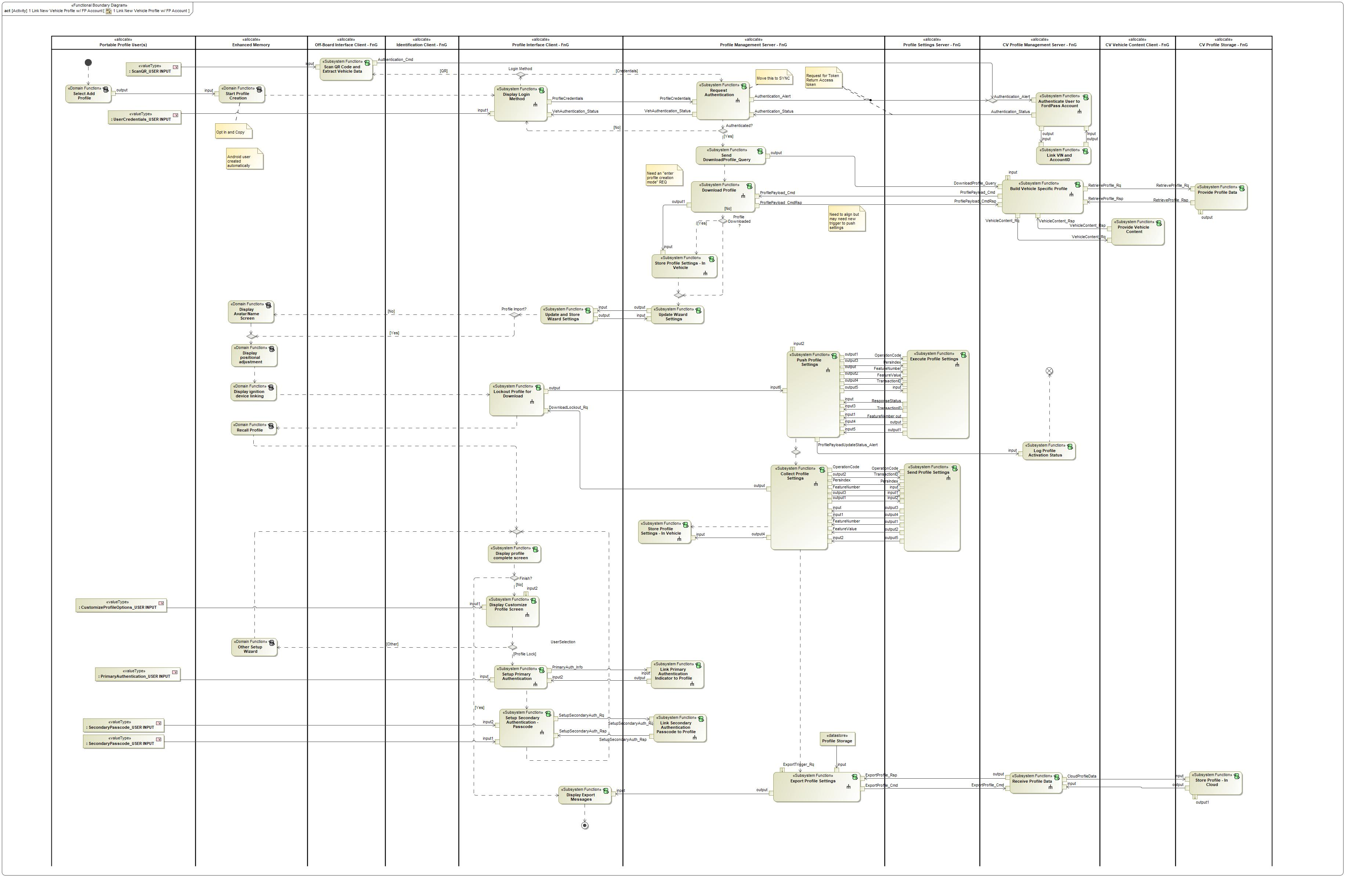

Figure 6: 1 Link New Vehicle Profile w/ FP Account

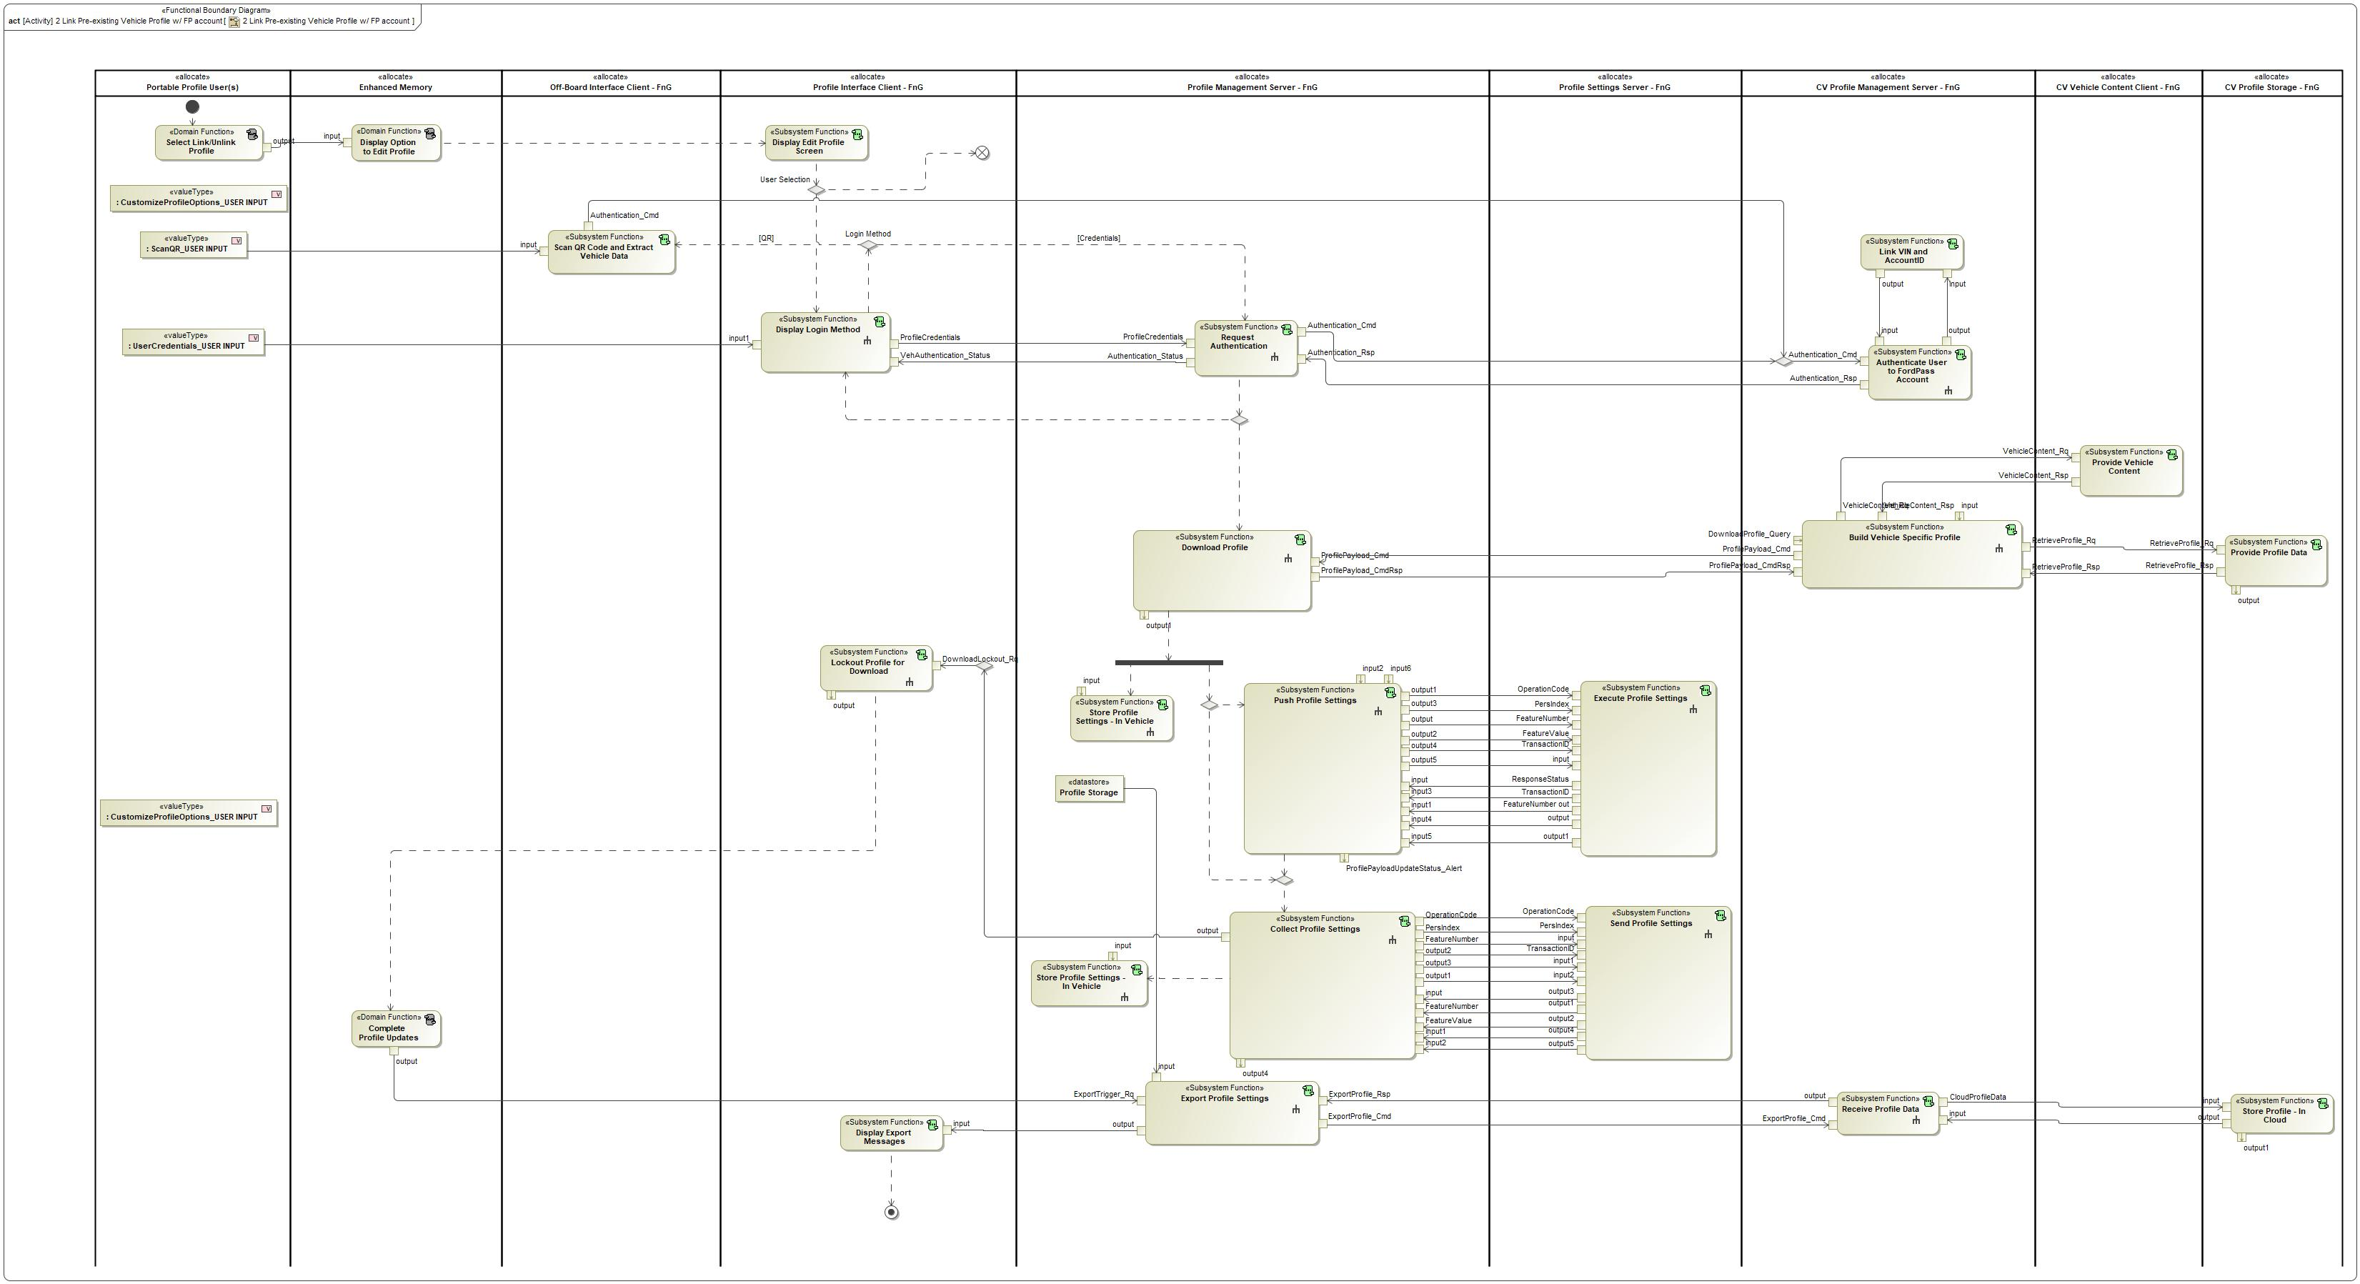

Figure 7: 2 Link Pre-existing Vehicle Profile w/ FP account

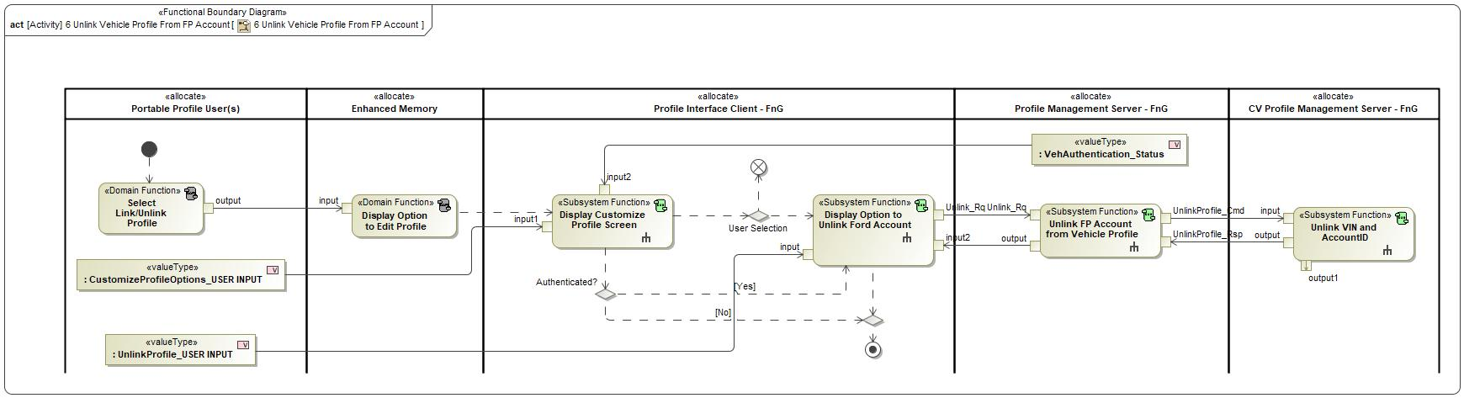

Figure 8: 6 Unlink Vehicle Profile From FP Account

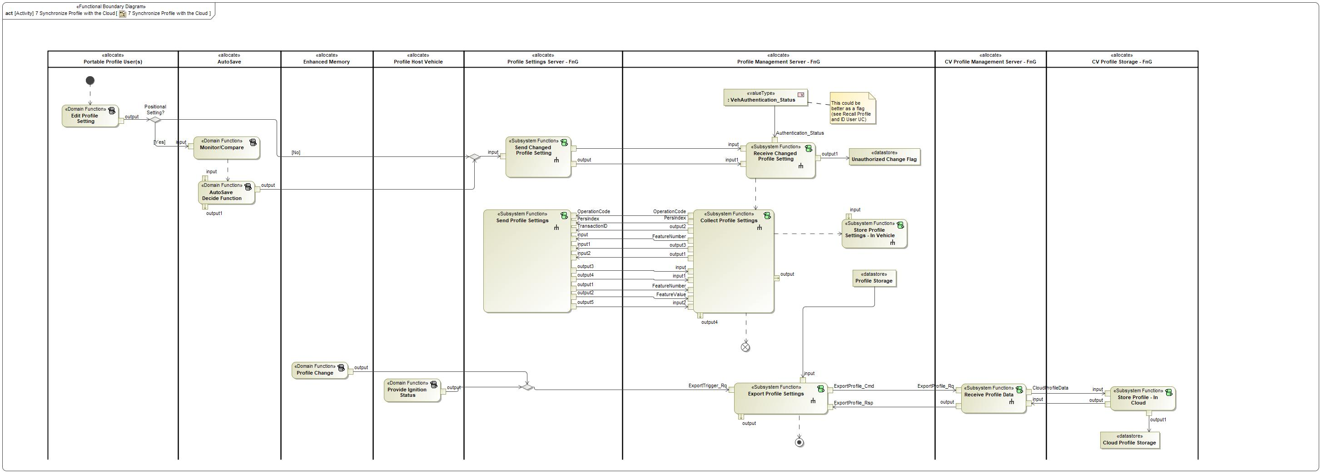

Figure 9: 7 Synchronize Profile with the Cloud

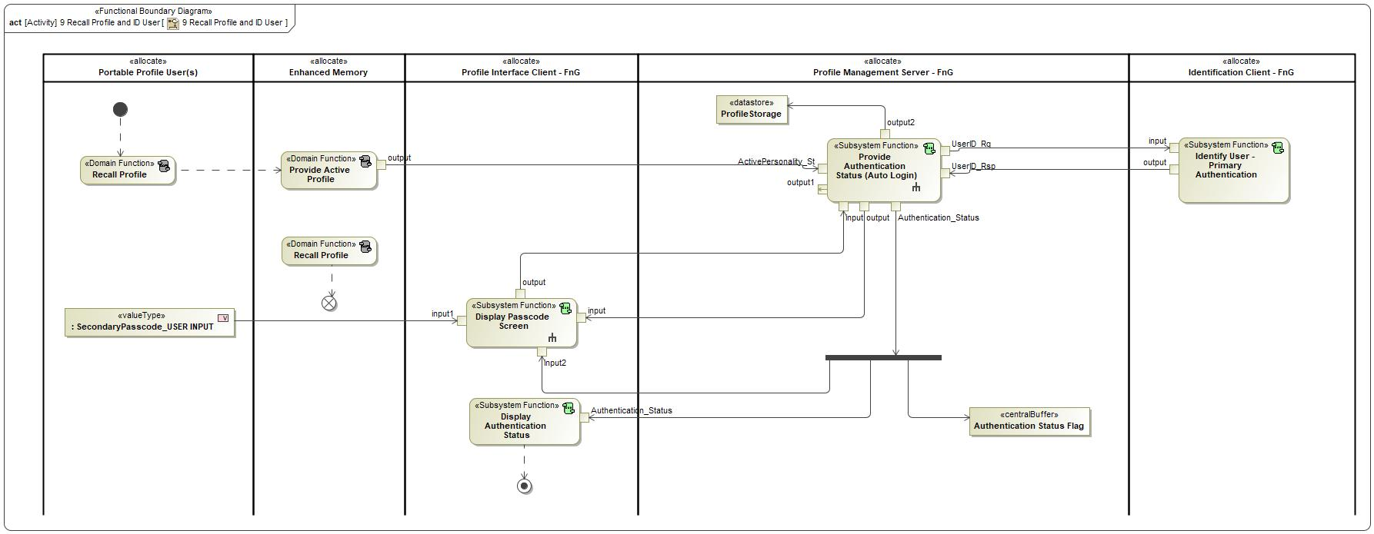

Figure 10: 9 Recall Profile and ID User

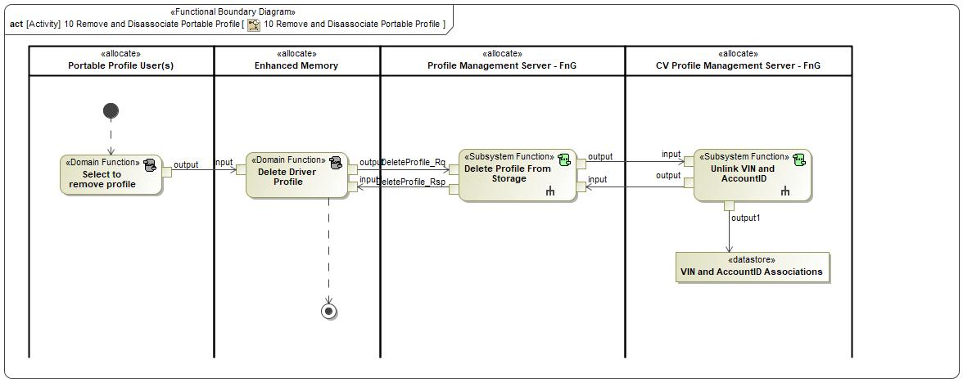

Figure 11: 10 Remove and Disassociate Portable Profile

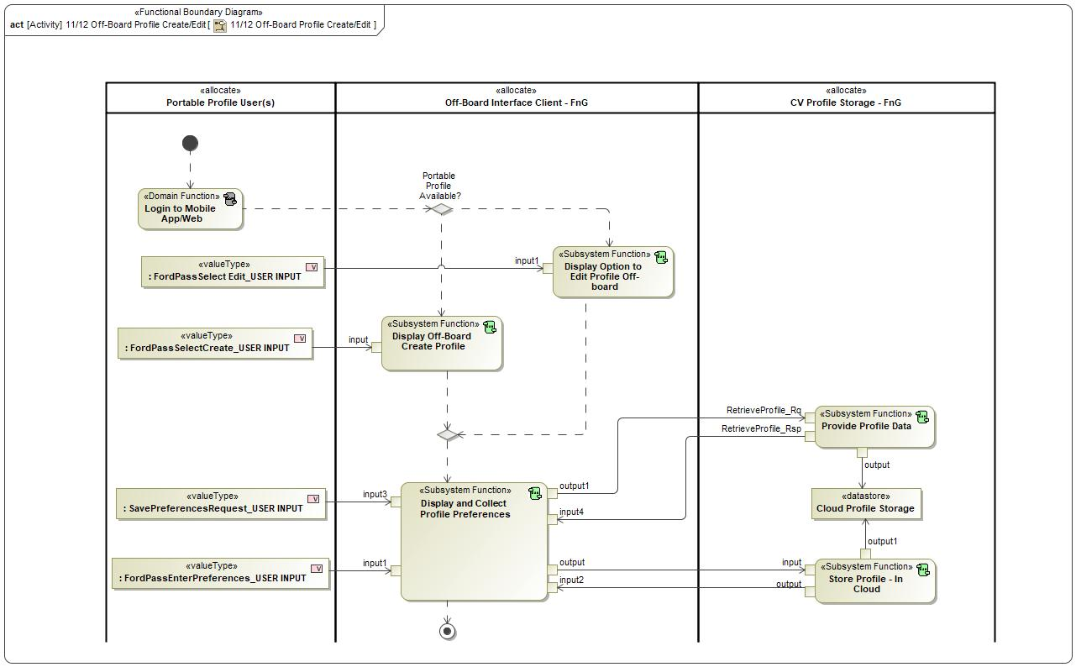

Figure 12: 11/12 Off-Board Profile Create/Edit

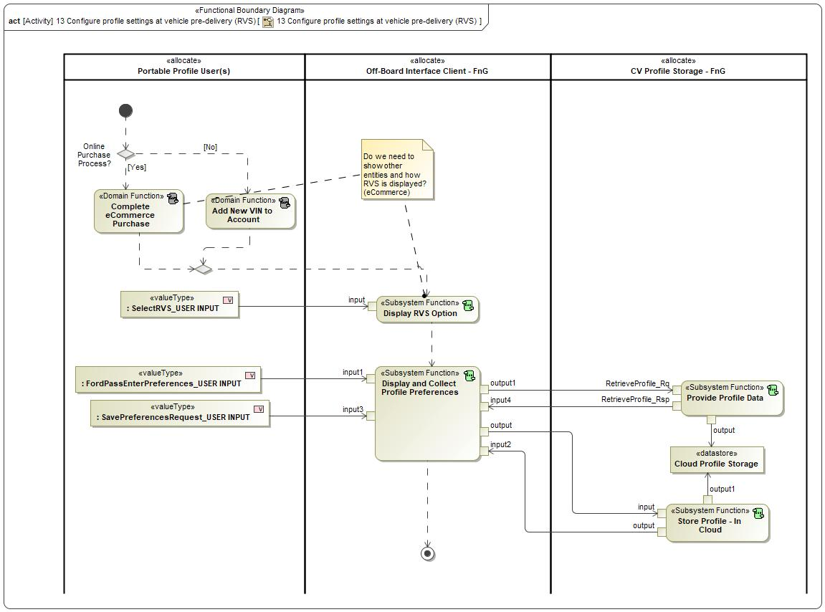

Figure 13: 13 Configure profile settings at vehicle pre-delivery (RVS)

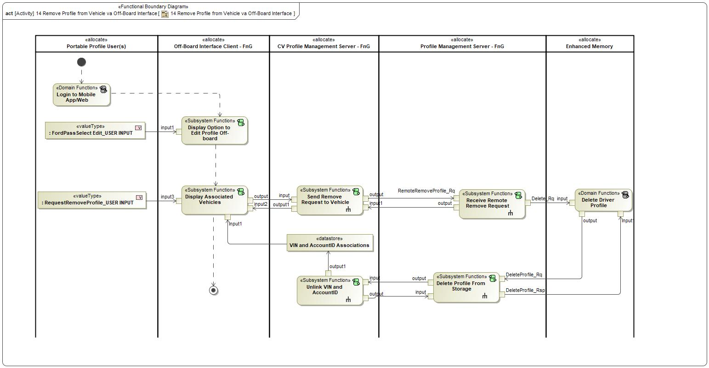

Figure 14: 14 Remove Profile from Vehicle va Off-Board Interface

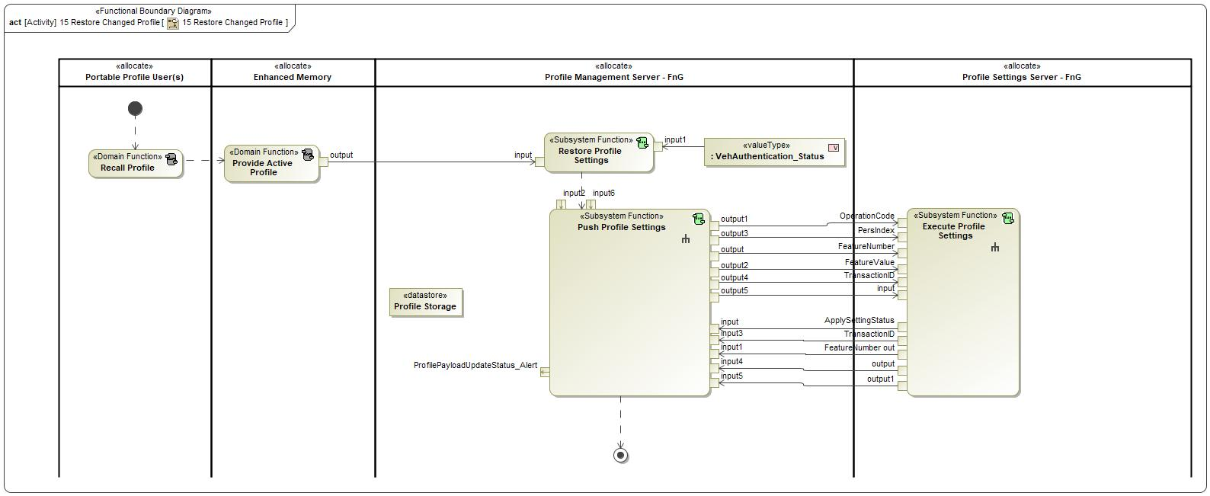

Figure 15: 15 Restore Changed Profile

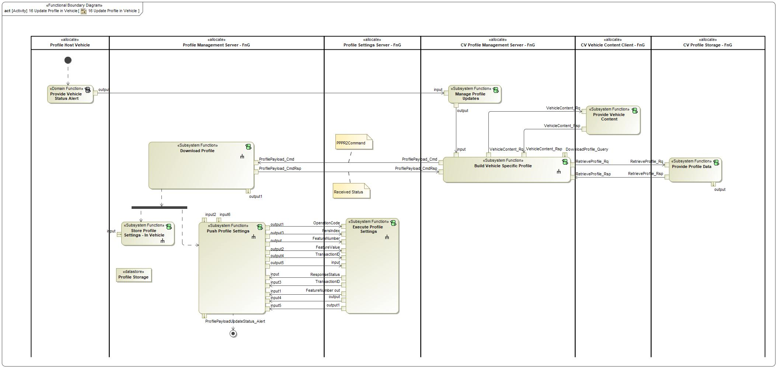

Figure 16: 16 Update Profile in Vehicle

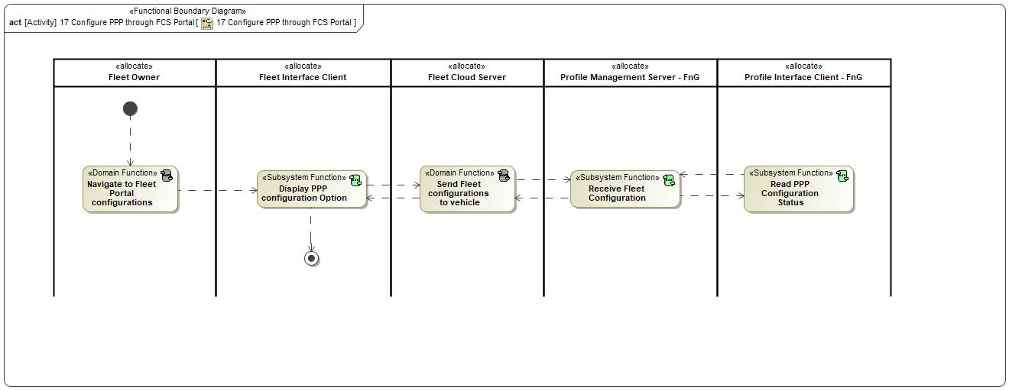

Figure 17: 17 Configure PPP through FCS Portal

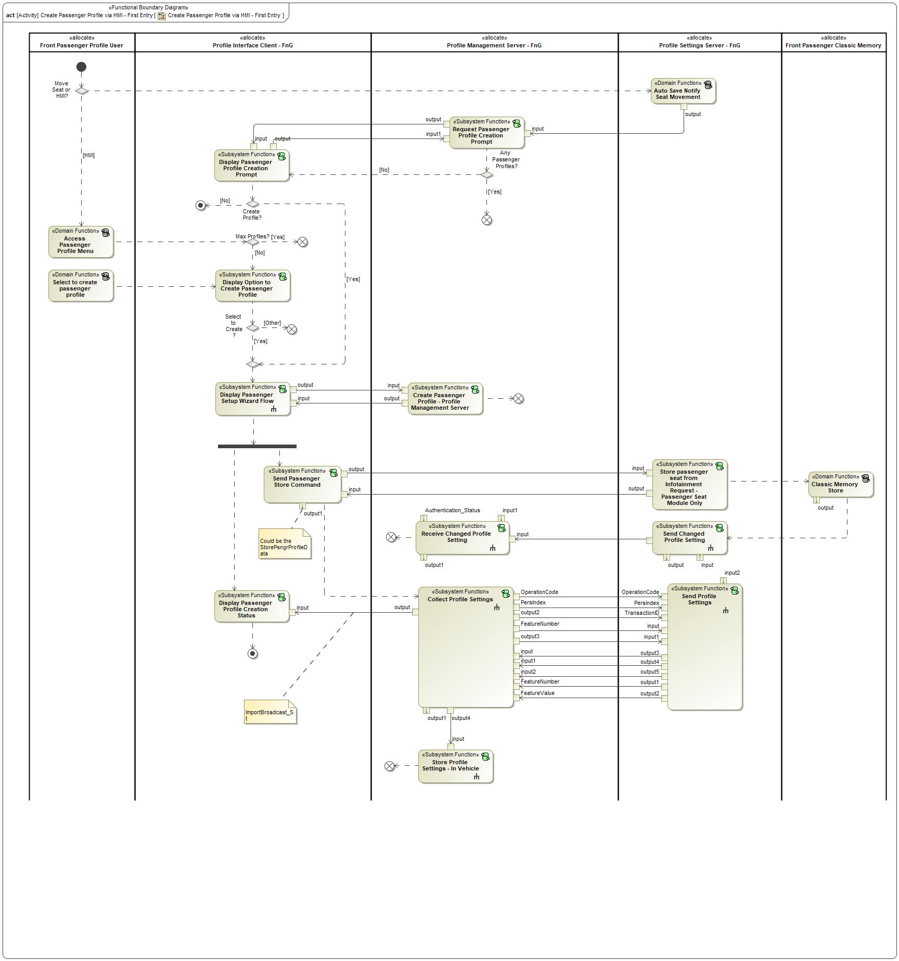

Figure 18: Create Passenger Profile via HMI - First Entry

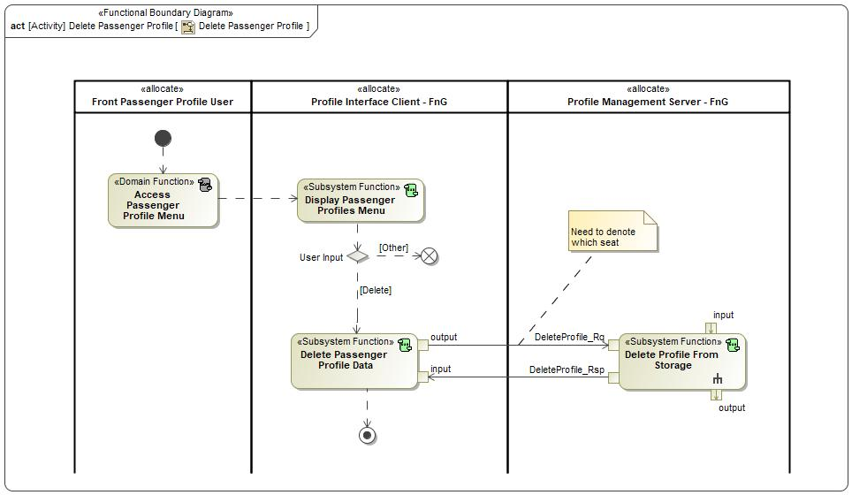

Figure 19: Delete Passenger Profile

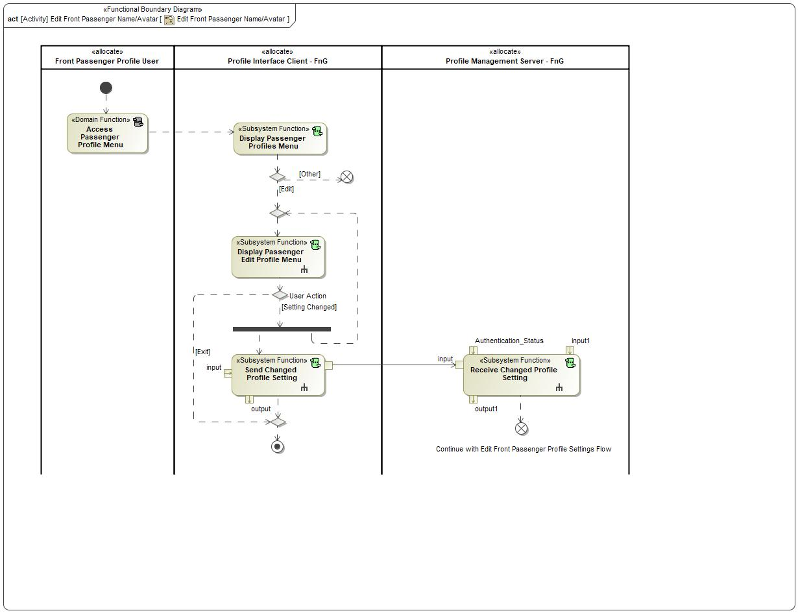

Figure 20: Edit Front Passenger Name/Avatar

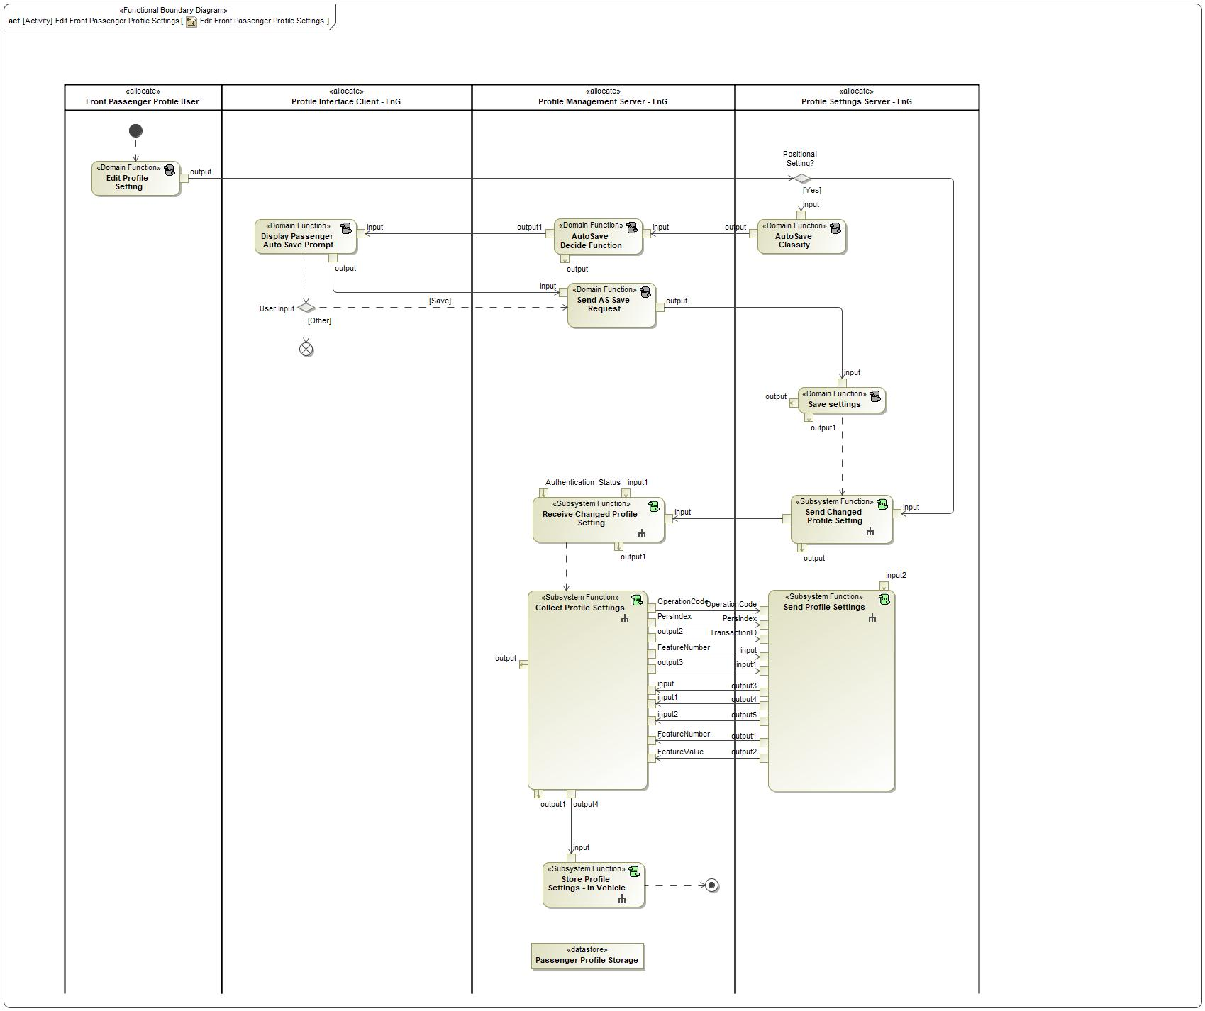

Figure 21: Edit Front Passenger Profile Settings

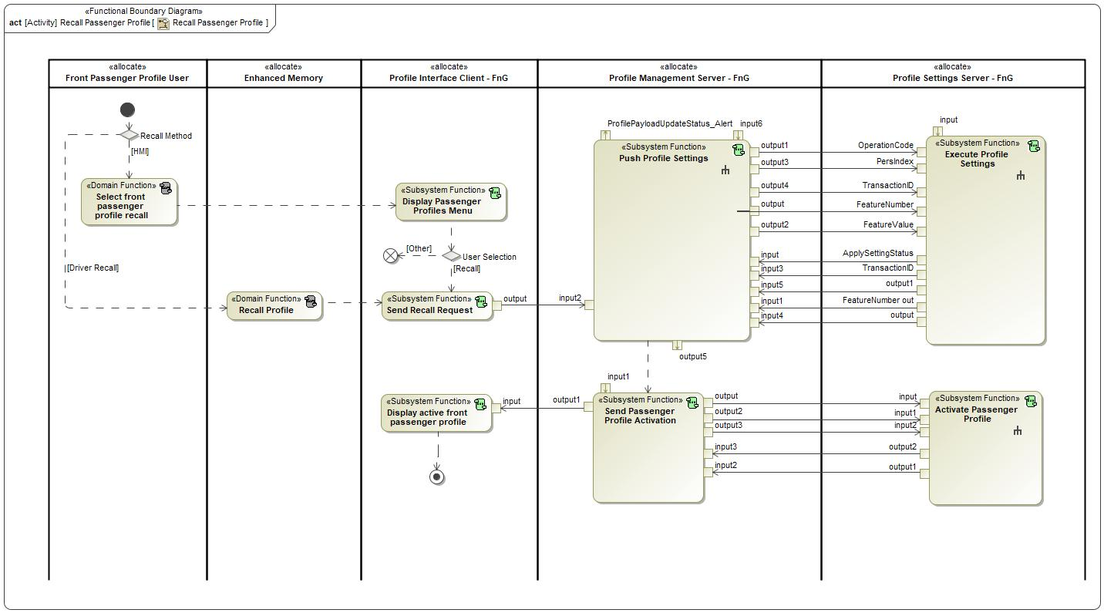

Figure 22: Recall Passenger Profile

### List of Functions

**#Hint:** The functions shown in the Functional Architecture should be listed and described in the table below

| **Function Name** | Description | Comments |
| --- | --- | --- |
| *(activity)* Receive Profile Data | *(activity)* A cloud function that receives any profile data from the vehicle and passes it along to the cloud profile storage. |  |
| *(activity)* Display positional adjustment |  |  |
| *(activity)* Recall Profile | *(activity)* DOMAIN Function - Profile User |  |
| *(activity)* Display Avatar/Name Screen |  |  |
| *(activity)* Execute Profile Settings | *(activity)* This is a function of the Profile Setting Servers with the purpose of receiving and applying profile settings that are sent by the Profile Management Server. This function executes profile settings using Feature Number, Feature Value and Pers Index as inputs. The Profile Setting Servers utilize this function when receiving OperationCode = SET from Profile Management Server. |  |
| *(activity)* Send DownloadProfile_Query |  |  |
| *(activity)* Lockout Profile for Download | *(activity)* This function is allocated to the Profile Interface Client and provides an HMI graphic that locks out the HMI screen so that the customer cannot make any changes while the PPP feature is applying settings. |  |
| *(activity)* Select Add Profile | *(activity)* DOMAIN Function - Profile User |  |
| *(activity)* Update Wizard Settings |  |  |
| *(activity)* Collect Profile Settings | *(activity)* This function collects all in-vehicle profile settings from the Profile Setting Servers. The function interacts with the in-vehicle profile storage to save and store the profile settings. |  |
| *(activity)* Log Profile Activation Status |  |  |
| *(activity)* Display ignition device linking |  |  |
| *(activity)* Store Profile Settings - In Vehicle | *(activity)* This function receives profile settings as inputs from multiple function sources and outputs profile settings when the settings are being exported to the cloud or pushed to the Profile Setting Servers. |  |
| *(activity)* Request Authentication | *(activity)* This function receives the authentication status from the cloud and provides the status to requesting vehicle functions. Function occurs when a customer logs in to a vehicle for the first time. |  |
| *(activity)* Setup Primary Authentication | *(activity)* This is an HMI function that allows the user to setup their primary authentication method for their profile. |  |
| *(activity)* Link VIN and AccountID | *(activity)* This is a cloud function that stores all of the VINs that a portable profile is currently available in. |  |
| *(activity)* Start Profile Creation | *(activity)* DOMAIN Function - Enhanced Memory |  |
| *(activity)* Provide Profile Data | *(activity)* This function stores profile data in the cloud and associates the data to a user profile. |  |
| *(activity)* Link Primary Authentication Indicator to Profile | *(activity)* This function links a primary authentication indicator (BT device, Face ID, NFC, etc.) to the user's vehicle profile to be used for profile authentication. |  |
| *(activity)* Display Export Messages | *(activity)* This function communicates any necessary messages to the user while profile settings are being uploaded to the cloud. |  |
| *(activity)* Display Customize Profile Screen | *(activity)* This function displays a screen that provides the ability for the user to customize certain parameters/aspects of their profile. |  |
| *(activity)* Authenticate User to FordPass Account | *(activity)* This function receives the user credentials and authenticates them with the backend system to ensure the credentials are associated to a valid FordPass account. |  |
| *(activity)* Setup Secondary Authentication - Passcode | *(activity)* This is an HMI function that receives the secondary authentication passcode from the user. This function is executed when primary authentication of a user is unavailable or fails. |  |
| *(activity)* Scan QR Code and Extract Vehicle Data | *(activity)* A function of the Off-Board Interface Client that uses the mobile device's camera to scan a QR code and extract relevant vehicle data to authenticate a user on a specific vehicle. |  |
| *(activity)* Download Profile | *(activity)* This function sends a Download_Cmd to the cloud to initiate a profile download and receives a profile payload for the authenticated user of the profile via the Download_Rsp. |  |
| *(activity)* Display Login Method | *(activity)* This is an HMI function that is displayed to collect user credentials from the user. The credentials are used to authenticate a user in order to link their profile to their FordPass account and import their profile settings. |  |
| *(activity)* Push Profile Settings | *(activity)* This function reads user profile data from the Profile Management Server storage and uses the Personalization Service to send the profile data (Feature Number/Feature Value) to the correct Profile Setting Servers. |  |
| *(activity)* Update and Store Wizard Settings |  |  |
| *(activity)* Display profile complete screen |  |  |
| *(activity)* Export Profile Settings | *(activity)* A function that will export profile settings from the vehicle to the cloud when a new vehicle profile is initially created or when profile settings are changed by the profile user. |  |
| *(activity)* Link Secondary Authentication Passcode to Profile | *(activity)* This function receives a passcode value from the Profile Interface Client and links the passcode to the profile being edited or created. The Secondary Authentication Passcode is intended to be a backup method for a user to be authenticated to their profile. If Primary Authentication fails, Secondary Authentication is prompted. |  |
| *(activity)* Store Profile - In Cloud | *(activity)* Cloud storage of the profile settings that is associated with the user's FordPass account. |  |
| *(activity)* Store Profile Settings - In Vehicle | *(activity)* This function receives profile settings as inputs from multiple function sources and outputs profile settings when the settings are being exported to the cloud or pushed to the Profile Setting Servers. |  |
| *(activity)* Send Profile Settings | *(activity)* This function sends profile data associated to a user profile that is stored on the Profile Setting Server to the Profile Management Server when the PPPSettings_Rq with OperationCode = QUERY is received. The received query operation can be for a specific Feature Number or can be a batch query (FeatureNumber = NULL in PPPSettings_Rq) of all profile data associated to a profile. |  |
| *(activity)* Build Vehicle Specific Profile | *(activity)* A cloud function that uses vehicle configuration data and the user's portable profile data to build a vehicle specific profile to be sent to the vehicle. |  |
| *(activity)* Provide Vehicle Content | *(activity)* This function provides personalized vehicle content for specific vehicles in order to help create a vehicle specific profile. |  |
| *(activity)* Other Setup Wizard |  |  |

Table 12: List of Functions on 1 Link New Vehicle Profile w/ FP Account

| **Function Name** | Description | Comments |
| --- | --- | --- |
| *(activity)* Store Profile Settings - In Vehicle | *(activity)* This function receives profile settings as inputs from multiple function sources and outputs profile settings when the settings are being exported to the cloud or pushed to the Profile Setting Servers. |  |
| *(activity)* Download Profile | *(activity)* This function sends a Download_Cmd to the cloud to initiate a profile download and receives a profile payload for the authenticated user of the profile via the Download_Rsp. |  |
| *(activity)* Send Profile Settings | *(activity)* This function sends profile data associated to a user profile that is stored on the Profile Setting Server to the Profile Management Server when the PPPSettings_Rq with OperationCode = QUERY is received. The received query operation can be for a specific Feature Number or can be a batch query (FeatureNumber = NULL in PPPSettings_Rq) of all profile data associated to a profile. |  |
| *(activity)* Store Profile Settings - In Vehicle | *(activity)* This function receives profile settings as inputs from multiple function sources and outputs profile settings when the settings are being exported to the cloud or pushed to the Profile Setting Servers. |  |
| *(activity)* Link VIN and AccountID | *(activity)* This is a cloud function that stores all of the VINs that a portable profile is currently available in. |  |
| *(activity)* Provide Profile Data | *(activity)* This function stores profile data in the cloud and associates the data to a user profile. |  |
| *(activity)* Scan QR Code and Extract Vehicle Data | *(activity)* A function of the Off-Board Interface Client that uses the mobile device's camera to scan a QR code and extract relevant vehicle data to authenticate a user on a specific vehicle. |  |
| *(activity)* Display Login Method | *(activity)* This is an HMI function that is displayed to collect user credentials from the user. The credentials are used to authenticate a user in order to link their profile to their FordPass account and import their profile settings. |  |
| *(activity)* Display Option to Edit Profile | *(activity)* DOMAIN Function |  |
| *(activity)* Provide Vehicle Content | *(activity)* This function provides personalized vehicle content for specific vehicles in order to help create a vehicle specific profile. |  |
| *(activity)* Authenticate User to FordPass Account | *(activity)* This function receives the user credentials and authenticates them with the backend system to ensure the credentials are associated to a valid FordPass account. |  |
| *(activity)* Push Profile Settings | *(activity)* This function reads user profile data from the Profile Management Server storage and uses the Personalization Service to send the profile data (Feature Number/Feature Value) to the correct Profile Setting Servers. |  |
| *(activity)* Export Profile Settings | *(activity)* A function that will export profile settings from the vehicle to the cloud when a new vehicle profile is initially created or when profile settings are changed by the profile user. |  |
| *(activity)* Display Export Messages | *(activity)* This function communicates any necessary messages to the user while profile settings are being uploaded to the cloud. |  |
| *(activity)* Receive Profile Data | *(activity)* A cloud function that receives any profile data from the vehicle and passes it along to the cloud profile storage. |  |
| *(activity)* Lockout Profile for Download | *(activity)* This function is allocated to the Profile Interface Client and provides an HMI graphic that locks out the HMI screen so that the customer cannot make any changes while the PPP feature is applying settings. |  |
| *(activity)* Complete Profile Updates |  |  |
| *(activity)* Collect Profile Settings | *(activity)* This function collects all in-vehicle profile settings from the Profile Setting Servers. The function interacts with the in-vehicle profile storage to save and store the profile settings. |  |
| *(activity)* Execute Profile Settings | *(activity)* This is a function of the Profile Setting Servers with the purpose of receiving and applying profile settings that are sent by the Profile Management Server. This function executes profile settings using Feature Number, Feature Value and Pers Index as inputs. The Profile Setting Servers utilize this function when receiving OperationCode = SET from Profile Management Server. |  |
| *(activity)* Select Link/Unlink Profile | *(activity)* DOMAIN Function - Profile User |  |
| *(activity)* Build Vehicle Specific Profile | *(activity)* A cloud function that uses vehicle configuration data and the user's portable profile data to build a vehicle specific profile to be sent to the vehicle. |  |
| *(activity)* Request Authentication | *(activity)* This function receives the authentication status from the cloud and provides the status to requesting vehicle functions. Function occurs when a customer logs in to a vehicle for the first time. |  |
| *(activity)* Store Profile - In Cloud | *(activity)* Cloud storage of the profile settings that is associated with the user's FordPass account. |  |
| *(activity)* Display Edit Profile Screen |  |  |

Table 13: List of Functions on 2 Link Pre-existing Vehicle Profile w/ FP account

| **Function Name** | Description | Comments |
| --- | --- | --- |
| *(activity)* Display Customize Profile Screen | *(activity)* This function displays a screen that provides the ability for the user to customize certain parameters/aspects of their profile. |  |
| *(activity)* Select Link/Unlink Profile | *(activity)* DOMAIN Function - Profile User |  |
| *(activity)* Unlink FP Account from Vehicle Profile | *(activity)* This function receives an unlink request from the Profile Interface Client, breaks the association between Account ID and vehicle profile, and then sends a request to the cloud to disassociate the vehicle from the cloud profile. |  |
| *(activity)* Display Option to Unlink Ford Account | *(activity)* HMI function that provides the capability for the user to link their FP account to any pre-existing vehicle profiles. |  |
| *(activity)* Unlink VIN and AccountID | *(activity)* A function of the cloud that unlinks the cloud profile from a specific VIN. This occurs when a customer unlinks their FordPass account from a vehicle profile or when the customer deletes their profile from a vehicle. |  |
| *(activity)* Display Option to Edit Profile | *(activity)* DOMAIN Function |  |

Table 14: List of Functions on 6 Unlink Vehicle Profile From FP Account

| **Function Name** | Description | Comments |
| --- | --- | --- |
| *(activity)* AutoSave Decide Function | *(activity)* DOMAIN Function |  |
| *(activity)* Send Changed Profile Setting | *(activity)* A function of the Profile Setting Servers that sends a change notification to the Profile Management Server when a change is made to a profile setting of an active profile. The notification does not determine which profile setting was changed, just that a change occurred and the Profile Management Server must query the active profile to refresh the local copy. |  |
| *(activity)* Profile Change | *(activity)* DOMAIN Function - Enhanced Memory |  |
| *(activity)* Send Profile Settings | *(activity)* This function sends profile data associated to a user profile that is stored on the Profile Setting Server to the Profile Management Server when the PPPSettings_Rq with OperationCode = QUERY is received. The received query operation can be for a specific Feature Number or can be a batch query (FeatureNumber = NULL in PPPSettings_Rq) of all profile data associated to a profile. |  |
| *(activity)* Edit Profile Setting | *(activity)* DOMAIN Function - Profile User |  |
| *(activity)* Store Profile Settings - In Vehicle | *(activity)* This function receives profile settings as inputs from multiple function sources and outputs profile settings when the settings are being exported to the cloud or pushed to the Profile Setting Servers. |  |
| *(activity)* Store Profile - In Cloud | *(activity)* Cloud storage of the profile settings that is associated with the user's FordPass account. |  |
| *(activity)* Export Profile Settings | *(activity)* A function that will export profile settings from the vehicle to the cloud when a new vehicle profile is initially created or when profile settings are changed by the profile user. |  |
| *(activity)* Receive Profile Data | *(activity)* A cloud function that receives any profile data from the vehicle and passes it along to the cloud profile storage. |  |
| *(activity)* Receive Changed Profile Setting | *(activity)* This function receives the values of a changed profile setting for an active profile and arbitrates if the setting should be saved to the profile based on the authentication status of the vehicle user. |  |
| *(activity)* Collect Profile Settings | *(activity)* This function collects all in-vehicle profile settings from the Profile Setting Servers. The function interacts with the in-vehicle profile storage to save and store the profile settings. |  |
| *(activity)* Monitor/Compare | *(activity)* DOMAIN Function |  |
| *(activity)* Provide Ignition Status | *(activity)* DOMAIN Function - Host Vehicle |  |

Table 15: List of Functions on 7 Synchronize Profile with the Cloud

| **Function Name** | Description | Comments |
| --- | --- | --- |
| *(activity)* Provide Authentication Status (Auto Login) | *(activity)* This function provides the current authentication status of the active profile in the vehicle to other functions of the system. Authentication status is based on the active profile and which user is identified in the vehicle. User identification is provided by the Identification Client. |  |
| *(activity)* Recall Profile | *(activity)* DOMAIN Function - Profile User |  |
| *(activity)* Provide Active Profile | *(activity)* DOMAIN Function - Enhanced Memory |  |
| *(activity)* Display Passcode Screen | *(activity)* This function displays a screen that allows the user to enter their passcode. |  |
| *(activity)* Recall Profile | *(activity)* DOMAIN Function - Profile User |  |
| *(activity)* Identify User - Primary Authentication | *(activity)* This function identifies the user that has an active profile in the host vehicle. |  |
| *(activity)* Display Authentication Status | *(activity)* The function is allocated to the Profile Interface Client which is inside the vehicle. This is an HMI function that displays whether the owner of the active profile has been successfully authenticated by either the primary (PaaK, FR, NFC, etc.) or secondary (PIN) authentication methods. |  |

Table 16: List of Functions on 9 Recall Profile and ID User

| **Function Name** | Description | Comments |
| --- | --- | --- |
| *(activity)* Unlink VIN and AccountID | *(activity)* A function of the cloud that unlinks the cloud profile from a specific VIN. This occurs when a customer unlinks their FordPass account from a vehicle profile or when the customer deletes their profile from a vehicle. |  |
| *(activity)* Delete Driver Profile | *(activity)* DOMAIN Function - Enhanced Memory |  |
| *(activity)* Delete Profile From Storage | *(activity)* This function receives a request to delete a profile stored to the vehicle, deletes the profile from storage, and then sends a request to the cloud to disassociate the vehicle from the cloud profile. This function also executes the delete profile when a Master Reset occurs on the vehicle. |  |
| *(activity)* Select to remove profile | *(activity)* DOMAIN Function - Profile User |  |

Table 17: List of Functions on 10 Remove and Disassociate Portable Profile

| **Function Name** | Description | Comments |
| --- | --- | --- |
| *(activity)* Login to Mobile App/Web | *(activity)* DOMAIN Function |  |
| *(activity)* Display Off-Board Create Profile | *(activity)* This function provides the user an interface to create or edit a portable profile from outside a vehicle. |  |
| *(activity)* Store Profile - In Cloud | *(activity)* Cloud storage of the profile settings that is associated with the user's FordPass account. |  |
| *(activity)* Display Option to Edit Profile Off-board | *(activity)* Off-Board Interface Client function that provides the user the option to edit a pre-existing portable profile. |  |
| *(activity)* Display and Collect Profile Preferences | *(activity)* A function of the Off-Board Interface Client that is used to receive input from the customer to collect profile preferences from outside of the vehicle. This function can be used in the RVS scenario of collecting preferences pre vehicle delivery or when a customer decides to create/edit their profile using the off-board interface. |  |
| *(activity)* Provide Profile Data | *(activity)* This function stores profile data in the cloud and associates the data to a user profile. |  |

Table 18: List of Functions on 11/12 Off-Board Profile Create/Edit

| **Function Name** | Description | Comments |
| --- | --- | --- |
| *(activity)* Display and Collect Profile Preferences | *(activity)* A function of the Off-Board Interface Client that is used to receive input from the customer to collect profile preferences from outside of the vehicle. This function can be used in the RVS scenario of collecting preferences pre vehicle delivery or when a customer decides to create/edit their profile using the off-board interface. |  |
| *(activity)* Store Profile - In Cloud | *(activity)* Cloud storage of the profile settings that is associated with the user's FordPass account. |  |
| *(activity)* Complete eCommerce Purchase |  |  |
| *(activity)* Add New VIN to Account |  |  |
| *(activity)* Display RVS Option |  |  |
| *(activity)* Provide Profile Data | *(activity)* This function stores profile data in the cloud and associates the data to a user profile. |  |

Table 19: List of Functions on 13 Configure profile settings at vehicle pre-delivery (RVS)

| **Function Name** | Description | Comments |
| --- | --- | --- |
| *(activity)* Display Associated Vehicles | *(activity)* This function is allocated to the Off-Board Interface Client and displays the different vehicles that the user's portable profile is currently saved to. The user can select from the list of vehicles and request to remove their profile from that vehicle. |  |
| *(activity)* Delete Driver Profile | *(activity)* DOMAIN Function - Enhanced Memory |  |
| *(activity)* Delete Profile From Storage | *(activity)* This function receives a request to delete a profile stored to the vehicle, deletes the profile from storage, and then sends a request to the cloud to disassociate the vehicle from the cloud profile. This function also executes the delete profile when a Master Reset occurs on the vehicle. |  |
| *(activity)* Receive Remote Remove Request | *(activity)* This function receives a remote remove request from the cloud and then sends a request to the Enhanced Memory system to delete the requested profile. |  |
| *(activity)* Send Remove Request to Vehicle | *(activity)* A function allocated to the cloud that relays remote remove requests from the Off-Board Interface Client to the Profile Management Server of a specific vehicle. |  |
| *(activity)* Display Option to Edit Profile Off-board | *(activity)* Off-Board Interface Client function that provides the user the option to edit a pre-existing portable profile. |  |
| *(activity)* Login to Mobile App/Web | *(activity)* DOMAIN Function |  |
| *(activity)* Unlink VIN and AccountID | *(activity)* A function of the cloud that unlinks the cloud profile from a specific VIN. This occurs when a customer unlinks their FordPass account from a vehicle profile or when the customer deletes their profile from a vehicle. |  |

Table 20: List of Functions on 14 Remove Profile from Vehicle va Off-Board Interface

| **Function Name** | Description | Comments |
| --- | --- | --- |
| *(activity)* Execute Profile Settings | *(activity)* This is a function of the Profile Setting Servers with the purpose of receiving and applying profile settings that are sent by the Profile Management Server. This function executes profile settings using Feature Number, Feature Value and Pers Index as inputs. The Profile Setting Servers utilize this function when receiving OperationCode = SET from Profile Management Server. |  |
| *(activity)* Restore Profile Settings | *(activity)* This function checks to see if there were any unauthorized changes made to the active profile. If so, the function will request the Profile Management Server to Push the changed profile settings out to the Profile Setting Servers. |  |
| *(activity)* Recall Profile | *(activity)* DOMAIN Function - Profile User |  |
| *(activity)* Push Profile Settings | *(activity)* This function reads user profile data from the Profile Management Server storage and uses the Personalization Service to send the profile data (Feature Number/Feature Value) to the correct Profile Setting Servers. |  |
| *(activity)* Provide Active Profile | *(activity)* DOMAIN Function - Enhanced Memory |  |

Table 21: List of Functions on 15 Restore Changed Profile

| **Function Name** | Description | Comments |
| --- | --- | --- |
| *(activity)* Execute Profile Settings | *(activity)* This is a function of the Profile Setting Servers with the purpose of receiving and applying profile settings that are sent by the Profile Management Server. This function executes profile settings using Feature Number, Feature Value and Pers Index as inputs. The Profile Setting Servers utilize this function when receiving OperationCode = SET from Profile Management Server. |  |
| *(activity)* Provide Vehicle Content | *(activity)* This function provides personalized vehicle content for specific vehicles in order to help create a vehicle specific profile. |  |
| *(activity)* Provide Vehicle Status Alert |  |  |
| *(activity)* Provide Profile Data | *(activity)* This function stores profile data in the cloud and associates the data to a user profile. |  |
| *(activity)* Build Vehicle Specific Profile | *(activity)* A cloud function that uses vehicle configuration data and the user's portable profile data to build a vehicle specific profile to be sent to the vehicle. |  |
| *(activity)* Push Profile Settings | *(activity)* This function reads user profile data from the Profile Management Server storage and uses the Personalization Service to send the profile data (Feature Number/Feature Value) to the correct Profile Setting Servers. |  |
| *(activity)* Download Profile | *(activity)* This function sends a Download_Cmd to the cloud to initiate a profile download and receives a profile payload for the authenticated user of the profile via the Download_Rsp. |  |
| *(activity)* Store Profile Settings - In Vehicle | *(activity)* This function receives profile settings as inputs from multiple function sources and outputs profile settings when the settings are being exported to the cloud or pushed to the Profile Setting Servers. |  |
| *(activity)* Manage Profile Updates |  |  |

Table 22: List of Functions on 16 Update Profile in Vehicle

| **Function Name** | Description | Comments |
| --- | --- | --- |
| *(activity)* Navigate to Fleet Portal configurations |  |  |
| *(activity)* Display PPP configuration Option | *(activity)* HMI function to display the option for a Fleet Owner to configure the PPP feature ON or OFF for their fleet vehicles. |  |
| *(activity)* Send Fleet configurations to vehicle |  |  |
| *(activity)* Receive Fleet Configuration | *(activity)* Profile Management Server receives PPP configuration data from the Fleet Cloud Server that contains a configuration request. |  |
| *(activity)* Read PPP Configuration Status | *(activity)* Upon receiving configuration request, this function updates the configuration value to turn the feature ON or OFF based on the data from the received request. |  |

Table 23: List of Functions on 17 Configure PPP through FCS Portal

| **Function Name** | Description | Comments |
| --- | --- | --- |
| *(activity)* Auto Save Notify Seat Movement |  |  |
| *(activity)* Create Passenger Profile - Profile Management Server | *(activity)* Creates the first instance of a Passenger Profile within the Profile Management Server. In order to create a new Passenger Profile, there must be at least a valid Profile Name provided. |  |
| *(activity)* Store passenger seat from Infotainment Request - Passenger Seat Module Only | *(activity)* Function that stores the current seat position to the requested PersIndex when the InfotainmentPsngrPersStore_Rq is received. |  |
| *(activity)* Request Passenger Profile Creation Prompt | *(activity)* A function of the Profile Management Server that sends a request to the Profile Interface Client when a Passenger Seat was moved and there are no Passenger Profiles created. |  |
| *(activity)* Send Passenger Store Command | *(activity)* Function that requests the Passenger Classic Memory system to store the current seat position to the requested PersIndex. |  |
| *(activity)* Access Passenger Profile Menu |  |  |
| *(activity)* Display Passenger Profile Creation Status | *(activity)* HMI function that displays the status of a new Passenger Profile Creation. |  |
| *(activity)* Send Changed Profile Setting | *(activity)* A function of the Profile Setting Servers that sends a change notification to the Profile Management Server when a change is made to a profile setting of an active profile. The notification does not determine which profile setting was changed, just that a change occurred and the Profile Management Server must query the active profile to refresh the local copy. |  |
| *(activity)* Select to create passenger profile |  |  |
| *(activity)* Display Passenger Profile Creation Prompt | *(activity)* HMI function to display a Passenger Profile Creation Prompt when there are no Passenger Profiles created. |  |
| *(activity)* Display Option to Create Passenger Profile | *(activity)* HMI function that displays when a Passenger Profile can be created. |  |
| *(activity)* Display Passenger Setup Wizard Flow | *(activity)* HMI function that navigates the user through a Passenger Profile Creation Setup Wizard. |  |
| *(activity)* Classic Memory Store |  |  |
| *(activity)* Receive Changed Profile Setting | *(activity)* This function receives the values of a changed profile setting for an active profile and arbitrates if the setting should be saved to the profile based on the authentication status of the vehicle user. |  |
| *(activity)* Send Profile Settings | *(activity)* This function sends profile data associated to a user profile that is stored on the Profile Setting Server to the Profile Management Server when the PPPSettings_Rq with OperationCode = QUERY is received. The received query operation can be for a specific Feature Number or can be a batch query (FeatureNumber = NULL in PPPSettings_Rq) of all profile data associated to a profile. |  |
| *(activity)* Store Profile Settings - In Vehicle | *(activity)* This function receives profile settings as inputs from multiple function sources and outputs profile settings when the settings are being exported to the cloud or pushed to the Profile Setting Servers. |  |
| *(activity)* Collect Profile Settings | *(activity)* This function collects all in-vehicle profile settings from the Profile Setting Servers. The function interacts with the in-vehicle profile storage to save and store the profile settings. |  |

Table 24: List of Functions on Create Passenger Profile via HMI - First Entry

| **Function Name** | Description | Comments |
| --- | --- | --- |
| *(activity)* Display Passenger Profiles Menu | *(activity)* HMI function that displays all available Passenger Profiles. |  |
| *(activity)* Access Passenger Profile Menu |  |  |
| *(activity)* Delete Passenger Profile Data | *(activity)* This function deletes all passenger profile header information from the Profile Interface Client (Name, Avatar, etc.) and sends a request to the Profile Management Server to delete the profile from storage. |  |
| *(activity)* Delete Profile From Storage | *(activity)* This function receives a request to delete a profile stored to the vehicle, deletes the profile from storage, and then sends a request to the cloud to disassociate the vehicle from the cloud profile. This function also executes the delete profile when a Master Reset occurs on the vehicle. |  |

Table 25: List of Functions on Delete Passenger Profile

| **Function Name** | Description | Comments |
| --- | --- | --- |
| *(activity)* Send Changed Profile Setting | *(activity)* A function of the Profile Setting Servers that sends a change notification to the Profile Management Server when a change is made to a profile setting of an active profile. The notification does not determine which profile setting was changed, just that a change occurred and the Profile Management Server must query the active profile to refresh the local copy. |  |
| *(activity)* Receive Changed Profile Setting | *(activity)* This function receives the values of a changed profile setting for an active profile and arbitrates if the setting should be saved to the profile based on the authentication status of the vehicle user. |  |
| *(activity)* Display Passenger Profiles Menu | *(activity)* HMI function that displays all available Passenger Profiles. |  |
| *(activity)* Display Passenger Edit Profile Menu | *(activity)* HMI function to display some Passenger Profile settings that can be edited by the user. |  |
| *(activity)* Access Passenger Profile Menu |  |  |

Table 26: List of Functions on Edit Front Passenger Name/Avatar

| **Function Name** | Description | Comments |
| --- | --- | --- |
| *(activity)* Display Passenger Auto Save Prompt |  |  |
| *(activity)* Send Profile Settings | *(activity)* This function sends profile data associated to a user profile that is stored on the Profile Setting Server to the Profile Management Server when the PPPSettings_Rq with OperationCode = QUERY is received. The received query operation can be for a specific Feature Number or can be a batch query (FeatureNumber = NULL in PPPSettings_Rq) of all profile data associated to a profile. |  |
| *(activity)* Edit Profile Setting | *(activity)* DOMAIN Function - Profile User |  |
| *(activity)* Collect Profile Settings | *(activity)* This function collects all in-vehicle profile settings from the Profile Setting Servers. The function interacts with the in-vehicle profile storage to save and store the profile settings. |  |
| *(activity)* Receive Changed Profile Setting | *(activity)* This function receives the values of a changed profile setting for an active profile and arbitrates if the setting should be saved to the profile based on the authentication status of the vehicle user. |  |
| *(activity)* Store Profile Settings - In Vehicle | *(activity)* This function receives profile settings as inputs from multiple function sources and outputs profile settings when the settings are being exported to the cloud or pushed to the Profile Setting Servers. |  |
| *(activity)* AutoSave Decide Function | *(activity)* DOMAIN Function |  |
| *(activity)* Send AS Save Request |  |  |
| *(activity)* Send Changed Profile Setting | *(activity)* A function of the Profile Setting Servers that sends a change notification to the Profile Management Server when a change is made to a profile setting of an active profile. The notification does not determine which profile setting was changed, just that a change occurred and the Profile Management Server must query the active profile to refresh the local copy. |  |
| *(activity)* AutoSave Classify |  |  |
| *(activity)* Save settings |  |  |

Table 27: List of Functions on Edit Front Passenger Profile Settings

| **Function Name** | Description | Comments |
| --- | --- | --- |
| *(activity)* Send Recall Request | *(activity)* Profile Interface Client requests the Profile Management Server to initial a passenger profile recall. |  |
| *(activity)* Activate Passenger Profile | *(activity)* Action taken by the Profile Setting Server when a Passenger Profile Activation request has been received. |  |
| *(activity)* Push Profile Settings | *(activity)* This function reads user profile data from the Profile Management Server storage and uses the Personalization Service to send the profile data (Feature Number/Feature Value) to the correct Profile Setting Servers. |  |
| *(activity)* Send Passenger Profile Activation | *(activity)* Request from the Profile Management Server to activate a Passenger Profile. This function invokes the Personalization Service to send the Activate Request. |  |
| *(activity)* Select front passenger profile recall |  |  |
| *(activity)* Execute Profile Settings | *(activity)* This is a function of the Profile Setting Servers with the purpose of receiving and applying profile settings that are sent by the Profile Management Server. This function executes profile settings using Feature Number, Feature Value and Pers Index as inputs. The Profile Setting Servers utilize this function when receiving OperationCode = SET from Profile Management Server. |  |
| *(activity)* Recall Profile | *(activity)* DOMAIN Function - Profile User |  |
| *(activity)* Display Passenger Profiles Menu | *(activity)* HMI function that displays all available Passenger Profiles. |  |
| *(activity)* Display active front passenger profile | *(activity)* HMI function that displays to the user the active Front Passenger Profile. |  |

Table 28: List of Functions on Recall Passenger Profile

## Logical Architecture

**#Classification:** Functional Safety Analysis only

**#Hint:** FS Analysis requires a description of the boundary of the feature and its elements. A simple block diagram or a SysML Internal Block Diagram could be used to depict the Logical Architecture

***#Link:*** [*Ford Functional Safety Sharepoint*](https://pd3.spt.ford.com/sites/GlobalFunctionalSafety/Pages/default.aspx)

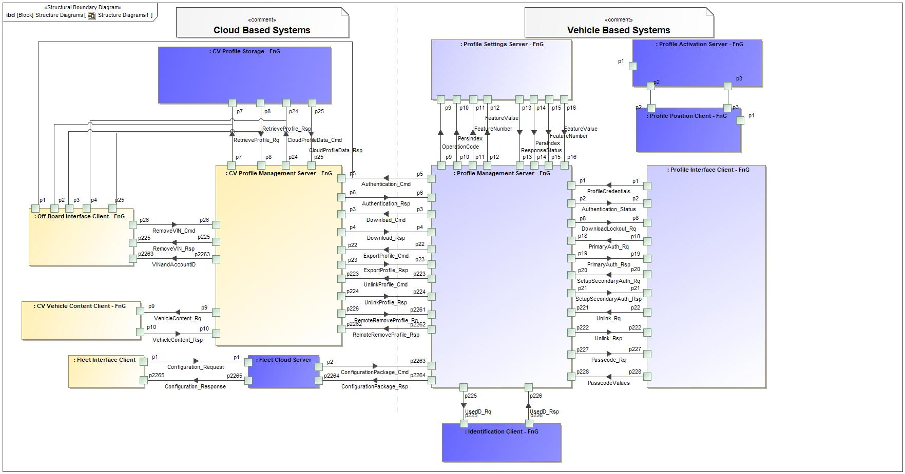

Figure 23: Structure Diagrams1

### Logical Elements

**#Hint:** Lists the elements of the Logical Architecture and the functions from the Functional Architecture, which are allocated to those elements.

|  |  |  |  |
| --- | --- | --- | --- |
| **Element Name** | **Description** | **Allocated Functions** | **Comments** |
| CV Profile Management Server - FnG | The CV Profile Management Server coordinates profile requests sent to and from vehicles. | * Authenticate User to FordPass Account * Build Vehicle Specific Profile * Link VIN and AccountID * Manage Profile Updates * Receive Profile Data * Send Remove Request to Vehicle * Unlink VIN and AccountID |  |
| CV Profile Storage - FnG | CV Profile Storage is the subsystem that stores a user's profile data in the cloud. | * Provide Profile Data * Store Profile - In Cloud |  |
| CV Vehicle Content Client - FnG | The CV Vehicle Content Client provides the list of available personalized settings on a specific vehicle. | * Provide Vehicle Content |  |
| Fleet Cloud Server | Communicates requests received by the Fleet Interface Client with the Profile Management Server. | * Send Fleet configurations to vehicle |  |
| Fleet Interface Client | Interface for the Fleet Owner to select PPP configurations. | * Display PPP configuration Option |  |
| Identification Client - FnG | Identification Client is the subsystem that identifies who is inside of the host vehicle. | * Identify User - Primary Authentication |  |
| Off-Board Interface Client - FnG | The Off-Board Interface Client is the subsystem that will provide user interface to the users outside of the host vehicle. (i.e. FordPass) | * Display and Collect Profile Preferences * Display Associated Vehicles * Display Off-Board Create Profile * Display Option to Edit Profile Off-board * Display RVS Option * Scan QR Code and Extract Vehicle Data |  |
| Profile Activation Server - FnG | The Profile Activation Server is an Enhanced Memory logical function group that determines the active profile in the vehicle. |  |  |
| Profile Interface Client - FnG | The Profile Interface Client is the subsystem that interfaces with the customer inside of the host vehicle. Any functionality that requires a display or an interaction with the customer isl be provided through this subsystem. The Profile Interface Client is also in charge of alerting the customer if there are any errors within the system. | * Display Authentication Status * Display Customize Profile Screen * Display Export Messages * Display Login Method * Display Option to Unlink Ford Account * Display Passcode Screen * Lockout Profile for Download * Read PPP Configuration Status * Setup Primary Authentication * Setup Secondary Authentication - Passcode |  |
| Profile Management Server - FnG | The Profile Management Server is a subsystem in the vehicle that stores current profile data and applies the data to the applicable Profile Setting Servers. The Profile Management Server is the main touch point from the vehicle to the cloud and is responsible for all importing and exporting of the profile settings, as well as any other required communication with the cloud. In the vehicle the Profile Management Server manages the storage of profile settings for each profile on the vehicle, as well as the different authentication indicators for each profile. | * Collect Profile Settings * Delete Profile From Storage * Download Profile * Export Profile Settings * Link Primary Authentication Indicator to Profile * Link Secondary Authentication Passcode to Profile * Provide Authentication Status (Auto Login) * Push Profile Settings * Read PPP Configuration Status * Receive Changed Profile Setting * Receive Fleet Configuration * Receive Remote Remove Request * Request Authentication * Restore Profile Settings * Store Profile Settings - In Vehicle * Unlink FP Account from Vehicle Profile |  |
| Profile Position Client - FnG | The Profile Position Client is an Enhanced Memory logical function group that handles positional saves and recalls. |  |  |
| Profile Settings Server - FnG | The Profile Setting Server logical block is a generic term for any vehicle module that owns the execution and storage of profile settings. The scope of the logical block is how each module interacts with the Profile System, and not with the customer. This specification describes the general design each Profile Setting Server must follow to enable Personal and Portable Profiles. | * Execute Profile Settings * Send All Profile Settings * Send Changed Profile Setting |  |

Table 29: Logical Elements

### Logical Interfaces

**#Hint:** Describe the interactions of the feature with other features or elements.

|  |  |  |  |
| --- | --- | --- | --- |
| **Interface** | **Direction** | **Description** | **Value Range** |
| Authentication_Cmd | p5 (Profile Management Server - FnG) To p5 (CV Profile Management Server - FnG) | Profile credentials sent to the cloud to be authenticated. |  |
| Authentication_Rsp | p6 (CV Profile Management Server - FnG) To p6 (Profile Management Server - FnG) | A success or failure response for the Authentication_Cmd. The response tells the vehicle if the provided credentials are authenticated or not. |  |
| Authentication_Status | p2 (Profile Management Server - FnG) To p2 (Profile Interface Client - FnG) | Internal vehicle status that broadcasts if a profile is authenticated or not. Profile Management Server is the transmitter of the signal and the receiver is the Profile Interface Client. |  |
| CloudProfileData_Cmd | p24 (CV Profile Management Server - FnG) To p24 (CV Profile Storage - FnG) | Profile data that is either sent from the Off-Board Interface Client or the vehicle to the CV Profile Storage. |  |
| CloudProfileData_Rsp | p25 (CV Profile Storage - FnG) To p25 (CV Profile Management Server - FnG) | A success/failure response when profile data is sent to the CV Profile Storage to be saved. |  |
| ConfigurationPackage_Cmd | p2 (Fleet Cloud Server) To p2263 (Profile Management Server - FnG) | Configuration Package sent to Profile Management Server to execute configuration request. |  |
| ConfigurationPackage_Rsp | p2264 (Profile Management Server - FnG) To p2264 (Fleet Cloud Server) | Response to the ConfigurationPackage_Cmd that contains status message. |  |
| Configuration_Request | p1 (Fleet Interface Client) To p1 (Fleet Cloud Server) | Request from the Fleet Interface Client to the Fleet Cloud Server to configure PPP for selected VINs. |  |
| Configuration_Response | p2265 (Fleet Cloud Server) To p2265 (Fleet Interface Client) | Response to the Configuration_Request containing status message. |  |
| DownloadLockout_Rq | p8 (Profile Management Server - FnG) To p8 (Profile Interface Client - FnG) | A command sent to the Profile Interface Client when the Profile Management Server is actively downloading and applying profile data. Signal prompts Profile Interface Client to display a lockout screen and communicate status. |  |
| Download_Cmd | p3 (Profile Management Server - FnG) To p3 (CV Profile Management Server - FnG) | Command sent from the vehicle to the cloud to download a portable profile. |  |
| Download_Rsp | p4 (CV Profile Management Server - FnG) To p4 (Profile Management Server - FnG) | A response to the Download_Cmd. The response imports profile data for the requesting profile. |  |
| ExportProfile_Cmd | p22 (Profile Management Server - FnG) To p22 (CV Profile Management Server - FnG) | This signal will send user profile data from the vehicle to the cloud to be stored. |  |
| ExportProfile_Rsp | p23 (CV Profile Management Server - FnG) To p23 (Profile Management Server - FnG) | A response to the ExportProfile_Rq that indicates if the export was a success or failure. |  |
| FeatureNumber | p11 (Profile Management Server - FnG) To p11 (Profile Settings Server - FnG) | Signal that carries the hexadecimal values assigned to each setting that is stored in the profile. |  |
| p15 (Profile Settings Server - FnG) To p15 (Profile Management Server - FnG) | Signal that carries the hexadecimal values assigned to each setting that is stored in the profile. |  |
| FeatureValue | p12 (Profile Management Server - FnG) To p12 (Profile Settings Server - FnG) | Carries the setting configuration for a Feature Number. Feature Numbers and Feature Values are always paired together. |  |
| p16 (Profile Settings Server - FnG) To p16 (Profile Management Server - FnG) | Carries the setting configuration for a Feature Number. Feature Numbers and Feature Values are always paired together. |  |
| OperationCode | p9 (Profile Management Server - FnG) To p9 (Profile Settings Server - FnG) | Determines which operation the Profile Setting Server is requested to execute. Depending on the operation code, the following signals could contain more or less data. |  |
| PasscodeValues | p228 (Profile Interface Client - FnG) To p228 (Profile Management Server - FnG) | Passcode values received by the user and passed to Profile Management Server. Signal also communicates if the user selected to "skip" the secondary authentication. |  |
| Passcode_Rq | p227 (Profile Management Server - FnG) To p227 (Profile Interface Client - FnG) | Signal from Profile Management Server to Profile Interface Client to display the passcode screen. |  |
| PersIndex | p10 (Profile Management Server - FnG) To p10 (Profile Settings Server - FnG) | Determines the profile number that the Profile Setting Server needs to execute an operation on. |  |
| p14 (Profile Settings Server - FnG) To p14 (Profile Management Server - FnG) | Determines the profile number that the Profile Setting Server needs to execute an operation on. |  |
| PrimaryAuth_Rq | p18 (Profile Interface Client - FnG) To p18 (Profile Management Server - FnG) | Signal from Profile Interface Client to Profile Management Server to store Primary Authentication for the active user. |  |
| PrimaryAuth_Rsp | p19 (Profile Management Server - FnG) To p19 (Profile Interface Client - FnG) | Signal from Profile Management Server to Profile Interface Client providing the status of the Primary Authentication linking to the active profile. |  |
| ProfileCredentials | p1 (Profile Interface Client - FnG) To p1 (Profile Management Server - FnG) | Credential values that are collected by Profile Interface Client and sent to the Profile Management Server. |  |
| RemoteRemoveProfile_Rq | p226 (CV Profile Management Server - FnG) To p2261 (Profile Management Server - FnG) | A request sent from the cloud to the vehicle to remotely remove a profile from a vehicle. |  |
| RemoteRemoveProfile_Rsp | p2262 (Profile Management Server - FnG) To p2262 (CV Profile Management Server - FnG) |  |  |
| RemoveVIN_Cmd | p26 (Off-Board Interface Client - FnG) To p26 (CV Profile Management Server - FnG) | A command from the Off-Board Interface Client (mobile app/web) that requests a profile to be removed from a specific VIN. |  |
| RemoveVIN_Rsp | p225 (CV Profile Management Server - FnG) To p225 (Off-Board Interface Client - FnG) |  |  |
| ResponseStatus | p13 (Profile Settings Server - FnG) To p13 (Profile Management Server - FnG) | Determines the status of the response to a PPPSettings_Rq. The ResponseStatus can indicate if an operation is successful, in-progress, failed or if there are errors. |  |
| RetrieveProfile_Rq | p7 (CV Profile Management Server - FnG) To p7 (CV Profile Storage - FnG) | CV Profile Management Server requests to retrieve profile data from the CV Profile Storage. |  |
| RetrieveProfile_Rsp | p8 (CV Profile Storage - FnG) To p8 (CV Profile Management Server - FnG) | CV Profile Storage providing the requested profile data to the CV Profile Management Server |  |
| SetupSecondaryAuth_Rq | p20 (Profile Interface Client - FnG) To p20 (Profile Management Server - FnG) | Passcode values sent from Profile Interface Client to Profile Management Server during initial passcode creation. |  |
| SetupSecondaryAuth_Rsp | p21 (Profile Management Server - FnG) To p21 (Profile Interface Client - FnG) | Signal from Profile Management Server to Profile Interface Client communicating status of secondary authentication passcode creation for the profile being created/edited. |  |
| UnlinkProfile_Cmd | p223 (Profile Management Server - FnG) To p223 (CV Profile Management Server - FnG) | A command sent from the vehicle to the cloud to unlink a FordPass account from the requesting vehicle profile. |  |
| UnlinkProfile_Rsp | p224 (CV Profile Management Server - FnG) To p224 (Profile Management Server - FnG) | Signal sent from the CV Profile Management Server to the vehicle with the status of the Unlink profile command. |  |
| Unlink_Rq | p22 (Profile Interface Client - FnG) To p221 (Profile Management Server - FnG) | Request from the Profile Interface Client to the Profile Management Server to unlink a profile from its linked Ford account. |  |
| Unlink_Rsp | p222 (Profile Management Server - FnG) To p222 (Profile Interface Client - FnG) | Response to the Unlink_Rq indicating a Success or Failure when unlinking a profile from a Ford Account. |  |
| UserID_Rq | p225 (Profile Management Server - FnG) To p225 (Identification Client - FnG) | Request to the authentication manager to ID the user of the vehicle. |  |
| UserID_Rsp | p226 (Identification Client - FnG) To p226 (Profile Management Server - FnG) | User ID information sent by the Identification Client to the Profile Management Server that indicates who is identified in the vehicle. |  |
| VehicleContent_Rq | p9 (CV Profile Management Server - FnG) To p9 (CV Vehicle Content Client - FnG) | A request to gather the personalizable vehicle content for a specific VIN. |  |
| VehicleContent_Rsp | p10 (CV Vehicle Content Client - FnG) To p10 (CV Profile Management Server - FnG) | A response to VehicleContent_Rq that contains personalizable vehicle content for a specific VIN. |  |
| VINandAccountID | p2263 (CV Profile Management Server - FnG) To p2263 (Off-Board Interface Client - FnG) | Provides the list of vehicles that are associated with the user's account ID. |  |

Table 30: Feature Interactions

# Open Concerns

**#Hint:** The following list presents open concerns, which have to be discussed or clarified over the course of the on-going requirements engineering.

| ID | Concern Description | e-Tracker / Reference | Responsible | Status | Solution |
| --- | --- | --- | --- | --- | --- |
| 1 |  |  |  |  |  |

Table 31: Open Concerns *(Not supported by MagicDraw report generation)*

# Revision History

**#Hint:** A new version number is assigned to a document with a given revision each time it is checked in to Team Center (TCSE). After release of a revision, the document cannot be edited and no new versions can be created on that revision. When updating the document after that, a new revision has to be created and new versions on that revision will be created upon checking in.

|  |  |  |  |  |
| --- | --- | --- | --- | --- |
| Version | Rev. | Date | Description | Responsible |
| *1* | *0* | *10/7/2020* | * *Initial Version* | *Jbauer50* |
| *1* | *1* | *3/1/2021* | * *Added Cloud Connectivity Data Analytics Requirements Section (5.4.3.1) to the template* * *Added Data elements table to Cloud Connectivity Data Analytics Requiremetns* | *Jbauer50* |
| *1* | *2* | *5/28/2021* | * *Added section 7 Cybersecurity to the feature document to comply with updated template* * *Added all cyber security requirements in section (16 requirements)* * *Added requirement to limit HMI to 3 profiles if positional settings do not support PPP* * *Added requirement to define configurations to enable/disable Profile Setting Servers from the portability interface.* | *Jbauer50* |
| *1* | *3* | *8/20/2021* | * *Added Fleet Configuration Feature Requirements, Use Case, logical functions, logical blocks (Fleet Interface Client, Fleet Cloud Server)* | *Jbauer50* |
| *1* | *4* | *10/7/2021* | * *Added Passenger Profile use cases, requirements, functions, activity diagrams, context diagram, data analytics* | *Jbauer50* |

## Template Revisions

*#Important: Do not change this section*

|  |  |  |  |  |
| --- | --- | --- | --- | --- |
| Version | Rev. | Date | Description | Responsible |
| *0* | *6* | *2015-05-26* | * *Chapter “Feature Overview” and made a 2nd level heading.* * *Chapter “Feature Modeling” divided into 3 subchapter (“Scenarios”, “Use Cases”, “State Machines”) for different modeling methods* | *Jbaden1* |
| *0* | *7* | *2015-05-27* | * *Table of Content updated* * *Template Revision History chapter added* | *Jbaden1* |
| *0* | *8* | *2015-07-02* | * *Section “Unsettled Issues” added* | *Alevin7* |
| *0* | *9* | *2015-08-04* | * *Section “Feature Variants” added* * *Section “Feature Boundary Diagram” renamed to “Feature Context Diagram”* * *Document Properties adapted to match needs of VBA macros* | *Jbaden1, Awegman1* |
| *1* | *0* | *2015-09-11* | * *Section “Feature Variants” reworked* * *Feature Goals removed. Only “Safety Goals“ chapter remains.* * *Heading 2 formatting issues corrected.* * *Requirements / Use Cases Listing removed from traceability chapter.* * *Formatting of attribute table in Notation chapter corrected* * *Open Topics / Known Issues chapter moved to the end* | *Jbaden1* |
| *1* | *1* | *2015-11-16* | * *Table-Styles removed (for smooth VSEM import)* * *Some clean-up of sections “Purpose” and “Audience”* | *Awegman1, jbaden1* |
| *1* | *2* | *2016-02-26* | * *Minor corrections based on lessons learned from CC and PCL pilot (e.g. section market/regions) and discussion with Functional Safety Team (purpose of feature)* * *Footer corrected* * *Boundary diagram interface chapter renamed to influences.* | *Jbaden1* |
| *1* | *3* | *2016-02-26* | * *Minor corrections after review with Whitney Keith from Functional Safety team* | *Jbaden1* |
| *1* | *4* | *2016-03-10* | * *Some cleanup of meta-data in Word Properties* | *Jbaden1* |
| *1* | *5* | *2016-03-10* | * *Footer formatting corrected (Issue 19)* * *Results from review with Functional Safety Team incorporated (Issue 20).* | *jbaden1* |
| *1* | *6* | *2016-04-18* | * *Scenario Template added* | *Jbaden1* |
| *1* | *7* | *2016-04-18* | * *Chapter “Operation Modes and States” moved before “Use Case” section.* | *Jbaden1* |
| *1* | *8* | *2016-04-18* | * *Broken Wiki links repaired.* | *Jbaden1* |
| *2* | *0* | *2016-05-19* | * *Adapted to Specification_Macros.dotm V2.0* * *Requirements Templates chapter (ch. 1.7.1) no longer has an attribute table, but refers directly to the Wiki..* | *Jbaden1* |
| *2* | *1* | *2016-06-10* | * *Table for Context Diagram modified (lists external entities and Influence Description only)* | *Jbaden1* |
| *2* | *2* | *2016-07-08* | * *Template version added to footer* * *Several hints added to the various sections* * *Findings from Functional Safety Team incorporated.* * *RE_SafetyRequirement style added* | *Jbaden1* |
| *2* | *3* | *2016-09-21* | * *Update from Functional Safety Team incorporated (“Lessons Learned”, “System Behaviors for HARA”)* | *Jbaden1* |
| *2* | *4* | *2016-11-15* | * *Update from Functional Safety Team incorporated (“Lessons Learned”, “System Behaviors for HARA”)* * *Explanatory notes made more formal* | *Jbaden1* |
| *3* |  |  | *Skipped to synchronize with Specification_Macros.dotm* |  |
| *4* |  |
| *5* | *0* | *2017-01-13* | * *Meta data updated for specification macros, version 3.1* * *SW Unit chapter removed for the time being* * *Green boxes added for user hints* | *Jbaden1* |
| *5* | *1* | *2017-01-18* | * *Minor editorial changes* | *Jbaden1* |
| *6* | *0* | *2017-02-03* | * *CR48: Chapter 6 renamed from “Safety” to “Functional Safety”. New sub-chapter “Safety” introduced in Non-Functional Requirements section* | *Jbaden1* |
| *6* | *0* | *2017-04-28* | * *CR7: “RequirementsTraceability” chapter removed* | *Jbaden1* |
| *6* | *0* | *2017-11-15* | * *CR32/53: New Cover Sheet + Disclaimer replaces FAP-150 like ones.* * *CR75: Some rewording -> Terminology to Glossary, Notation -> Document Conventions* * *CR49: Rename “Assumptions & Constraints” to “Assumptions”* * *CR74: Safety Assumptions added to chapter 6.* * *CR58: Add function allocation column to Logical Architecture chapter* | *Jbaden1* |
| *6* | *0* | *2018-01-31* | * *CR63: Updated links to Functional Safety Sharepoint* | *Jbaden1* |
| *6* | *0* | *2018-07-24* | * *CR69: Add FSR to FeatureDoc* * *CR64: Add new section "Design Requirements" to Function Spec and Feature Spec* | *Jbaden1* |
| *6* | *0* | *2018-08-06* | * *CR53: some corrections for metada and formatting* | *Jbaden1* |
| *6* | *0* | *2018-09-28* | * *Broken links to RE Wiki repaired* | *Jbaden1* |
| *6* | *0* | *2018-10-31* | * *Cover sheet and footer more GIS like. Functional Safety team feedback incorporated:*   + *New subsections “Functional Safety Requirements, (Decomposed) FSRs and Parameters / Values*   + *Removal of “Logical Architecture”* | *Jbaden1* |
| *6* | *0* | *2018-12-12* | * *FSR template removed, now as a macro in the Specification_Macros.dotm* | *Jbaden1* |
| *N* |  | *2019-04-03* | * *Updated code for context diagrams, actors and use cases.* * *Updated code structure with all macros at the beginning.* * *Updated code to populate assumptions using element-assumption relationship or hazardous event.* | *snuesch* |
| *N* |  | *2019-04-18* | * *Added structural boundary diagram for FuSa based on TGB discussion.* * *Added operating modes to functional safety requirements.* | *snuesch* |
| *N* |  | *2019-04-25* | * *Improved export of actions and activities on functional boundary diagram.* | *snuesch* |
| *6* | *0b* | *2019-05-23* | * *Re-introduce “Logical Architecture” (for Functional Safety)* | *Jbaden1* |
| *N* |  | *2019-06-17* | * *Aligned “Architecture” section with RE template.* * *Made “Ford Documents” table more flexible.* * *Added template terms to glossary* | *snuesch* |
| *N* |  | *2019-06-25* | * *Improved use cases to handle Primary and Secondary actors.* * *Added Performance Requirements to Uncategorized.* | *snuesch* |
| *6* | *0b* | *2019-06-26* | * *Chapter “Logical Elements” in “Logical Architecture” section added (FuSa CR 15136240)* * *“References” and “Glossary” chapter moved from section “Feature Overview” to “Introduction”. References and Glossary should be available in the document as early as possible* | *Jbaden1* |
| *N* |  | *2019-07-25* | * *Added populated “Logical Elements” table and allocated functions.* * *Export documentation field of context diagram.* | *snuesch* |
| *N* |  | *2019-08-09* | * *Export documentation field of use case diagram.* * *Fixed bug in Feature Requirement Verification Method.* * *Simplified export of References without publisher.* | *snuesch* |
| *N* |  | *2019-08-21* | * *Improved glossary and acronym tables* | *snuesch* |
| *N* |  | *2019-08-28* | * *Fixed bug in populating title in header* | *snuesch* |
| *N* |  | *2019-09-16* | * *Updated bibliography export* | *snuesch* |
| *N* |  | *2019-09-27* | * *Updated export of Verification Method and Requirement Status for Feature Requirements and V&V Method for Functional Safety Requirements.* | *snuesch* |
| *O* |  | *2019-11-12* | * *Updated bibliography export to include URL.* * *Allow hardware element on context diagram.* * *labelTag variable can be used to filter revision history.* * *Added logical property element type to beplled in from structural boundary diagram.* | *snuesch* |

# Appendix

## Definitions

No terms specified.

## Abbreviations

No acronyms specified.

Document ends here.